**ABSTRACT**

This study focuses on the development of the facial recognition desktop application “MukhApp”. This study’s main objective is to design and develop a robust facial recognition algorithm. This study aims to help the public and the agency of the government, the National Bureau of Investigation to enhance the investigators’ productivity by making the interview process of investigators in the quality control room quicker. The proposed system will feature an algorithm that should be usable in a simple and easily adaptable setup that implies a single camera setup, preferably a webcam, and no use of specialized equipment. Efficacy enhancement of the system is the major impacts of this study. The proponents have followed the software development procedures in developing the proposed system by applying the steps of System Development Life Cycle (SDLC) method. Based on the findings of the study, MukhApp is effective in terms of releasing clearance, reliable in terms of the consistency of the purpose, compatible in terms on Desktop setup, usable in terms of easy to use and is efficient in terms of the response time. The proponents found out that a facial recognition aids to distinguish the facial image of the person tagged with “HIT” on his name particularly in identifying with derogatory records.

*Keywords:* facial recognition, algorithm, efficacy, clearance

**INTRODUCTION**

Face recognition are part of facial image processing applications and its significance as a research area is increasingly recently. They use biometric information of humans is applicable easily instead of fingerprint, iris, signature etc., because these types of biometrics are not much suitable for non collaborative people. Face recognition is usually applied and preferred for people and security cameras in metropolitan life. This can be used for crime prevention, video surveillance, person verification and similar security activities. One of the uses of this technology is the person verification during processing of clearance which led to the development of this facial recognition desktop application titled MukhApp: Efficacy Enhancement in Releasing NBI Clearance using Facial Recognition.

Most individual living here in the Philippines need to apply for clearance for whatever purpose, to use in local employment or to work and travel abroad or as a supplemental ID in applying passport, etc. The term “clearance” is used in private organizations to have a proper process to investigate employees for access to sensitive information (Collins Dictionary, 2015).In the government, clearance tells if there have been criminal cases filed in the courts the person acquiring clearance. Here in the Philippines, the National Bureau of Investigation is one of the agencies of the government issuing a clearance.

Whenever somebody applies for an NBI clearance, NBI personnel explores through their database to check for any unlawful record, also known as “derogatory records” connected with the applicant’s name. A “hit” happens when the search returns a doubtful result. At this point, one can get “hit” nevertheless if the unlawful case belongs to you or a namesake. The verification process will take place later on and subjected for further record check with the Identification and Records Division at NBI Main office, Manila. To validate whether the unlawful case is under you or your namesake’s, NBI delays the issuance of the clearance. Applicants with a “hit” eminence are given ten working days waiting period, during which NBI investigators precisely check if the “derogatory records” belong to you or a namesake. However, the NBI has the final say when determining which applicants can be issued their clearances after the waiting period and which one should be referred to the Quality Control Division for the interview. This is the process by which NBI personnel reviews or verifies the genuine personality of the NBI Clearance applicant.

With this process, the problem is the interview process was prolonged because there is no supplementary basis for the identities of every applicant tagged with “hit”. They need to spend their precious time of waiting to be interviewed even though they know that their names are cleared from any cases. These applicants need to be interviewed for their verification and the interview process will be done one at a time. For instance, 8 out of the 10 applicants applying for a clearance were advised to come back after seven days because they were tagged with hit. Once you easily cleared your name, you are directed to the NBI Clearance Resident Lawyer to take an oath which they will give you a form, an Affidavit of Denial which they have to spend their time to wait again for their turn to be called.

In connection of the problem cited in the current process, one of the proponents experienced to get a NBI clearance (*See Appendix M*). The said proponent applied for an NBI clearance but was not released that day he applied for it because of the reason that he had the same name in their database and needed verification. That’s why the said proponent was advised to come back after seven days to get his NBI clearance. After seven days, the proponent came back to NBI and was advised to go to the Quality Control Room for an interview. The experienced of one of the proponents of the study resulted to the proposal of the study.

The National Bureau of Investigation Clearance is one of the most known clearances in the Philippines required by the residents in various purposes it may serve such as use as a proof of identity, to make changes in any authoritative documents, local employment and travel abroad. It is for the most part utilized as a kind of perspective by enlisting organizations or associations to check if its holder has no criminal records in the whole nation. The National Bureau of Investigation (NBI) clearance tells if there have been criminal cases filed in the courts of the Philippines against the person acquiring clearance. Its scope is not restricted to just a specific region; it covers the entire Philippines. The NBI clearance cannot tell if there have been civil cases filed against the person. Also, if the criminal case against the person is still with the prosecutor or the police or the NBI investigators or let us just say, still under investigation, the NBI clearance will reflect nothing. That means they are cleared. A criminal case goes thru many processes before it gets filed in court, and while the case is still at these stages it will not be reflected in the NBI clearance.

Since we are in the time of innovation, we continue finding better approaches to fix the previously mentioned issues that we as a collective have the current process. A facial recognition application for a certain agency of the government specifically the NBI can be used to make the quality control interview fast and effective. The Cambridge Dictionary defines “Facial Recognition” as software that can recognize a person from a digital image of their face. As people of this generation become more reliant with the use of new technology, the need for an application like facial recognition is becoming more evident. The proponents saw this and used the problem they encountered to develop the said system for the gain of not only the public but as well as the personnel of NBI with the objective; to efficiently enhance the investigators’ productivity by making the interview process of investigators in the quality control room quicker. Through the use of the proposed system, if proven the applicant does not match to the person with derogatory record, it will be a big help for the investigators to lessen the possible questions to be asked to the applicant tagged with hit.

This study is to study and improve the releasing of NBI Clearance for those people tagged with hit which the case study is the National Bureau of Investigation. The proponents came up to proposed the study which can be usable and simple adaptable set up wherein the authorize personnel can access the application. To implement this application, a prototype was created because of the fact that there’s an act protecting individual personal data or information in information and communications systems in the legislature and the private sector, making for this reason a national privacy commission, and for different purposes or also known as Republic Act 10173 – Data Privacy Act of 2012. (*See Appendix L*)

According to A. S. Tolba (2010),Face recognition is a biometric approach that utilizes computerized strategies to check or perceive the personality of a living individual dependent on his/her physiological qualities. In general, a biometric ID framework utilizes either physiological qualities, (for example, a finger print, iris pattern, or face) or standards of conduct, (for example, hand-writing, voice, or key-stroke design) to distinguish an individual. On account of human intrinsic defense of his/her eyes, a few people are hesitant to utilize eye recognizable proof frameworks. Face recognition has the advantage of being a simple, non intrusive framework to confirm individual personality in a natural and friendly way.

In addition, Face recognition begins with the detection of face patterns in some of the time jumbled scenes continues by normalizing the face pictures to represent geometrical and light changes, potentially utilizing data about the area and presence of facial landmarks and distinguishes the faces utilizing proper algorithms.

All face recognition algorithms predictable of two major parts: face detection and normalization and face identification. Algorithms comprised of the two sections are alluded to as completely programmed algorithms and those that comprise of just the subsequent part are called partially programmed algorithms. Halfway programmed algorithms are given a facial image and the directions of the focal point of the eyes. Completely programmed algorithms are just given facial image. Then again, the improvement of face recognition over the previous years permits an association into three sorts of recognition algorithms, to be specific frontal, profile, and view-tolerant recognition, dependent upon the sort of images and the recognition algorithms. While frontal recognition positively is the old style approach, view-tolerant algorithms ordinarily perform recognition in an increasingly complex manner by taking into thought a portion of the fundamental material science, geometry, and measurements. Profile conspires as remain solitary frameworks have a somewhat peripheral noteworthiness for distinguishing proof. Be that as it may, they are practical either for quick coarse pre-searches of enormous face database to diminish the computational burden for an ensuing complex algorithm, or as part of a hybrid recognition scheme. Such hybrid methodologies have a special status among face recognition frameworks as they join diverse recognition approaches in an either sequential or parallel request to defeat the inadequacy of the individual segments (A. S. Tolba, A.H. El-Baz, and A.A. El-Harby, 2012).

Eigenface is one of the most completely examined ways to deal with face recognition. It is otherwise called Karhunen-Loève extension, eigenpicture, eigenvector, and principal component(L. Sirovich and M. Kirby, 2014) utilized head part examination to efficiently represent pictures of faces. They contended that any face images could be roughly remade by a little accumulation of weights for each face and a standard face picture (eigenpicture). The weights portraying each face are acquired by anticipating the face image onto the eigenpicture(M. Turk and A. Pentland, 2015) utilized eigenfaces, which was persuaded by the strategy of Kirby and Sirovich, for face recognition and recognizable proof.

Graph matching is another way to deal with face recognition (M. Fills, J.C. Vorbruggen, J. Buhmann, J. Lange, C. Von Der Malsburg, R.P. Wurtz, and M. Konen, 2015) introduced a dynamic connection structure for mutilation invariant article recognition which utilized flexible graph matching to locate the nearest put away chart. Dynamic connection design is an expansion to old style artificial neural systems. Retained items are spoken to by meager diagrams; whose vertices are marked with a multi-resolution depiction as far as a nearby power range and whose edges are named with geometrical distance vectors. Object recognition can be defined as flexible diagram coordinating which is performed by stochastic enhancement of a coordinating cost function. They detailed great outcomes on a database of 87 individuals and a little arrangement of office things containing various articulations with a pivot of 15 degrees.

Geometrical feature matching techniques depend on the calculation of a set of geometrical highlights from the picture of a face. The way that face recognition is conceivable even at coarse goals as low as 8x6 pixels (S. Tamura, H. Kawa, and H. Mitsumoto, 2015) when the single facial highlights are barely uncovered in detail, suggests that the overall geometrical configuration of the face highlights is adequate for recognition. The general arrangement can be depicted by a vector speaking to the position and size of the main facial highlights, such as eyes and eyebrows, nose, mouth, and the state of face outline.

In the Proposed system, public can get NBI clearance the standard way or steps as NBI implemented on acquiring NBI clearance. On the off chance that the NBI permit the proponents, the proposed system will embed in their existing system that will help the NBI authority personnel in identifying and verification of individual tagged with “hit” when acquiring NBI clearance whether he/she has a derogatory records using facial recognition application. The proposed system will feature an algorithm that should be usable in a simple and easily adaptable setup that implies a single camera setup, preferably a webcam, and no use of specialized equipment.

The system has several users; the Admin, Sub-Admin and employees. The Administrator has the authority to register the list of sub-admin and the ability to update the records of applicant tagged with hit. The Sub-Admin has the authority to use the facial recognition application for those people tagged with hit and the ability to add new account of employee. While the employee has the authority to train a face that later be used in the recognition process of the system.

In order to meet the research objectives, the proponents have used Participatory action research. Initial, an underlying contextual investigation is performed for recognizable proof of issues, followed by theory development and implementation of a prototype information system. At long last, the prototype is employed in another full-scale project where the proponents participates and reflects upon the use of the prototype with the actors that are studied.

The proponents have adopted the Eigenface wherein the position and size of the facial features such as eyes and eyebrows, nose, mouth and the shape of face outline are the subject to be consider of the study. Facial feature point can be optionally extracted as a set of their coordinates during face template extraction. Key factors include the distance between your eyes and the distance from forehead to chin and also the lightings of the area of capturing picture.

The Proponents use Visual Basic studio for coding the proposed system. The Visual Basic Studio is an imaginative launching pad that you can use to edit, debug, and build code, and then publish an app. An incorporated development environment (IDE) is a component rich program that can be utilized for some parts of programming advancement. Well beyond the standard editorial manager and debugger that most IDEs give, Visual Basic Studio incorporates compilers, code completion tools, graphical originators, and a lot more highlights to facilitate the product improvement process.

MySQL depends on a client-server model. The center of MySQL will be MySQL server, which handles most of the database guidelines. MySQL server is accessible as a special program to be used in an exceedingly client server organized condition and as a library that may be embedded into independent applications. Commands are sent to MySQL Server by means of the MySQL client, which is introduced on a PC. MySQL was initially created to deal with huge databases rapidly. Although MySQL is normally introduced on just one machine, it can send the database to numerous areas, as clients can get to it through various MySQL customer interfaces. These interfaces send SQL explanations to the server and after that show the outcomes. The proponents utilize MySQL for dealing with the whole database.

The proponents conducted a preliminary survey last July 31, 2019 regarding the releasing of NBI Clearance in the National Bureau of Investigation, Pampanga; this survey is for gathering and verifying the problems existing in the current system and what improvements should be applied on the proposed system. From the 50 people getting NBI Clearance that were interviewed, 40 of them said that they are advised to come back after 7 days due to a “hit” happens when the search returns a suspicious result regardless if the criminal case belongs to them or a namesake.

**METHODOLOGY**

In this chapter, different methods and procedures will be discussed to gain information and proven knowledge about the problems and difficulties that the current system is facing to make the research easier, more organized and more understandable. By doing this, a new system will give you more suggestions in developing the software.

The motivation behind this part is to portray the research approach of the study, clarify the example choice, depict the methodology utilized in planning the instrument and gathering the information, and give a clarification of the factual strategy used to analyze information.

**Conceptual Framework**

A conceptual framework is defined as a system of ideas and objectives that lead to the creation of consistent set of rules and standards. Conceptual framework is important in conducting this study because it demonstrates the different functions involved in the proposed system. Conceptual framework in research outlines possible cause of action to present a preferred approach to the proposed system. It consists of Input- Process- Output, displaying how the system will work.

The proponents used a Conceptual Framework*(See Appendix E)* to visualize the input, process, and output of the existing and the proposed system. The Conceptual Framework of the proposed system showed how the study was conceptualized and made into reality. The inputs of the proposed system were the perceived problems and the basic inputs of the existing system which were gathered through interview. Proponents conducted brainstorming to know what the plan and concept will be to develop the proposed study. The perceived problems were verified through a preliminary survey and the results were analyzed thoroughly making the analysis results as the basis for the design and the flow of the proposed system. The proponents and the end users will test the system to check if it functions properly and if bugs or errors are found, the developers will troubleshoot the problem and once it is fix, the developers will test the system once more to find out if there are still problems or if the system works fine.

**Descriptive Research**

Descriptive research is utilized to depict attributes of a populace or wonder being considered. The descriptive research endeavors to depict, clarify and translate states of the present for example "what is". The reason for a descriptive is to look at a phenomenon that is happening at a particular place(s) and time. A descriptive research is worried about conditions, practices, structures, contrasts or connections that exist, feelings held procedures that are going on or patterns that are obvious.

**Sampling Techniques**

In sampling techniques and procedures, Unrestricted Random Sampling is a probability sampling which assumes that everyone in the population has an equal chance of being picked as sample or being part of the sample selected.

The proponents used purposive sampling under non-probability sampling and unrestricted random sampling under probability sampling. Collectively, these units formed the sample that the researcher studies. This kind of sampling technique was chosen by the proponents because the proponents wanted to choose respondents who have interests or willingness in the study

**Research Instrument**

The research instrument is the basis of the proponents in conducting the proposed study;it is used to gather information and data. Choosing reliable and proper instrument will allow gathering of data and information on the proposed study. The proponents interviewed, observed, and produced survey questionnaires that will be distributed to the respondents at the National Bureau of Investigation. These research instruments will help the proponents in gathering data that will be used as evidences that the proponents conducted the study. The outcome of the instruments used will be used as the baseline in making improvement in the current system.

**Interview**

Interview is a direct face-to-face endeavor to get solid and substantial measures as verbal reactions from at least one respondent. It includes posing inquiries and finding solutions from the members in the study.

The proponents interviewed the public who were applying for an NBI Clearance, as well as personnel from the NBI, who were familiar with the flow of the existing system. By asking those questions and answering it properly, the proponents gathered the information they needed in making their proposed system. The proponents conducted the interview in National Bureau of Investigation, Capitol Compound, Barangay Sto. Niño, City of San Fernando, Pampanga on February 27, 2019.

The proponents made an appointment with the National Bureau of Investigation to make an interview. The proponents prepared questions beforehand in order to make the sequence of the interview systematic. The proponents also interviewed some staff about their perspective about the current system. The interviews were recorded as using a smart phone as the recording device.

**Observation**

Observation includes the account of information through the utilization of instruments (e.g., questionnaire). Observation is an orderly information gathering approach. Researchers utilize all of their senses to look at individuals in normal settings or normally happening circumstances. Observation ought to be obviously communicated, cognizant documentations of how serving is finished. Observation of field setting incorporates deliberate and strategic act of spontaneity so as to build up a full comprehension of the setting of intrigue. Observation is the action or process of observing the current system of National Bureau of Investigation made by the proponents in order to gain information.

The proponents visited to the office of NBI in City of San Fernando, Pampanga to examine and observe the locale. In this instrument, the proponents will gather information on the spot by taking note of the details of the procedures, flows, and routine of the existing system of NBI. The proponents used this method to determine the possible improvements that can be incorporated in this study. The proponents conducted the observation last July 31, 2019.

**Questionnaires**

Questionnaires are set of printed or written questions, a research instrument consisting of a series of questions and other prompts for the purpose of gathering information from the respondents(*See Appendix D*). The research information is attained from the respondents normally from a related interest area.

The questionnaires were distributed to the public and selected NBI Personnel. These were written questions with corresponding choices as answers in order to get the needed research information about the proposed system. The proponents’ types of question used are closed ended questions; a type of question that is usually easy to answer as the choice of answer is limited. The response scales being used are Effective, Efficiency, Reliability and Accuracy, to know if the respondents are satisfied with their current system and to know if they need a much better one. The proponents conducted the distribution of questionnaire in NBI office in City of San Fernando, Pampanga last July 31, 2019.

The people tagged with “hit” that are applying for NBI Clearance at the National Bureau of Investigation in any level are the primary respondents of this study. Other respondents are the personnel from different branches who are familiar and used to the current system. The proponents selected 50 from the public and 10personnel from NBI to conduct a survey by means of providing questionnaires that are to be answered. Respondents are guided during the actual survey.

**Table 1 Respondents of the study**

|  |  |
| --- | --- |
| RESPONDENTS | POPULATION |
| People tagged with “hit” | 50 |
| NBI Personnel | 10 |
| Total | 60 |

A survey was conducted by distributing printed copies of the questionnaires to about sixty respondents in National Bureau of Investigation. It was distributed to the staff and random people tagged with “hit” that are applying for an NBI Clearance because they are the ones experiencing the difficulties and limitations of the current system.

**Internet**

The internet is having a huge database where you can find or search things you desire. The World Wide Web is an unprecedented asset for accessing data of numerous sorts, including recorded, and every day a more noteworthy number of sources become accessible on the web.

This instrument was used by the proponents in finding information they would like to know about their topics. This served as major source of information particularly from scholarly journals, current news, books, credible magazines, general information and other relevant content.

**Library**

Library research provided help in getting started on a research study. It covered topic selection, finding resources evaluating sources, writing tips and more. The place to start and complete the research needed.

The proponents went to DHVSU University Library building to gather information using prior research about the same topic and have used this as a reference to complete the proposed study. The proponents have also read books about Programming, probability and statistics and have used these books as a guide to finish the proposed study. The proponents also looked for books, articles and journals at Angeles University Foundation, System Plus College Foundation, University of the Assumption, National Library of Angeles City and the Department of Science and Technology that will help in their proposed study titled MukhApp: Efficacy Enhancement in releasing NBI Clearance using Facial Recognition.

**System Development Life Cycle**

SDLC stands for System Development Life Cycle a software development lifecycle. A software development lifecycle is basically a progression of steps, or stages, that give a model to the improvement and lifecycle management of an application or bit of programming.

The proponents used the method System Development Life Cycle (SDLC). It included the following: Planning Phase, Analysis Phase, Design Phase, Implementation Phase and Operational and Support Phase in developing the proposed system.

**Planning Phase**

The Planning phase is the first step of the system's life cycle. During this phase, the proponents’ objective of the project is determined, and the requirements to produce the proposed study are considered. An estimate of resources, such as personnel and costs are prepared, along with a concept for the proposed system.

In this phase, the proponents planned a strategic way for the benefits of the NBI. The proponents created a Gantt chart (*See Appendix C*) to maximize all the following activities: First, the proponents observed the current system of National Bureau of Investigation for possible features that can be added for the enhancement of the current system. Second, the proponents gathered information by conducting interviews, and distributing survey questionnaires to the public and personnel of NBI. Lastly, the group divided the tasks to each member in order to hasten the development and fulfillment of the study.

**Analysis Phase**

After all the plans were set up, the analysis phase begins. The end-user’s requirements were determined and documented, what their expectations from the system, and how will it perform.

In this phase, the proponents studied or analyzed the current system of National Bureau of Investigation and look for other existing systems similar to the proposed study; this helped in gaining more knowledge and understanding about the proposed system. The proponents conducted interviews and provided questionnaires to know the scope and limitations of the proposed system. The proponents also thought about the features of the system that can benefit mostly the public acquiring NBI Clearance.

**Design Phase**

In this phase, the system and software design is prepared from the required specifications. System Design helps in determining hardware and system prerequisites and furthermore helps in characterizing the general framework architecture.

The proponents created the system’s design in accordance with NBI system on acquiring NBI clearance; the proponents also studied the required specifications to know if the design that will be implemented will be able to support the target specifications, It was also put into consideration to create a system design that is appealing to the eye of the users, and a technical solution that satisfies the functional requirements for the system of National Bureau of Investigation. *(See Appendix J)*

**Table 2: Development Specification**

|  |  |
| --- | --- |
| **Hardware Specification** | **Software Specification** |
| i3 5th gen CPU 4gb RAM  1 Terabyte Hard Disk  Webcam 720p | Visual Basic Studio 2012  MySQL |

Using a pen and a piece of paper, the proponents drafted data flow diagrams (*See Appendix G*) to show the graphical representation of the flow of data through an [information system](http://en.wikipedia.org/wiki/Information_system) and to determine how the system looked like and how it will functioned. Data Flow Diagram (DFD) illustrated how data were transferred through an information system but it does not show program logic or processing steps. A set of DFD’s provides a logical model which shows what the system does, now how it does.

In showing the relationship between each table use in the Database, The proponents use Entity Relationship Diagram. (*See Appendix I*) An entity-relationship diagram (ERD) is a type of data modeling that shows a graphical representation of objects or concepts within an information system or organization and their relationship to one another. Entity Relationship Diagrams (ERDs) outline the logical structure of databases. An entity-relationship diagram (ERD) is a type of data modeling that shows a graphical representation of objects or concepts within an information system or organization and their relationship to one another.

**Implementation Phase**

Implementation Phase refers to the final process of moving the solution from development status to production status. This process is frequently called deployment, go-live, rollout or installation.

The proposed system is a prototype of Desktop Application of facial recognition. It means the system involved the use of desktop/laptop computers. During the implementation phase, the proponents guaranteed that all the goals that were set from planning to design phase are achieved, the testing of system was implemented to secure that all the features or functional requirements of the system are working properly. In this stage of the development of the proposed system, the proponents went to NBI to test and certified by the IT personnel in their department. In this way, it will serve the proponents a significant study on executing the proposed system to further continue for conceivable future use in the NBI Clearance Center. (See Appendix N)

**Operation and Support Phase**

Operation and Support Phase is the phase where the effectiveness of the application met the target requirements in making the system. In this final phase, the system and application became operational where the proponents needed to continue and guarantee that system met the performance according to the specification planned. The main target of this phase is to identify the root cause and resolutions for the critical willingness and degrading issues. These attempts included in decision making are respective change to the process improvements, modifications, upgrades and future addition of the MukhApp: Efficacy Enhancement in releasing NBI Clearance using Facial Recognition.

**Formative Evaluation**

The proponents have used Formative Evaluation in system evaluation, in order to evaluate the system during the development stage and make an early improvements or adjustments in the system if necessary.

This part of the study refers to the statistical computation and analysis of data gathered from the respondent of the administered survey questionnaires. This research will use weighted means as tools for gathering information.

After retrieving the questionnaires, the proponents performed statistical analysis to come up with the best interpretation. Weighted mean was used to determine the degree of importance of the items being analyzed following the formulas as follow:

**Weighted Mean**

**ΣWV**

**N**

**WM**=

*Where*:

**WM** = weighted mean

**WV**= weighted value

**N** = number of class

**Σ** = summation

In assessing the effectiveness of the system, the following rating scales with corresponding value were used:

|  |  |
| --- | --- |
| **Rating Scale** | **Descriptive Rating** |
| 5 | Strongly Agree |
| 4 | Agree |
| 3 | Fair |
| 2 | Disagree |
| 1 | Strongly Disagree |

To get the overall assessment of the current process from effectiveness, the weighted mean was computed and the following conversion table was used:

|  |  |
| --- | --- |
| **Weighted Mean** | **Descriptive Rating** |
| 4.51 – 5.00 | Very Effective |
| 3.51 – 4.50 | Effective |
| 2.51 – 3.50 | Fair |
| 1.51 – 2.50 | Less Effective |
| 1.00 – 1.50 | Not Effective |

In assessing the accuracy of the system, the following rating scales with corresponding value were used:

|  |  |
| --- | --- |
| **Rating Scale** | **Descriptive Rating** |
| 5 | Strongly Agree |
| 4 | Agree |
| 3 | Fair |
| 2 | Disagree |
| 1 | Strongly Disagree |

To get the overall assessment of the current process from accuracy, the weighted mean was computed and the following conversion table was used:

|  |  |
| --- | --- |
| **Weighted Mean** | **Descriptive Rating** |
| 4.51 – 5.00 | Very Accurate |
| 3.51 – 4.50 | Accurate |
| 2.51 – 3.50 | Fair |
| 1.51 – 2.50 | Less Accurate |
| 1.00 – 1.50 | Not Accurate |

In assessing the usability of the system, the following rating scales with corresponding value were used:

|  |  |
| --- | --- |
| **Rating Scale** | **Descriptive Rating** |
| 5 | Strongly Agree |
| 4 | Agree |
| 3 | Fair |
| 2 | Disagree |
| 1 | Strongly Disagree |

To get the overall assessment of the current process from usability, the weighted mean was computed and the following conversion table was used:

|  |  |
| --- | --- |
| **Weighted Mean** | **Descriptive Rating** |
| 4.51 – 5.00 | Very Usable |
| 3.51 – 4.50 | Usable |
| 2.51 – 3.50 | Fair |
| 1.51 – 2.50 | Less Usable |
| 1.00 – 1.50 | Not Usable |

In assessing the efficiency of the system, the following rating scales with corresponding value were used:

|  |  |
| --- | --- |
| **Rating Scale** | **Descriptive Rating** |
| 5 | Strongly Agree |
| 4 | Agree |
| 3 | Fair |
| 2 | Disagree |
| 1 | Strongly Disagree |

To get the overall assessment of the current process from efficiency, the weighted mean was computed and the following conversion table was used:

|  |  |
| --- | --- |
| **Weighted Mean** | **Descriptive Rating** |
| 4.51 – 5.00 | Very Efficient |
| 3.51 – 4.50 | Efficient |
| 2.51 – 3.50 | Fair |
| 1.51 – 2.50 | Less Efficient |
| 1.00 – 1.50 | Not Efficient |

**RESULTS**

The respondents of the study were the public acquiring NBI Clearance and personnel of NBI with the number of 60 respondents. Based on the results, out of 60 respondents in NBI, majority of them felt fair when it comes to effectiveness, accuracy, usability and efficiency of the existing system.

**Table 3: Assessment on the Effectiveness of the Existing System for the person tagged with hit when acquiring of NBI Clearance in the National Bureau of Investigation**

|  |  |  |  |  |  |  |  |  |
| --- | --- | --- | --- | --- | --- | --- | --- | --- |
| **Aspect** | **5** | **4** | **3** | **2** | **1** | **WV** | **WM** | **DR** |
| 1. Acquiring NBI Clearance is consistent in terms of data processing. | 6  (30) | 10  (40) | 15  (45) | 20  (40) | 9  (9) | **60**  **(164)** | **2.7** | **Fair** |
| 1. The level of service consistent for person tagged with “hit”. | 5  (25) | 10  (40) | 13  (39) | 19  (38) | 13  (13) | **60**  **(155)** | **2.5** | **Less Effective** |
| 1. Effectively generate records. | 5  (25) | 15  (60) | 10  (30) | 17  (34) | 13  (13) | **60**  **(162)** | **2.7** | **Fair** |
| **Average Weighted Mean = 2.63 (Fair)** | | | | | | | | |

In table 3, the presentation of data showed the effectiveness of the existing system. With the average computed mean of **2.63**, the data showed that the result was “**Fair”** about the effectiveness of the said system. With the computed average weighted mean, it simply showed that the current process is less effective. Even with the effectiveness sometimes, the data being process and the level of service to the clients was inconsistent.

**Table 4: Assessment on the Accuracy of the Existing System for the person tagged with hit when acquiring of NBI Clearance in the National Bureau of Investigation**

|  |  |  |  |  |  |  |  |  |
| --- | --- | --- | --- | --- | --- | --- | --- | --- |
| **Aspect** | **5** | **4** | **3** | **2** | **1** | **WV** | **WM** | **DR** |
| 1. Accurate in expanding the likelihood of distinguishing individual with derogatory records. | 5  (25) | 15  (60) | 15  (45) | 11  (22) | 14  (14) | **60**  **(166)** | **2.77** | **Fair** |
| 1. Accurate in performing the promised service. | 4  (20) | 7  (28) | 9  (27) | 25  (50) | 15  (15) | **60**  **(152)** | **2.33** | **Less Accurate** |
| 1. The service performed is free of errors. | 9  (45) | 10  (40) | 20  (60) | 19  (38) | 2  (2) | **60**  **(185)** | **3.08** | **Fair** |
| 1. Reliable in giving better information. | 9  (45) | 9  (36) | 10  (30) | 21  (42) | 11  (11) | **60**  **(164)** | **2.73** | **Fair** |
| **Average Weighted Mean = 2.73 (Fair)** | | | | | | | | |

In table 4, the presentation of data showed the accuracy of the existing system. With the average computed mean of **2.73**, the data showed that the result was “**Fair”** about the accuracy of the said system. With the computed average weighted mean, this meant that the existing system needed to improve the following; distinguishing with derogatory record and perform the promised service with free errors. The proposed system will solve the aforementioned problems.

**Table 5: Assessment on the Usability of the Existing System for the person tagged with hit when acquiring of NBI Clearance in the National Bureau of Investigation**

|  |  |  |  |  |  |  |  |  |
| --- | --- | --- | --- | --- | --- | --- | --- | --- |
| **Aspect** | **5** | **4** | **3** | **2** | **1** | **WV** | **WM** | **DR** |
| 1. Procedures are easy to understand and able to be applied consistently with minimal supervision. | 5  (25) | 19  (76) | 10  (30) | 12  (24) | 14  (14) | **60**  **(169)** | **2.82** | **Fair** |
| 1. Clearance centre has modern technology. | 4  (20) | 7  (28) | 9  (27) | 25  (50) | 15  (15) | **60**  **(140)** | **2.33** | **Less Usable** |
| **Average Weighted Mean = 2.57 (Fair)** | | | | | | | | |

In table 5, the presentation of data showed the usability of the existing system. With the average computed mean of **2.57**, the data showed that the result was “**Fair”** about the usability of the said system. With the computed average weighted mean, this meant that the existing system needed to improve the use of modern technology in the possibility of identifying with derogatory records. The proposed system will solve the aforementioned problems.

**Table 6: Assessment on the Efficiency of the Existing System for the person tagged with hit when acquiring of NBI Clearance in the National Bureau of Investigation**

|  |  |  |  |  |  |  |  |  |
| --- | --- | --- | --- | --- | --- | --- | --- | --- |
| **Aspect** | **5** | **4** | **3** | **2** | **1** | **WV** | **WM** | **DR** |
| 1. A promised service happens in a certain time. | 4  (20) | 6  (24) | 22  (66) | 14  (28) | 14  (14) | **60**  **(152)** | **2.53** | **Fair** |
| 1. The NBI clearance is released right away when the person tagged with hit is advised to return. | 0  (0) | 5  (20) | 15  (45) | 32  (64) | 8  (8) | **60**  **(137)** | **2.28** | **Less Efficient** |
| 1. Efficient in giving better quality of information. | 5  (25) | 10  (40) | 22  (66) | 11  (22) | 12  (12) | **60**  **(165)** | **2.75** | **Fair** |
| **Average Weighted Mean = 2.52 (Fair)** | | | | | | | | |

In table 6, the presentation of data showed the efficiency of the existing system. With the average computed mean of **2.52**, the data showed that the result was “**Fair”** about the efficiency of the said system. With the computed average weighted mean, this meant that the existing system needed to improve the releasing of NBI clearance for those people tagged with “hit”. The proposed system will solve the aforementioned problems.

**Table 7: Assessment on the Effectiveness of the Proposed System for the person tagged with hit when acquiring of NBI Clearance in the National Bureau of Investigation**

|  |  |  |  |  |  |  |  |  |
| --- | --- | --- | --- | --- | --- | --- | --- | --- |
| **Aspect** | **5** | **4** | **3** | **2** | **1** | **WV** | **WM** | **DR** |
| 1. Acquiring NBI Clearance is consistent in terms of data processing. | 0  (0) | 5  (20) | 0  (0) | 0  (0) | 0  (0) | **5**  **(20)** | **4** | **Effective** |
| 2. The level of service consistent for person tagged with “hit”. | 0  (0) | 5  (20) | 0  (0) | 0  (0) | 0  (0) | **1**  **(4)** | **4** | **Effective** |
| 3. Effectively generate records. | 0  (0) | 5  (20) | 0  (0) | 0  (0) | 0  (0) | **1**  **(4)** | **4** | **Effective** |
| **Average Weighted Mean = 4 (Effective)** | | | | | | | | |

In table 7, the presentation of data showed the effectiveness of the proposed system. With the average computed mean of **4.00**, the data showed that the result was “**Effective”** about the effectiveness of the said system. With the computed average weighted mean, it simply showed that the proposed system is effective.

**Table 8: Assessment on the Accuracy of the Proposed System for the person tagged with hit when acquiring of NBI Clearance in the National Bureau of Investigation**

|  |  |  |  |  |  |  |  |  |
| --- | --- | --- | --- | --- | --- | --- | --- | --- |
| **Aspect** | **5** | **4** | **3** | **2** | **1** | **WV** | **WM** | **DR** |
| 1. Accurate in expanding the likelihood of distinguishing individual with derogatory records. | 0  (0) | 4  (16) | 1  (3) | 0  (0) | 0  (0) | **5**  **(19)** | **3.8** | **Accurate** |
| 2. Accurate in performing the promised service. | 0  (0) | 5  (20) | 0  (0) | 0  (0) | 0  (0) | **5**  **(20)** | **4** | **Accurate** |
| 3.The service performed is free of errors. | 0  (0) | 5  (20) | 0  (0) | 0  (0) | 0  (0) | **5**  **(20)** | **4** | **Accurate** |
| 4. Reliable in giving better information. | 0  (0) | 4  (16) | 1  (3) | 0  (0) | 0  (0) | **5**  **(19)** | **3.8** | **Accurate** |
| **Average Weighted Mean = 3.9 (Accurate)** | | | | | | | | |

In table 8, the presentation of data showed the accuracy of the proposed system. With the average computed mean of **3.9**, the data showed that the result was “**Accurate”** about the accuracy of the said system. With the computed average weighted mean, this meant that the proposed system improved the following; distinguishing with derogatory records and performs the promised service with free errors.

**Table 9: Assessment on the Usability of the Proposed System for the person tagged with hit when acquiring of NBI Clearance in the National Bureau of Investigation**

|  |  |  |  |  |  |  |  |  |
| --- | --- | --- | --- | --- | --- | --- | --- | --- |
| **Aspect** | **5** | **4** | **3** | **2** | **1** | **WV** | **WM** | **DR** |
| 1. Procedures are easy to understand and able to be applied consistently with minimal supervision. | 0  (0) | 5  (20) | 0  (0) | 0  (0) | 0  (0) | **5**  **(20)** | **4** | **Usable** |
| 2. Clearance centre has modern technology. | 0  (0) | 5  (20) | 0  (0) | 0  (0) | 0  (0) | **5**  **(20)** | **4** | **Usable** |
| **Average Weighted Mean = 4 (Usable)** | | | | | | | | |

In table 9, the presentation of data showed the usability of the proposed system. With the average computed mean of **4.00**, the data showed that the result was “**Usable”** about the usability of the said system. With the computed average weighted mean, this meant that the proposed system improved the use of modern technology in the possibility of identifying with derogatory records.

**Table 10: Assessment on the Efficiency of the Proposed System for the person tagged with hit when acquiring of NBI Clearance in the National Bureau of Investigation**

|  |  |  |  |  |  |  |  |  |
| --- | --- | --- | --- | --- | --- | --- | --- | --- |
| **Aspect** | **5** | **4** | **3** | **2** | **1** | **WV** | **WM** | **DR** |
| 1. A promised service happens in a certain time. | 0  (0) | 5  (20) | 0  (0) | 0  (0) | 0  (0) | **5**  **(20)** | **4** | **Efficient** |
| 2. The NBI clearance is released right away when the person tagged with hit is advised to return. | 0  (0) | 3  (12) | 2  (6) | 0  (0) | 0  (0) | **5**  **(18)** | **3.6** | **Efficient** |
| 3. Efficient in giving better quality of information. | 0  (0) | 5  (20) | 0  (0) | 0  (0) | 0  (0) | **5**  **(20)** | **4** | **Efficient** |
| **Average Weighted Mean = 3.87 (Efficient)** | | | | | | | | |

In table 10, the presentation of data showed the efficiency of the proposed system. With the average computed mean of **3.87**, the data showed that the result was “**Efficient”** about the efficiency of the said system. With the computed average weighted mean, this meant that the proposed system improved the releasing of NBI clearance for those people tagged with “hit”.

**Table 11: Assessment on the Security of the Proposed System for the person tagged with hit when acquiring of NBI Clearance in the National Bureau of Investigation**

|  |  |  |  |  |  |  |  |  |
| --- | --- | --- | --- | --- | --- | --- | --- | --- |
| **Aspect** | **5** | **4** | **3** | **2** | **1** | **WV** | **WM** | **DR** |
| 1. The public has a sense of security in transacting with the NBI clearance current system. | 0  (0) | 5  (20) | 0  (0) | 0  (0) | 0  (0) | **5**  **(20)** | **4** | **Secured** |
| 2. Only authorized personnel have the authority to use the current NBI clearance system. | 0  (0) | 5  (20) | 0  (0) | 0  (0) | 0  (0) | **5**  **(20)** | **4** | **Secured** |
| 3. The current NBI clearance system has a log-in for information security. | 0  (0) | 5  (20) | 0  (0) | 0  (0) | 0  (0) | **5**  **(20)** | **4** | **Secured** |
| **Average Weighted Mean = 4 (Secured)** | | | | | | | | |

In table 11, the presentation of data showed the security of the proposed system. With the average computed mean of **4**, the data showed that the result was “**Secured”** about the security of the said system. With the computed average weighted mean, this meant that the information in the proposed system is secured.

**DISCUSSION**

The main findings of the proponents from the study they have conducted are that, even though the existing process is functional, it is not totally satisfactory and at a standstill has room for enhancement. The proposed system will be the enhancement that the proponents will help make the process easier and more efficient. The plan is to make the interview process of investigators in the quality control room quicker. Because one of the proponents has experienced the process first-hand, they know what kind of problem that may arise when the releasing of clearance comes.

The proponents’ anticipation is to confidently make the process more efficient, effective and convenient for the ones that use it the most. To achieve this, the proponents proposed the use of facial recognition to try and solve the problems that the existing process has. It can help to enhance the employees’ productivity by reducing their time on interviewing individual tagged with “hit”.

Though the plan for the proposed system is to have the whole process to use facial recognition application, there are still some conditions where the public would still need to actually go to the NBI for a key step in the process. Another weak point would be for the study itself where the proponents had a hard time collecting understanding because of how limited the available data was because of how hardly any studies were conducted on the subject matter especially with the added feature of the facial recognition application.

The existing system starts off when the public apply for an appointment online in getting NBI clearance. Once the public set the appointment date, they can go to the NBI to acquire NBI clearance and NBI personnel will check their application form for verification. If they have the same name in their system or “with hit” as what they call in the existing system, public cannot get the clearance on the day they acquire for it and need to come back after seven days for their clearance to be released. It sounds simple but it is actually quite time consuming for the public and NBI personnel, because of the scheduling they need to do in order to release the clearances, which sometimes do not always work out, because either the public might not be able to come on the day of releasing. The plan to enhance the system is to make it to use a facial recognition application in order to make the process of releasing the clearance for those people tagged with “hit” more efficient and effective.

In the survey that the proponents have conducted, the proponents received an awfully outsized number of uncertain answers for the survey on the existing process. One rationale could be because the respondents feel uninterested about the existing process because it has not caused them any problems in the past, despite the fact that it causes some problems for some individuals. Another rationale could be because the respondents don’t have anything to evaluate it to because they’ve gotten used to using the existing system that they’ve never seen it as a problem.

The immense changes the proponents expect will happen with the completion of the proposed system will be that, the process for the interview of those people tagged with “hit” will become quicker and more efficient and will get rid of the hassle of setting schedules for the releasing of clearances for both public and NBI personnel. The system will also help the NBI in the possibility of identifying with derogatory records.

**CONCLUSION**

The overall study was considered successful as the aim and objective of the MukhApp: Efficacy Enhancement in releasing NBI Clearance using facial recognition was met successfully. The system was able to speed up the process of releasing NBI clearance due to the facial recognition application which enabled applicants tagged with hit to receive their clearances in no delay. The system had shown strengths, going through months of development which included prototypes of various features and functionalities. The system was tested many times. These tests proved that the system is fully functional, stable and reliable to be used. The result of the tests was further confirmed by the user acceptance testing. All known bugs were detected and debugged off the system as it underwent intense testing.

**RECOMMENDATIONS**

The proposed system is ready to use. However, there are still some improvements to be made. More features and functions could be added to the system. The feedbacks received from the acceptance testing, (*See Appendix N*) were very positive, however they did point out that the system could be even better with additional features and functionalities.

Moreover, if the proposed system was extended more, and implemented as the actual system in releasing NBI Clearance of the NBI, it could be huge for the people tagged with “hit” and next leap of advancement towards the modern technology.

Lastly, they suggested for future approaches, this will may helpful for the next researchers to improve and change if they would like to take a new study. SDLC methods would be the one to look for. It is used by most of the software development companies are it incorporates different flexible techniques. However, for a small team study such as this, the previously chosen and discussed methodology would be better, as prototypes generated faster and it is quicker to get feedbacks and correct them.

**REFERENCES**

A. H. EL-Baz (2012) is with the Mathematics Department, Damietta Faculty of

Science, New Damietta, Egypt, and doing PhD research on pattern

Recognition,

A. S. Tolba (2010) is with the Information Systems Department, Mansoura

University, Egypt.

Blog that focus on providing helpful and relevant guides and information on

acquiring clearances in the Philippines[www.philippineclearances.com](http://www.philippineclearances.com)

(2019)

Collins Dictionary (2015). A Free dictionary and thesaurus

www.collinsdictionary.com

D.B. Graham and N.M., “Allinson face recognition from unfamiliar

views: Subspace methods and pose dependency,” In AFGR, 1998.

L. Sirovich and M. Kirby (2014), “Low-Dimensional procedure for the

characterisation of human faces,” J. Optical Soc. of Am., vol. 4, pp.

519-524

M. Lades, J.C. Vorbruggen, J. Buhmann, J. Lange, C. Von Der Malsburg (2015),

“Distortion Invariant object recognition in the dynamic link architecture,” IEEE Trans. Computers, vol 42, pp. 300-311

M. Turk and A. Pentland (2015), “Eigenfaces for recognition,” J. Cognitive

Neuroscience, vol. 3, pp. 71-86

National Privacy Commission (2019)

[www.privacy.gov.ph/data-privacy-act](http://www.privacy.gov.ph/data-privacy-act)

Neural networks for applications such as biometric person identification,

computer vision, robotics and artificial intelligence

[www.neurotechnology.com](http://www.neurotechnology.com)(2019)

R.P. Wurtz, and M. Konen, “Distortion Invariant object recognition in the dynamic

link architecture,” IEEE Trans. Computers, vol. 42, pp. 300-311, 1993.

S. Tamura, H. Kawa, and H. Mitsumoto (2015), ―Male/Female identification from

very low resolution face images by neural network,‖ Pattern Recognition

[us.norton.com/internetsecurity-iot-how-facial-recognition-software-works.html](https://us.norton.com/internetsecurity-iot-how-facial-recognition-software-works.html)

Appendices

APPENDIX A

(Title Defense and Evaluation Forms)

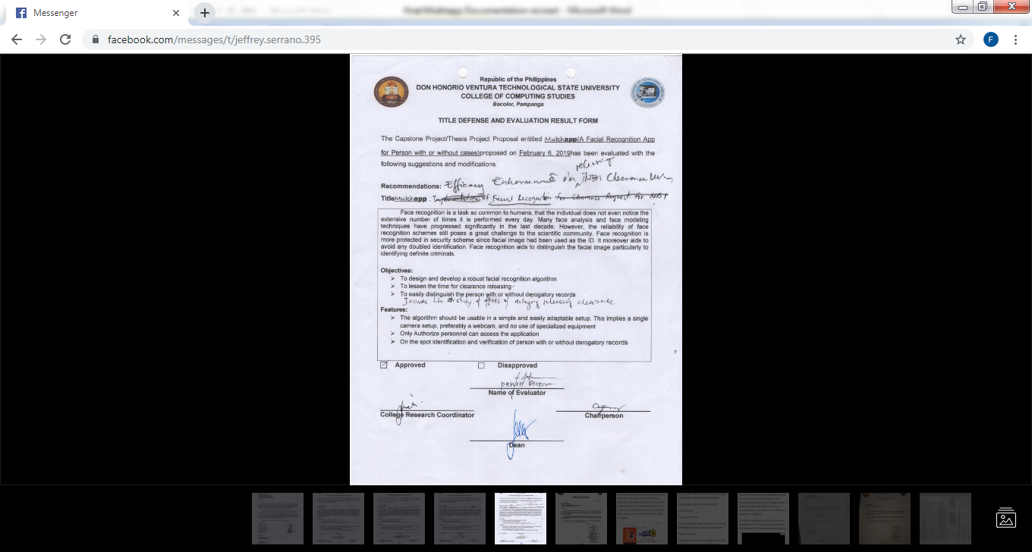

**Figure1.0: Title Defense and Evaluation Result Form**

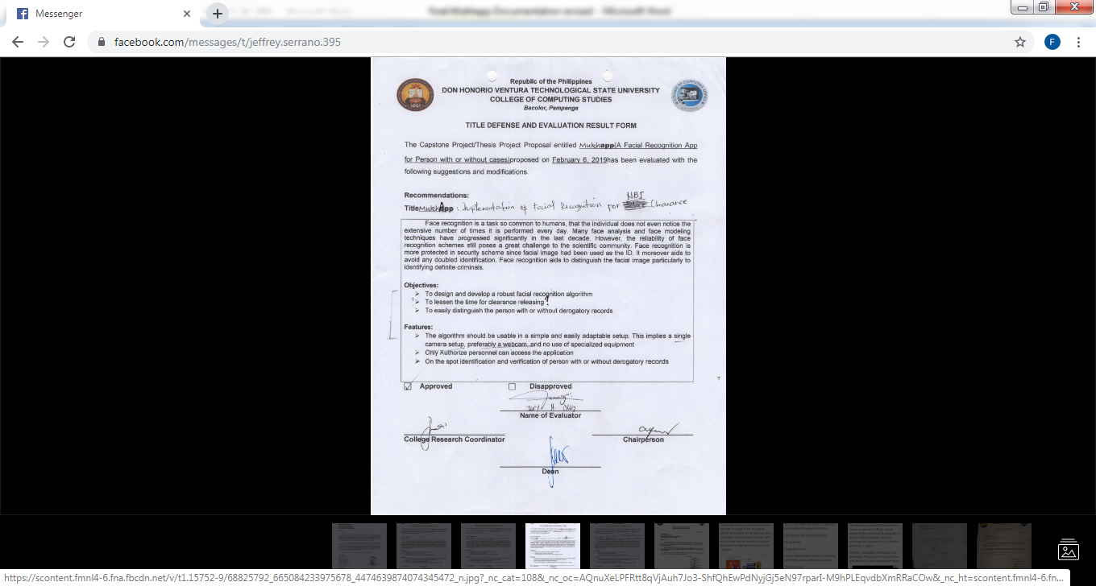

**Figure1.1: Title Defense and Evaluation Result Form**

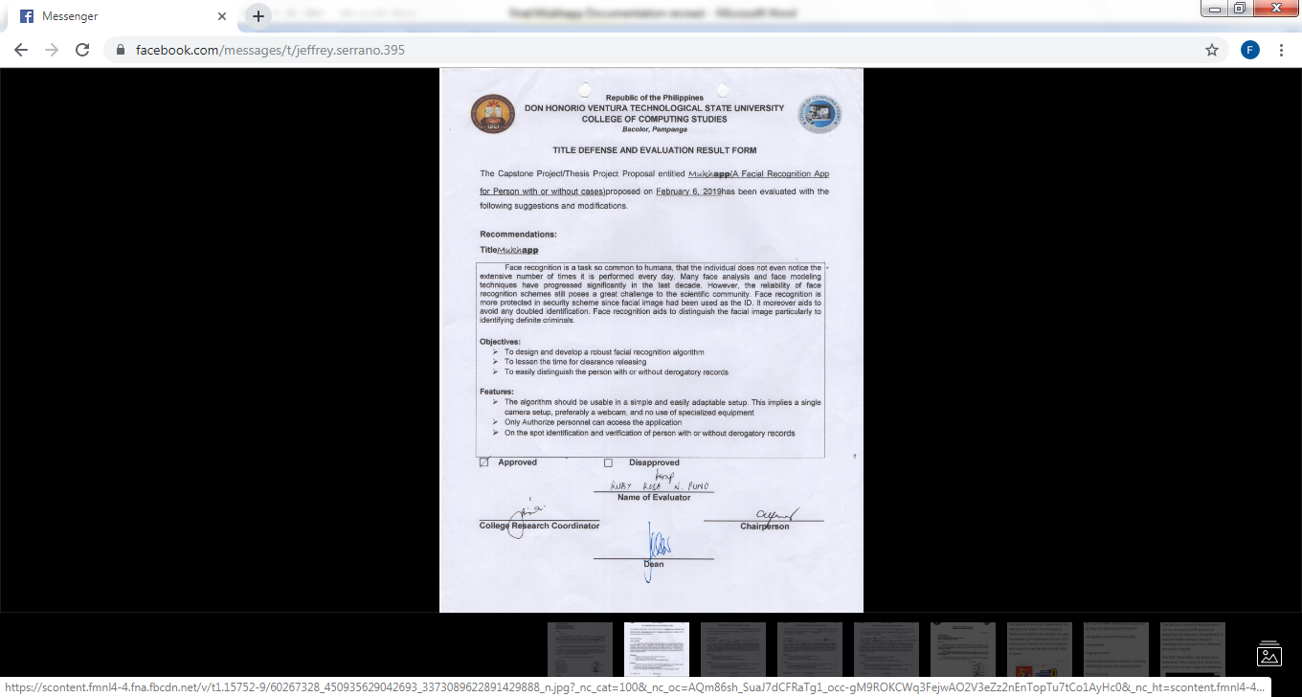

**Figure1.2: Title Defense and Evaluation Result Form**

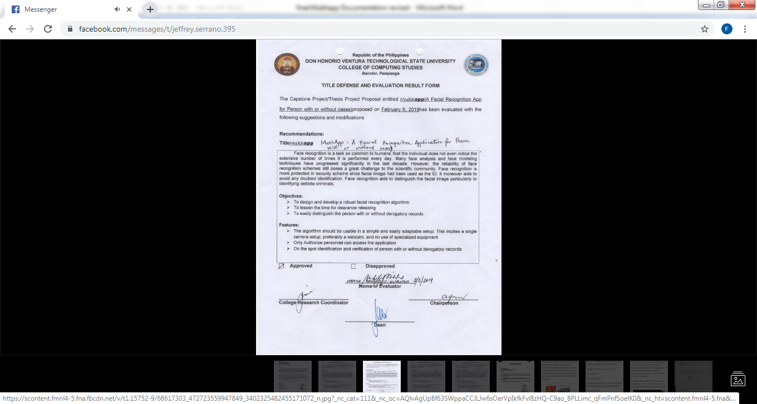

**Figure1.3: Title Defense and Evaluation Result Form**

APPENDIX B

(Sample Letters)

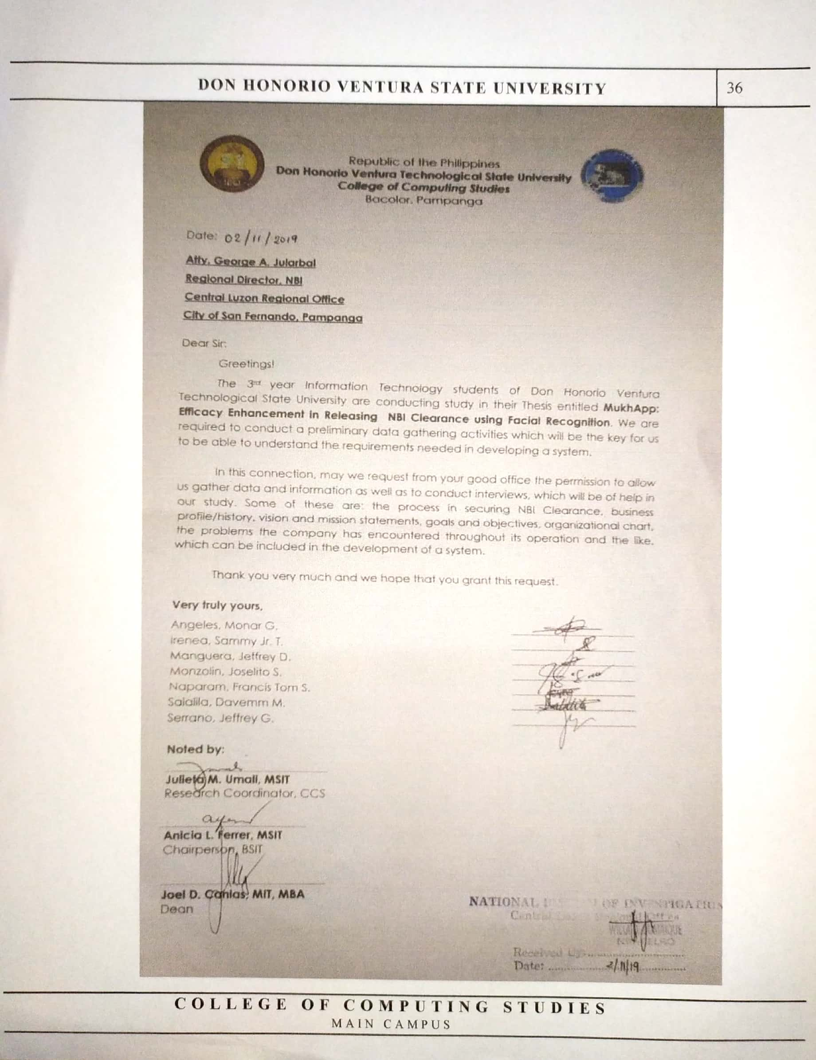

**Figure 2.0: Letter Request to National Bureau of Investigation**

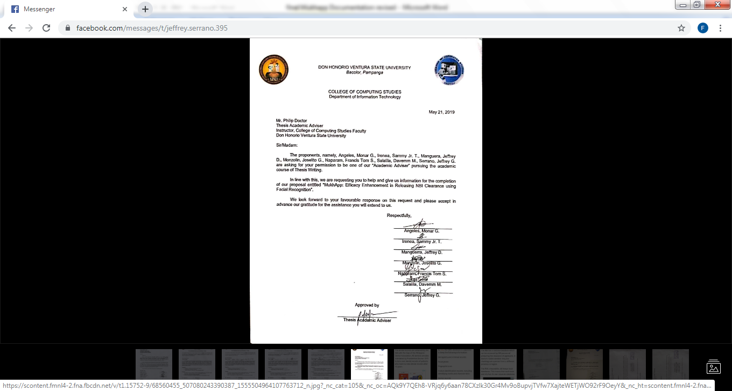

**Figure 2.1: Letter Request to Technical and Academic Adviser**

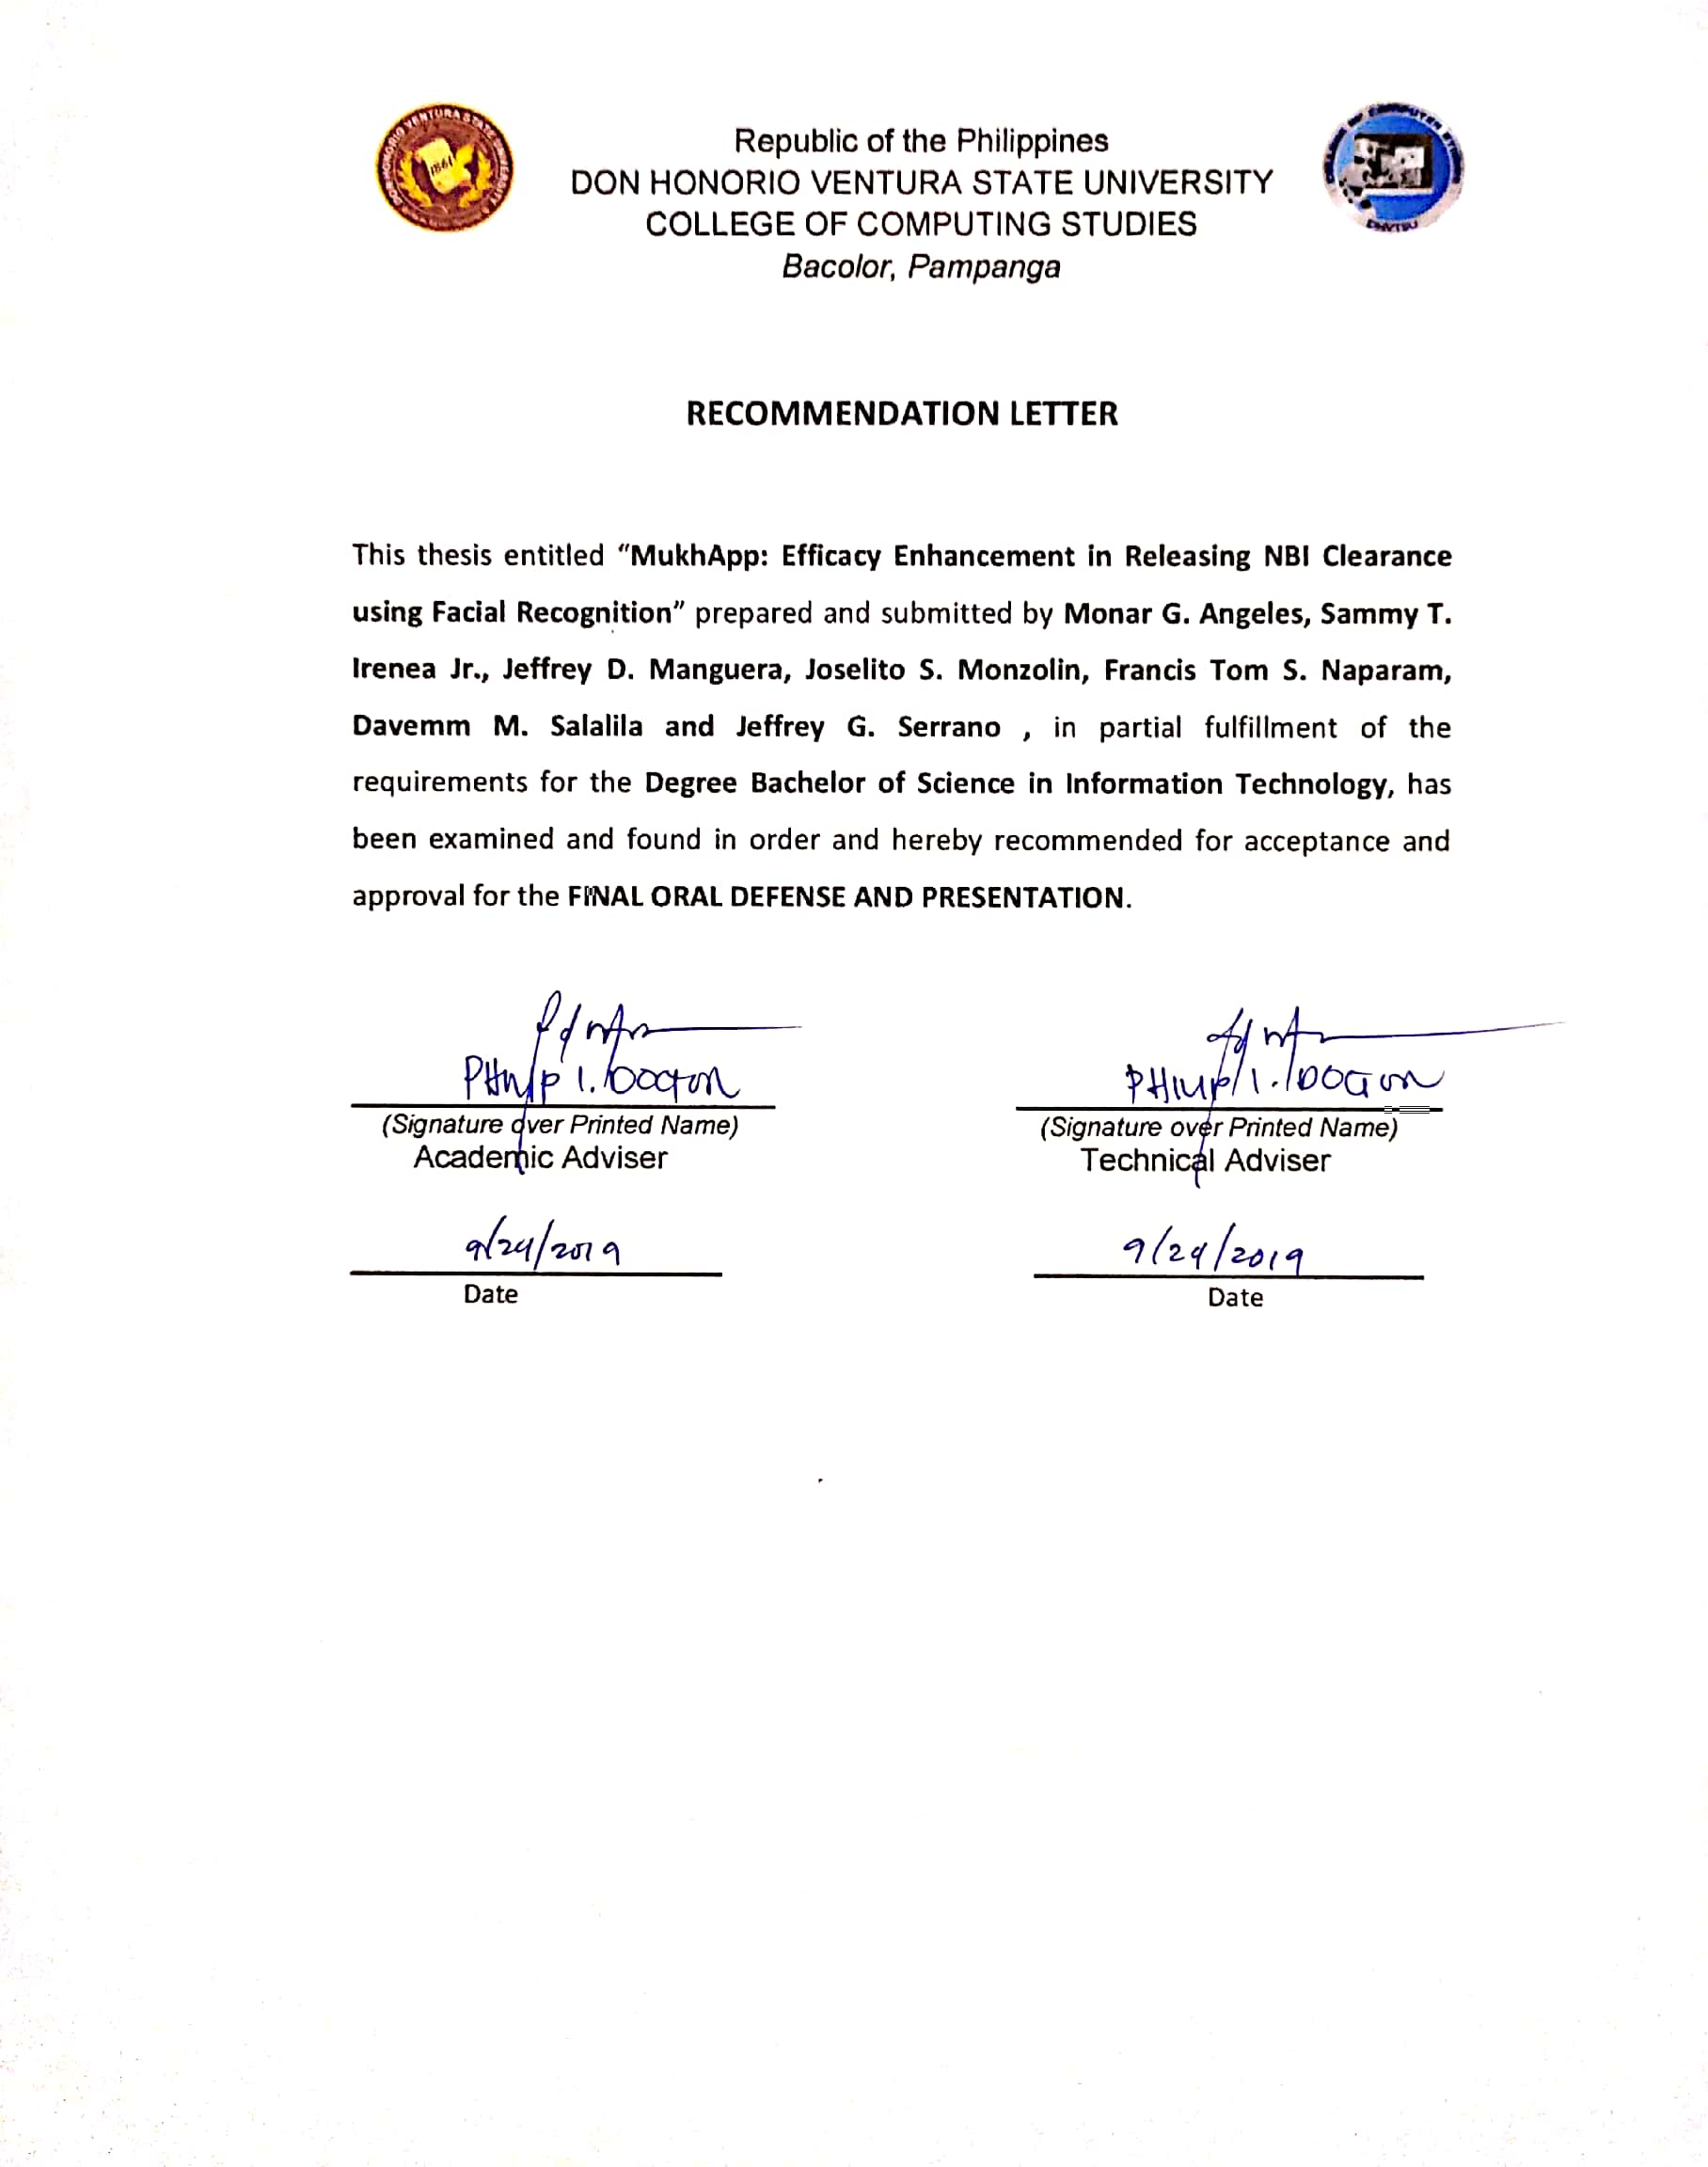

**Figure 2.2: Recommendation Letter for Final Defense**

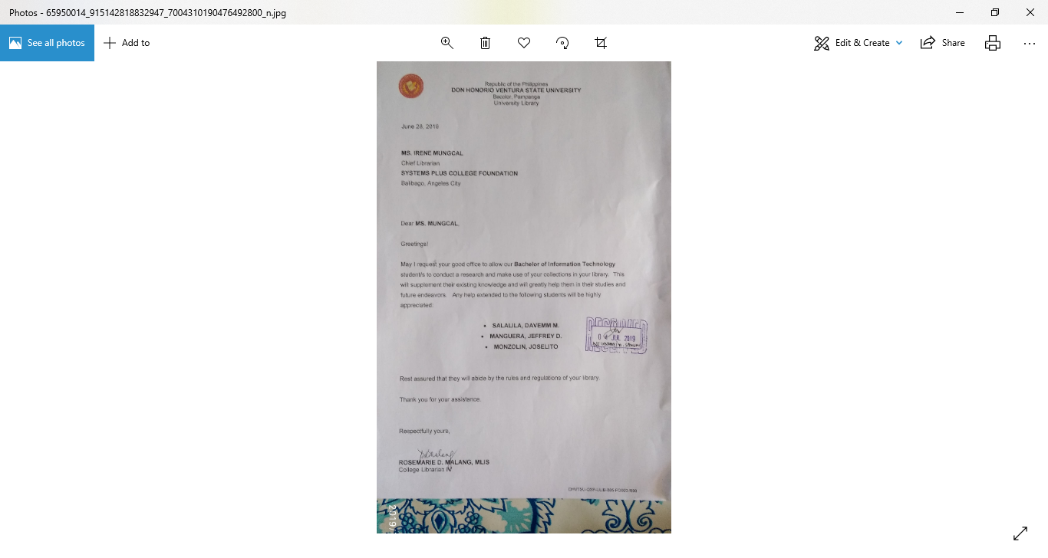

**Figure 2.3: Letter Request to Library (SPCF)**

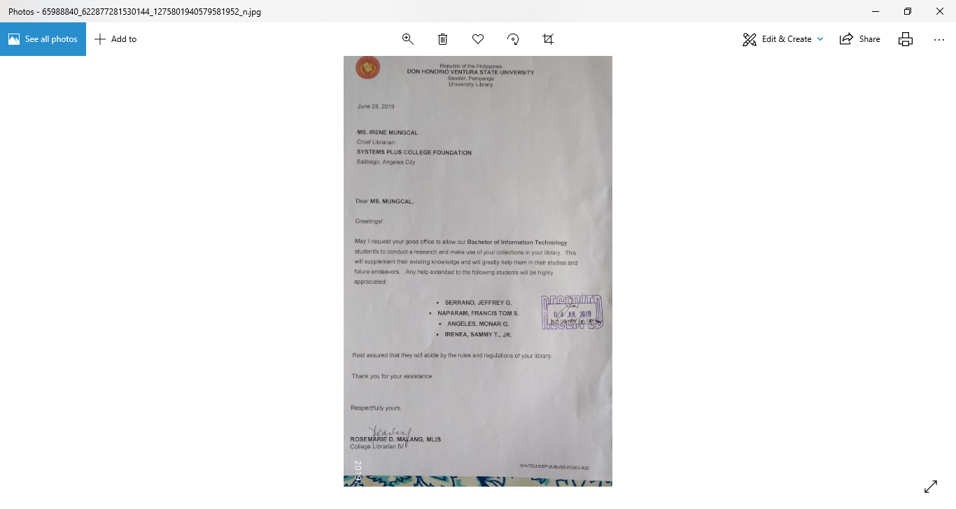

**Figure 2.4: Letter Request to Library (SPCF)**

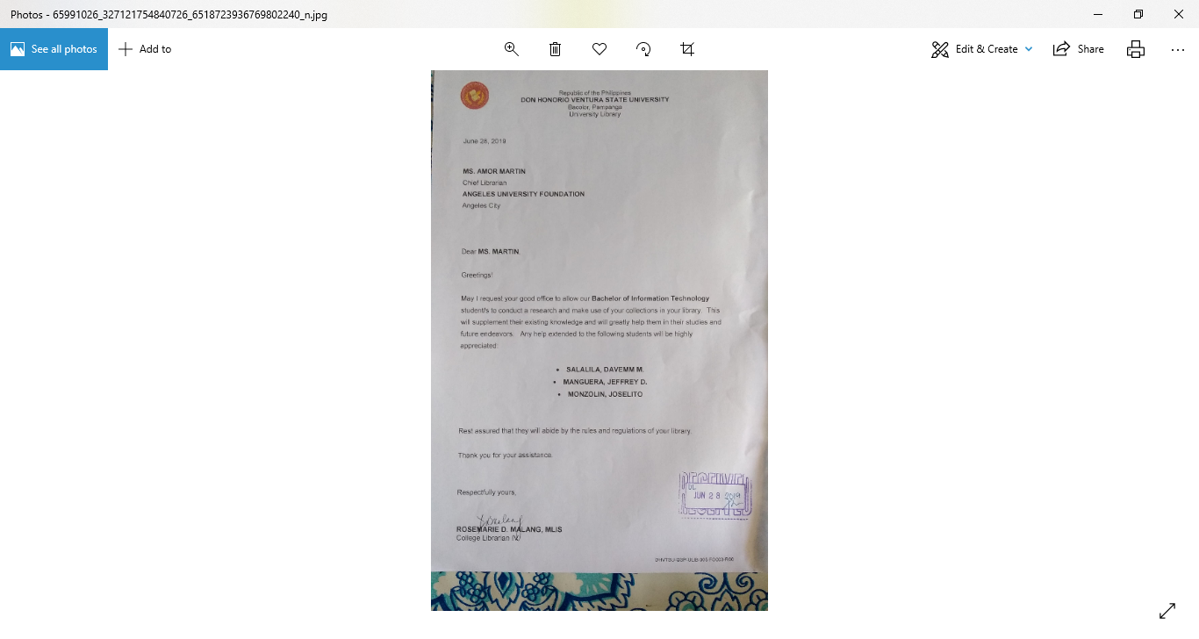

**Figure 2.5: Letter Request to Library (AUF)**

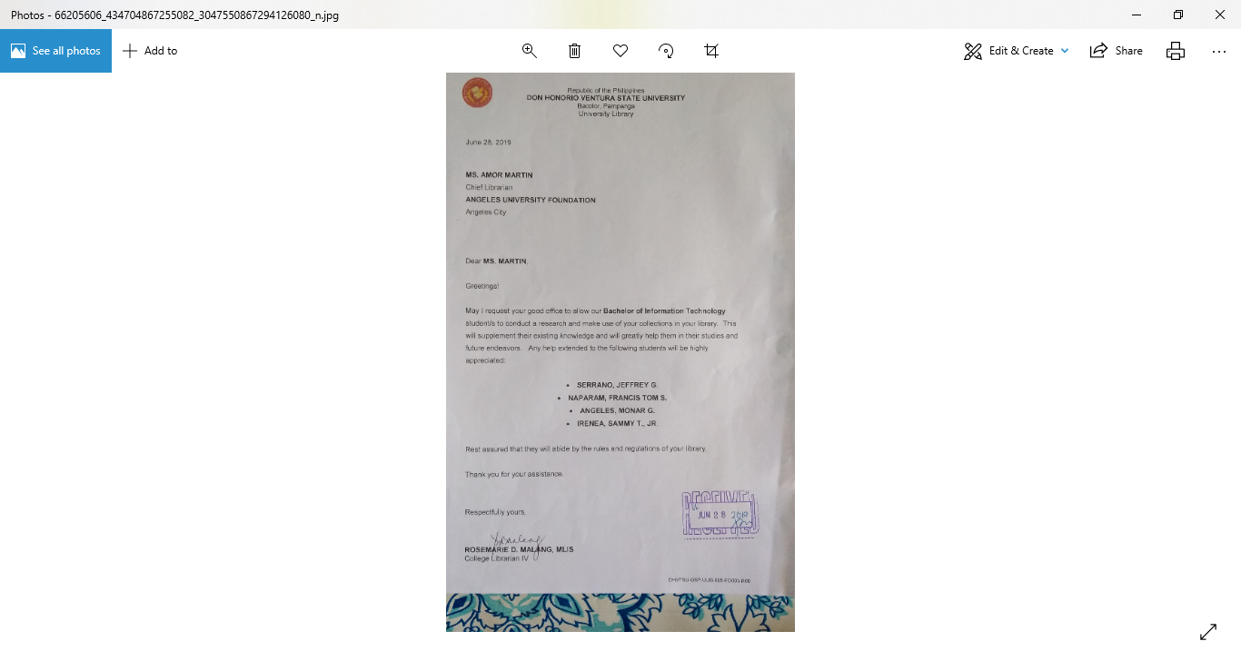

**Figure 2.6: Letter Request to Library (AUF)**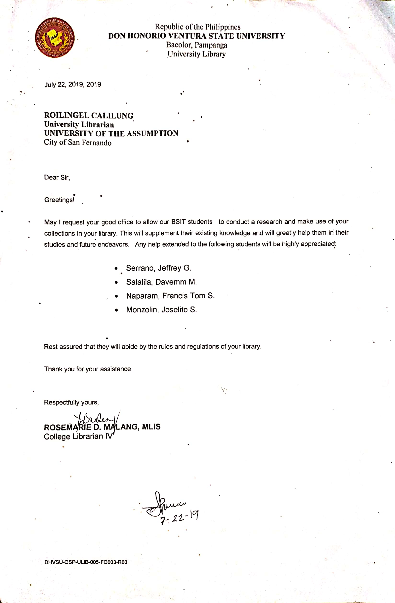

**Figure 2.7: Letter Request to Library (UA)**

APPENDIX C

(Gantt Chart)

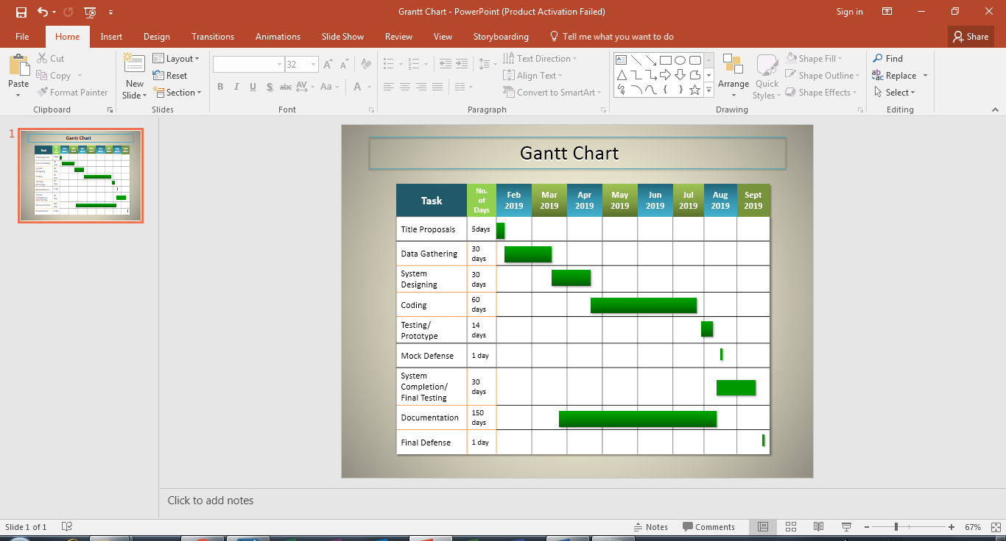

APPENDIX D

(Questionnaires and Evaluating Tools)

**Preliminary Survey**

Name: (*Optional)*\_\_\_\_\_\_\_\_\_\_\_\_\_\_\_\_\_\_\_\_ Age: \_\_\_\_\_

Please answer the following questions based from your experience on acquiring NBI Clearance. There is no right or wrong answers; all we are interested in is the number that truly reflects your feelings about the current system being provided by the NBI.

1. Do you have an existing NBI Clearance?

Yes No

If Yes, How is your experience in getting a NBI Clearance?

Very Satisfied Satisfied Good Fair Poor

1. Have you ever been tagged with Hit?

Yes No

If Yes,

1. What was the reason?

Namesake With Derogatory Records Others

1. How many days do they advise you to get your clearance?

1day 5days 7days 14days

1. Do you get your clearance right away when you return on the releasing day?

Yes No

If No,

1. What was the reason?

Interview Clearance not yet available Others

1. During interview, how is your experienced?

Very Satisfied Satisfied Good Fair Poor

1. How will you rate the NBI’s current system on acquisition of NBI clearance?

Very Satisfied Satisfied Good Fair Poor

1. In terms of efficiency of the NBI clearance current system, how will you rate it in giving better quality of information?

Very Satisfied Satisfied Good Fair Poor

Signature

**Evaluating Tools for the Existing System**

Name: (*Optional)*\_\_\_\_\_\_\_\_\_\_\_\_\_\_\_\_\_\_\_\_ Age: \_\_\_\_\_

Please rate each statement based from your Expectations and opinions of the current system by showing the extent to which you think you should possess the following feature. If you strongly disagree on the statement check 1, if you strongly agree on the statement check 5, if your feeling is less strong check one of the numbers in the middle. There is no right or wrong answers; all we are interested is in the number that truly reflects your feelings about the current system being provided by the NBI.

**LEGEND: 5 – Strongly Agree 2 – Disagree**

**4 –Agree 1–Strongly disagree**

**3 –Fair**

|  |  |  |  |  |  |
| --- | --- | --- | --- | --- | --- |
| **Effectiveness** | **5** | **4** | **3** | **2** | **1** |
| 1. The current system on acquiring NBI Clearance is consistent in terms of data processing. |  |  |  |  |  |
| 1. The level of service of the NBI clearance center current system is consistent for person tagged with hit. |  |  |  |  |  |
| 1. The NBI clearance current system is effectively generate records. |  |  |  |  |  |

|  |  |  |  |  |  |
| --- | --- | --- | --- | --- | --- |
| **Accuracy** | **5** | **4** | **3** | **2** | **1** |
| 1. The current system of NBI clearance is accurate in expanding the likelihood of distinguishing individual with derogatory records. |  |  |  |  |  |
| 1. The NBI clearance center current system is accurate in performing the promised service. |  |  |  |  |  |
| 1. The service performed of the NBI clearance current system is free of errors. |  |  |  |  |  |
| 1. The NBI clearance current system is reliable in giving better information. |  |  |  |  |  |

|  |  |  |  |  |  |
| --- | --- | --- | --- | --- | --- |
| **Usability** | **5** | **4** | **3** | **2** | **1** |
| 1. The current NBI clearance system procedures are easy to understand and able to be applied consistently with minimal supervision. |  |  |  |  |  |
| 1. The NBI clearance center current system has modern technology. |  |  |  |  |  |

|  |  |  |  |  |  |
| --- | --- | --- | --- | --- | --- |
| **Efficiency** | **5** | **4** | **3** | **2** | **1** |
| 1. A promised service happens in a certain time with the NBI Clearance current system. |  |  |  |  |  |
| 1. In the current system, the NBI clearance is released right away when the person tagged with hit is advised to return. |  |  |  |  |  |
| 1. The current system is efficient in giving better quality of information. |  |  |  |  |  |

Signature

**Evaluating Tools for the Proposed System**

Name: (*Optional)*\_\_\_\_\_\_\_\_\_\_\_\_\_\_\_\_\_\_\_\_ Age: \_\_\_\_\_

Please rate each statement based from your Expectations and opinions of the proposed system by showing the extent to which you think you should possess the following feature. If you strongly disagree on the statement check 1, if you strongly agree on the statement check 5, if your feeling is less strong check one of the numbers in the middle. There is no right or wrong answers; all we are interested is in the number that truly reflects your feelings about the proposed system.

**LEGEND: 5 – Strongly Agree 2 – Disagree**

**4 – Agree 1 – Strongly disagree**

**3 – Fair**

|  |  |  |  |  |  |
| --- | --- | --- | --- | --- | --- |
| **Effectiveness** | **5** | **4** | **3** | **2** | **1** |
| 1. The proposed system on acquiring NBI Clearance is consistent in terms of data processing. |  |  |  |  |  |
| 1. The level of service of the NBI clearance centre proposed system is consistent for person tagged with hit. |  |  |  |  |  |
| 1. The NBI clearance proposed system is effectively generate records. |  |  |  |  |  |

|  |  |  |  |  |  |
| --- | --- | --- | --- | --- | --- |
| **Accuracy** | **5** | **4** | **3** | **2** | **1** |
| 1. The proposed system of NBI clearance is accurate in expanding the likelihood of distinguishing individual with derogatory records. |  |  |  |  |  |
| 1. The NBI clearance centre proposed system is accurate in performing the promised service. |  |  |  |  |  |
| 1. The service performed of the NBI clearance proposed system is free of errors. |  |  |  |  |  |
| 1. The NBI clearance proposed system is reliable in giving better information. |  |  |  |  |  |

|  |  |  |  |  |  |
| --- | --- | --- | --- | --- | --- |
| **Usability** | **5** | **4** | **3** | **2** | **1** |
| 1. The proposed NBI clearance system procedures are easy to understand and able to be applied consistently with minimal supervision. |  |  |  |  |  |
| 1. The NBI clearance centre proposed system has modern technology. |  |  |  |  |  |

|  |  |  |  |  |  |
| --- | --- | --- | --- | --- | --- |
| **Efficiency** | **5** | **4** | **3** | **2** | **1** |
| 1. A promised service happens in a certain time with the NBI Clearance proposed system. |  |  |  |  |  |
| 1. In the proposed system, the NBI clearance is released right away when the person tagged with hit is advised to return. |  |  |  |  |  |
| 1. The proposed system is efficient in giving better quality of information. |  |  |  |  |  |

|  |  |  |  |  |  |
| --- | --- | --- | --- | --- | --- |
| **Security** | **5** | **4** | **3** | **2** | **1** |
| 1. The public has a sense of security in transacting with the NBI clearanceproposedsystem. |  |  |  |  |  |
| 1. Only authorized personnel have the authority to use the proposed NBI clearance system. |  |  |  |  |  |
| 1. The proposed NBI clearance system has a security access. |  |  |  |  |  |

Signature

APPENDIX E

(Conceptual Framework)

OUTPUT

INPUT

Assessment of Data through;

* Survey
* Interview
* Questionnaires
* Observation

Software

* MySQL.
* Visual Basic Studio.

Hardware

* Desktop Computer.
* Webcam

Data

* NBI Clearance Process.
* Public Assessment on acquiring Clearance.

PROCESS

MukhApp: Efficacy Enhancement in Securing NBI Clearance Using Facial Recognition of NBI, City of San Fernando Pampanga

EVALUATION PROCESS

**Figure 3: Conceptual Framework of the Proposed System**

APPENDIX F

(Context Diagram)

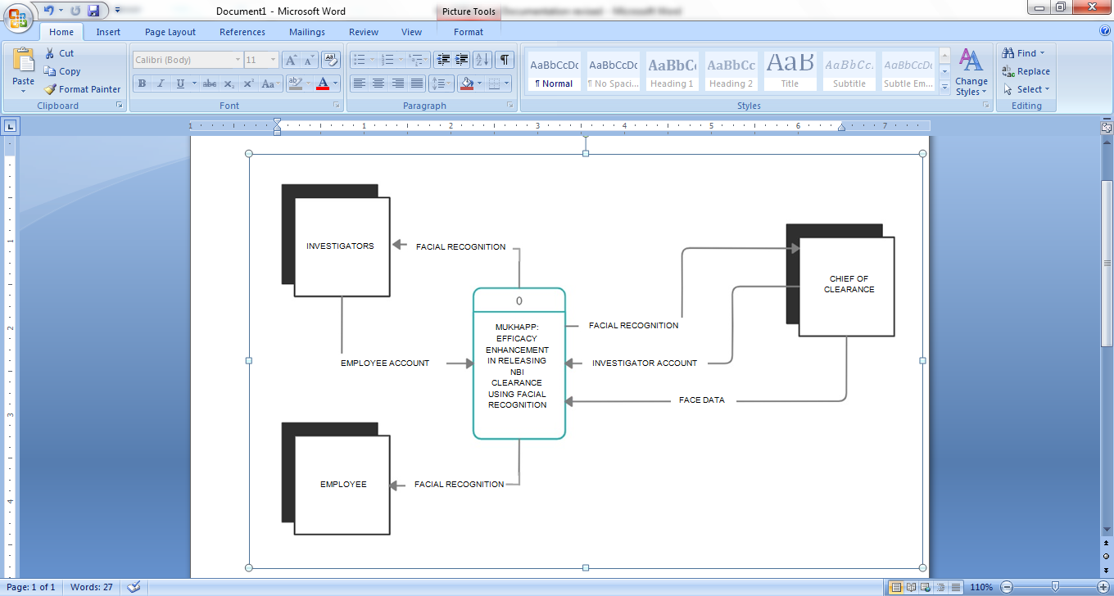

**Figure4: Context Diagram of the Proposed System**

APPENDIX G

(Data Flow Diagram)

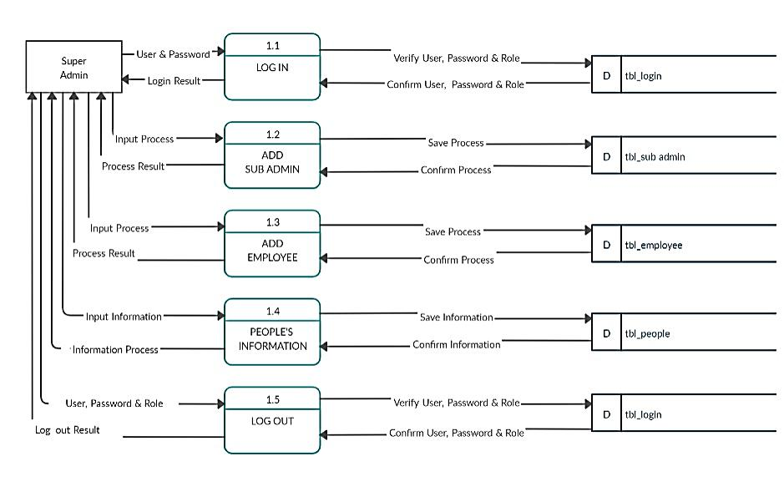

**Figure 5.0: Diagram 0 DFD of the Proposed System**

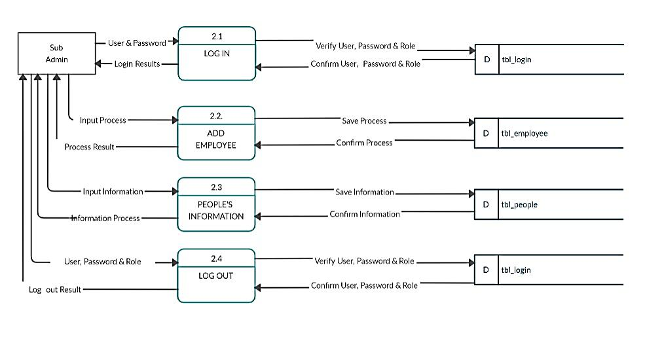

**Figure 5.1: Diagram 0 DFD of the Proposed System**

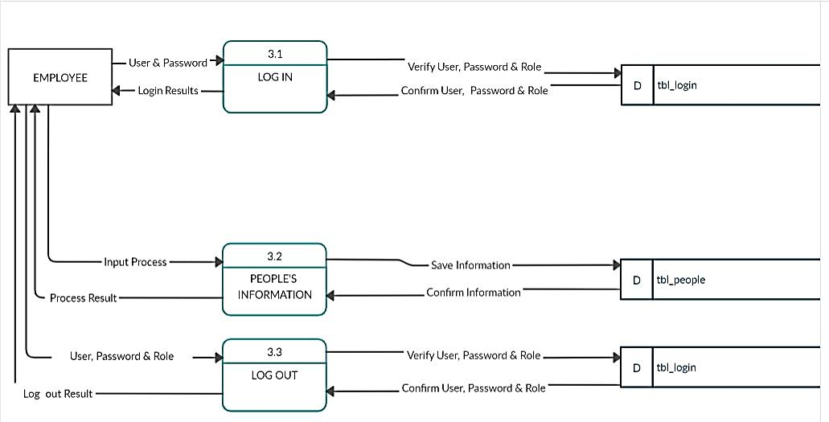

**Figure 5.2:Diagram 0 DFD of the Proposed System**

APPENDIX H

(System Architecture)

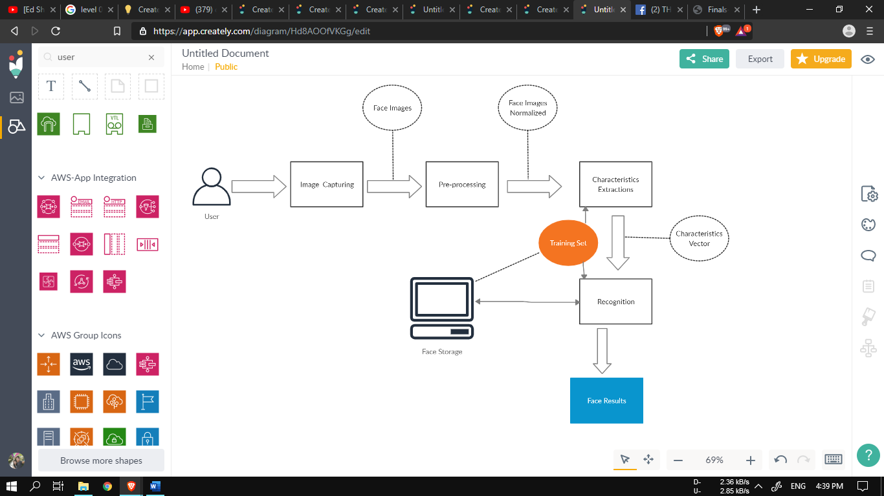

**Figure 6: System Architecture of the Proposed System**

APPEDIX I

(Entity Relationship Diagram)

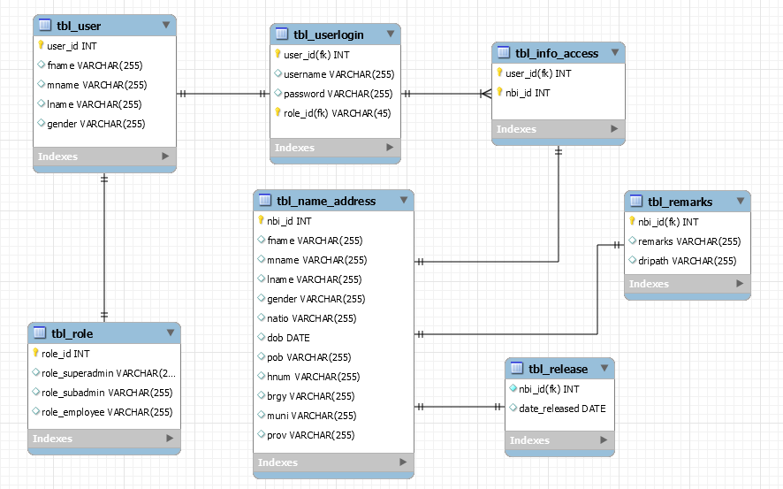

**Figure 7: Entity Relationship Diagram of the Proposed System**

APPENDIX J

(Screenshots of the Proposed System)

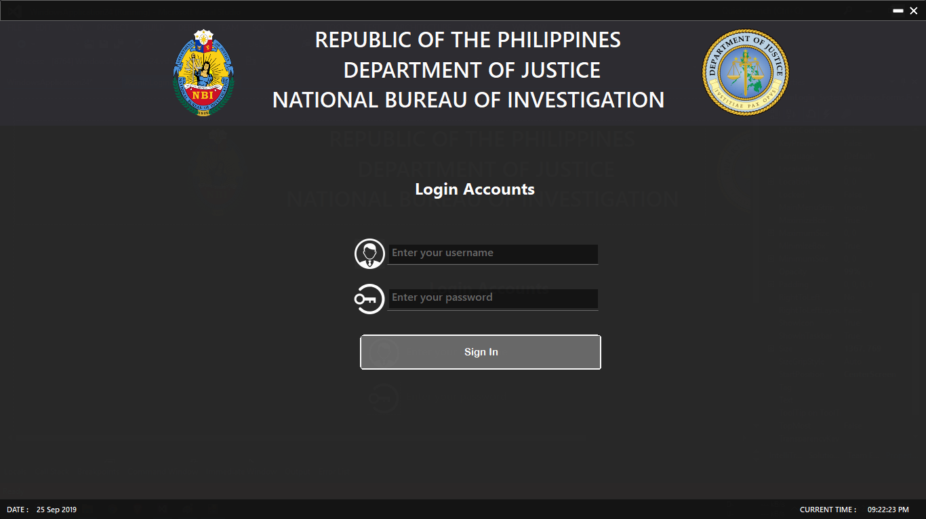

**Figure8.0:Log in Form of the Proposed System**



**Figure8.1: Loading Form of the Proposed System**

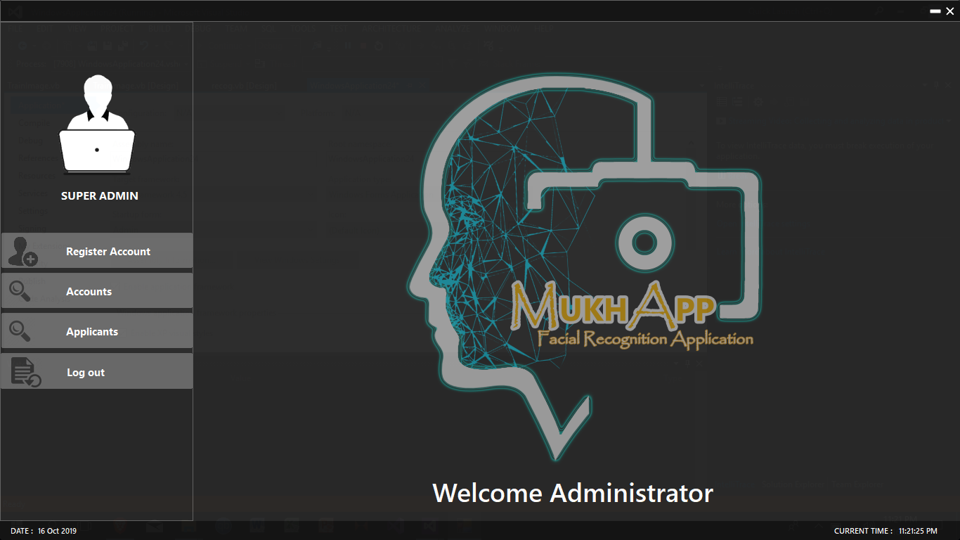

**Figure8.2: Super Admin Interface of the Proposed System**

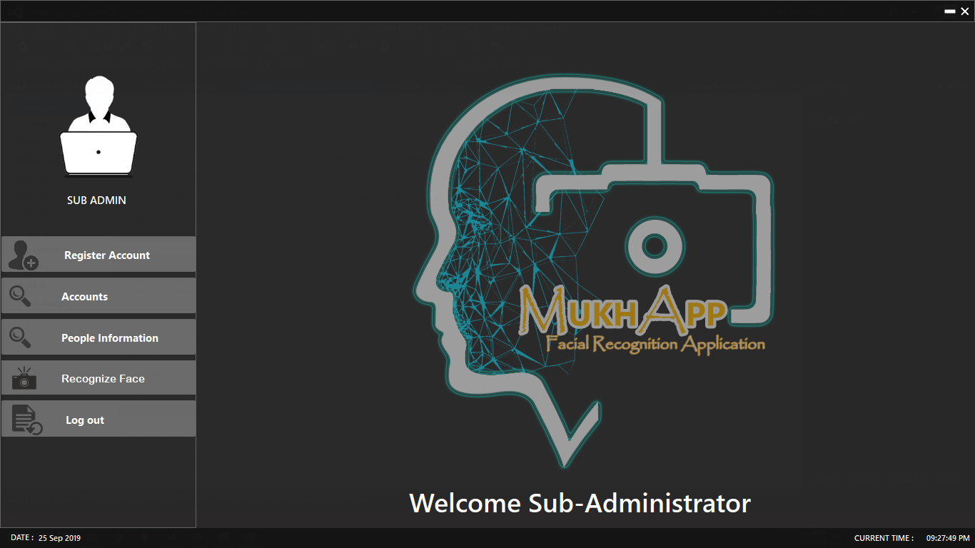

**Figure8.3: Sub-Admin Interface of the Proposed System**

**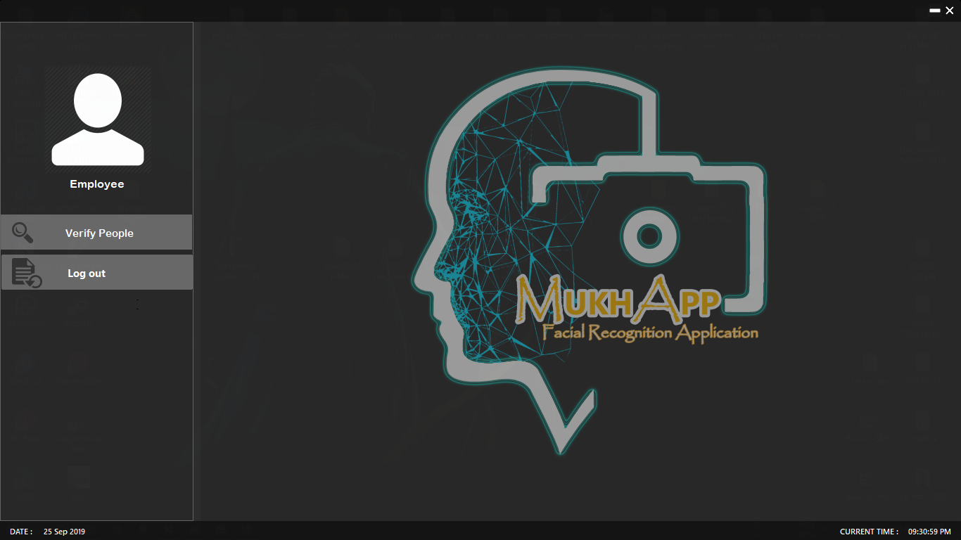**

**Figure 8.4: Employee Interface of the Proposed System**

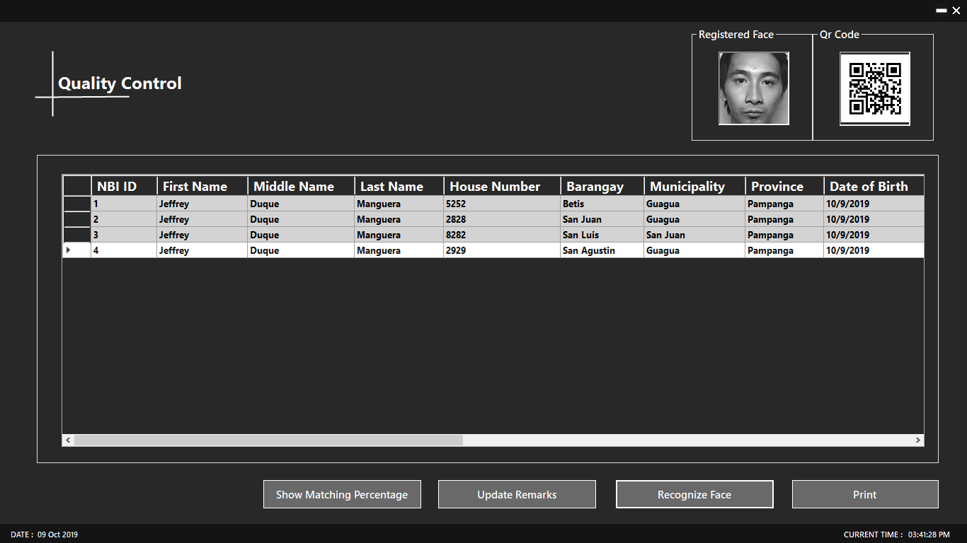

**Figure 8.5: Quality Control Interface of the Proposed System**

**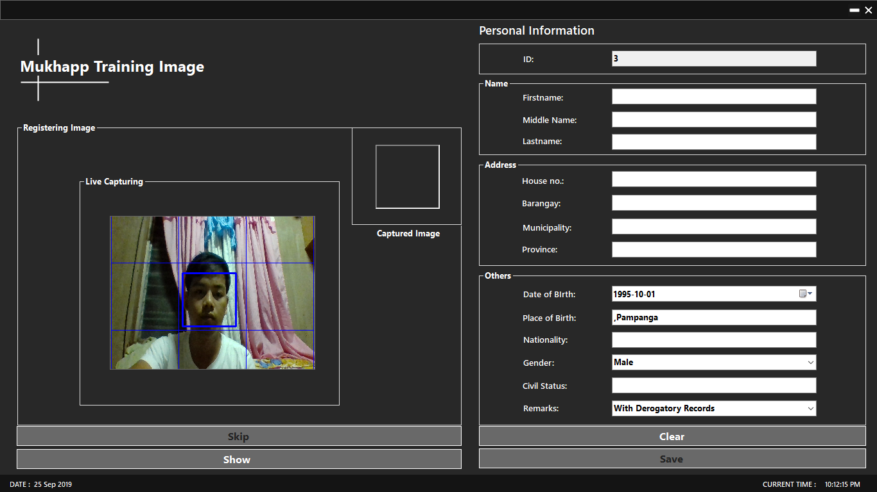**

**Figure 8.6:Training Image interface of the Proposed System**

**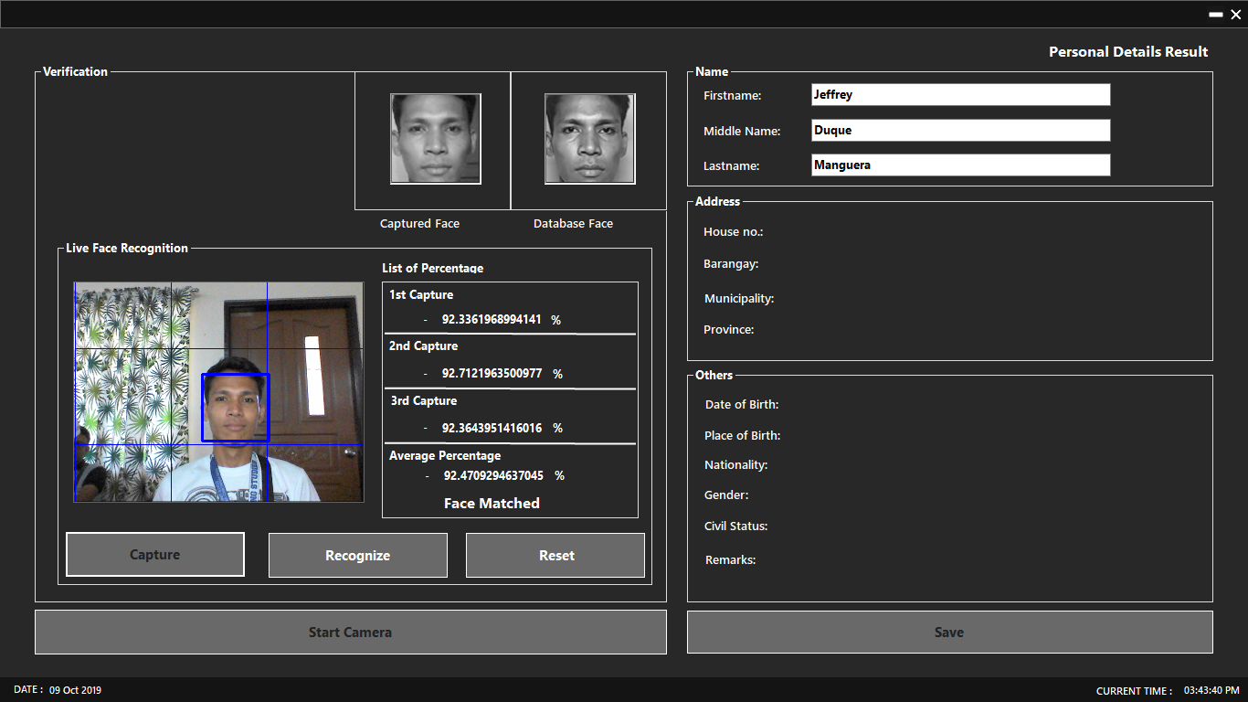**

**Figure 8.7: Verification of Records Interface of the Proposed System**

**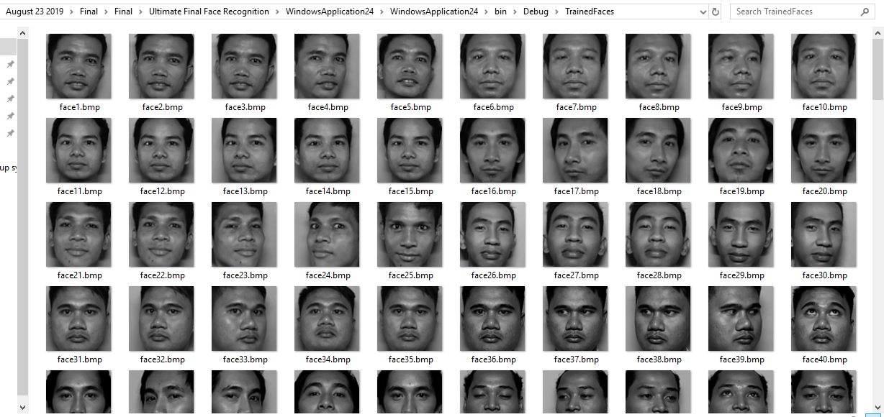**

**Figure 8.8:Sample face captured database of the Proposed System**

**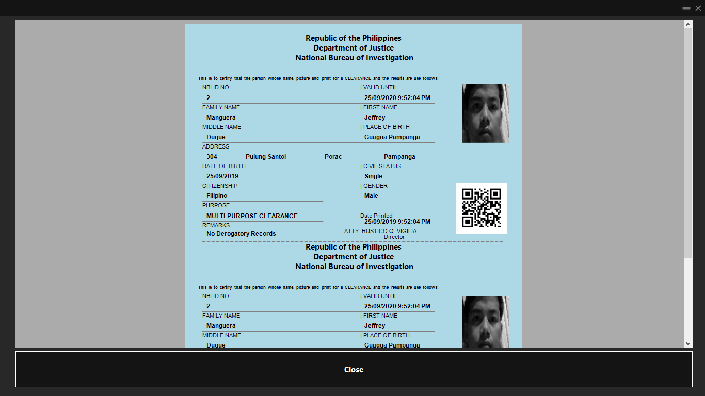**

**Figure 8.9:Print preview of NBI Clearance of the Proposed System**

APPENDIX K

(Sample Codes)

Imports MySql.Data.MySqlClient

Imports System.IO

Imports System.Security.Cryptography

Public Class Admin

Dim drag As Boolean ''For searchtxt placeholder''

Dim x, y As Integer ''Dragable form''

Dim newpoint As New Point ''Dragable form''

Dim catstate As String

''Connection''

Dim mycon As New MySqlConnection

Dim myadapt As New MySqlDataAdapter

Dim mydset As DataSet

Dim read As MySqlDataReader

Private \_ToolTip As New ToolTip()

Private Sub Admin\_Load(sender As Object, e As EventArgs) Handles MyBase.Load

Try

Timer2.Start()

''Setting the Placeholder for searchtxt''

With searchtxt

.SelectionStart = .TextLength

.SelectionLength = 0

.SelectionStart = 0

.ScrollToCaret()

End With

Timer1.Enabled = True ''Setting Timer''

\_ToolTip.AutomaticDelay = 100

\_ToolTip.AutoPopDelay = 30000

\_ToolTip.InitialDelay = 100

\_ToolTip.ReshowDelay = 100

''Get the max id for incrementation''

mycon.ConnectionString = GlobalStringVar.connection

mycon.Open()

myadapt.SelectCommand = mycon.CreateCommand

myadapt.SelectCommand.CommandText = "select max(user\_id) + 1 AS UserID from tbl\_user"

myadapt.SelectCommand.ExecuteNonQuery()

mycon.Close()

mydset = New DataSet

myadapt.Fill(mydset, "con"

DataGridView1.DataSource = mydset

DataGridView1.DataMember = "con"

DataGridView1.Refresh()

idtxt.Text = Me.DataGridView1.SelectedCells(0).Value.ToString

If DataGridView1.SelectedCells(0).Value.ToString = "" Then

idtxt.Text = 1

End If

'cells in alternating rows properties'

adminDG.BackgroundColor = Color.FromArgb(40, 40, 40)

adminDG.BorderStyle = BorderStyle.Fixed3D

' Set property values appropriate for read-only display and

' limited interactivity.

adminDG.AllowUserToAddRows = False

adminDG.AllowUserToDeleteRows = False

adminDG.AllowUserToOrderColumns = True

adminDG.ReadOnly = True

adminDG.SelectionMode = DataGridViewSelectionMode.FullRowSelect

adminDG.MultiSelect = False

adminDG.AllowUserToResizeColumns = False

adminDG.ColumnHeadersHeightSizeMode = DataGridViewColumnHeadersHeightSizeMode.AutoSize

adminDG.AllowUserToResizeRows = False

adminDG.RowHeadersWidthSizeMode = DataGridViewRowHeadersWidthSizeMode.DisableResizing

' Set the selection background color for all the cells

adminDG.DefaultCellStyle.SelectionBackColor = Color.White

adminDG.DefaultCellStyle.SelectionForeColor = Color.FromArgb(20, 20, 20)

' SetRowHeadersDefaultCellStyle.SelectionBackColor so that its default

' value won't override DataGridView.DefaultCellStyle.SelectionBackColor

adminDG.RowHeadersDefaultCellStyle.SelectionBackColor = Color.Empty

' Set the background color for all rows and for alternating rows.

' The value for alternating rows overrides the value for all rows.

adminDG.RowsDefaultCellStyle.BackColor = Color.LightGray

adminDG.AlternatingRowsDefaultCellStyle.BackColor = Color.LightGray

'Set the row and column header styles

adminDG.ColumnHeadersDefaultCellStyle.ForeColor = Color.White

adminDG.ColumnHeadersDefaultCellStyle.BackColor = Color.DimGray

'left side nawalanglaman'

adminDG.RowHeadersDefaultCellStyle.BackColor = Color.FromArgb(40, 40, 40)

adminDG.ColumnHeadersDefaultCellStyle.ForeColor = Color.White

'headerbackcolor'

adminDG.ColumnHeadersDefaultCellStyle.BackColor = Color.FromArgb(40, 40, 40)

''headertext alignment'

adminDG.EnableHeadersVisualStyles = False

'PEOPLE INFO DATAGRID'

'cells in alternating rows properties'

peopleinfoDG.BackgroundColor = Color.FromArgb(40, 40, 40)

peopleinfoDG.BorderStyle = BorderStyle.Fixed3D

' Set property values appropriate for read-only display and

' limited interactivity.

peopleinfoDG.AllowUserToAddRows = False

peopleinfoDG.AllowUserToDeleteRows = False

peopleinfoDG.AllowUserToOrderColumns = True

peopleinfoDG.ReadOnly = True

peopleinfoDG.SelectionMode = DataGridViewSelectionMode.FullRowSelect

peopleinfoDG.MultiSelect = False

peopleinfoDG.AllowUserToResizeColumns = False

peopleinfoDG.ColumnHeadersHeightSizeMode = DataGridViewColumnHeadersHeightSizeMode.AutoSize

peopleinfoDG.AllowUserToResizeRows = False

peopleinfoDG.RowHeadersWidthSizeMode = DataGridViewRowHeadersWidthSizeMode.DisableResizing

' Set the selection background color for all the cells

peopleinfoDG.DefaultCellStyle.SelectionBackColor = Color.White

peopleinfoDG.DefaultCellStyle.SelectionForeColor = Color.FromArgb(20, 20, 20)

' SetRowHeadersDefaultCellStyle.SelectionBackColor so that its default

' value won't override DataGridView.DefaultCellStyle.SelectionBackColor

peopleinfoDG.RowHeadersDefaultCellStyle.SelectionBackColor = Color.Empty

' Set the background color for all rows and for alternating rows.

' The value for alternating rows overrides the value for all rows.

peopleinfoDG.RowsDefaultCellStyle.BackColor = Color.LightGray

peopleinfoDG.AlternatingRowsDefaultCellStyle.BackColor = Color.LightGray

'Set the row and column header styles

peopleinfoDG.ColumnHeadersDefaultCellStyle.ForeColor = Color.White

peopleinfoDG.ColumnHeadersDefaultCellStyle.BackColor = Color.DimGray

'left side nawalanglaman'

peopleinfoDG.RowHeadersDefaultCellStyle.BackColor = Color.FromArgb(40, 40, 40)

peopleinfoDG.ColumnHeadersDefaultCellStyle.ForeColor = Color.White

'headerbackcolor'

peopleinfoDG.ColumnHeadersDefaultCellStyle.BackColor = Color.FromArgb(40, 40, 40)

''headertext alignment'

peopleinfoDG.EnableHeadersVisualStyles = False

Panel1.BorderStyle = BorderStyle.FixedSingle

If btnAdd.selected = True Then

btnAccounts.Enabled = False

btnPeopleinfo.Enabled = False

startTrain.Enabled = False

startcam.Enabled = False

btnLogout.Enabled = False

End If

Catch ex As Exception

MsgBox(ex.Message)

End Try

End Sub

Private Sub Timer1\_Tick(sender As Object, e As EventArgs) Handles Timer1.Tick

''Setting the current date''

Label5.Text = Date.Now.ToString("dd MMM yyyyhh:mm:sstt")

End Sub

Private Sub btnAdd\_Click(sender As Object, e As EventArgs) Handles btnAdd.Click

Try

MsgProceedTrain.Close()

MsgExitAdmin.Close()

MsgLogoutAD.Close()

UpdatePeopleInfo.Close()

UpdateAccForm.Close()

hideOnForm() 'global function to hide specific design in form'

'Refresh (maxid)'

mycon.Open()

myadapt.SelectCommand = mycon.CreateCommand

myadapt.SelectCommand.CommandText = "select max(user\_id) + 1 from tbl\_user"

myadapt.SelectCommand.ExecuteNonQuery()

mycon.Close()

mydset = New DataSet

myadapt.Fill(mydset, "con")

DataGridView1.DataSource = mydset

DataGridView1.DataMember = "con"

DataGridView1.Refresh()

idtxt.Text = Me.DataGridView1.SelectedCells(0).Value.ToString

If DataGridView1.SelectedCells(0).Value.ToString = "" Then

idtxt.Text = 1

End If

RegisterForm.Show()

Catch ex As Exception

MsgBox(ex.Message)

End Try

End Sub

Private Sub btnAccounts\_Click(sender As Object, e As EventArgs) Handles btnAccounts.Click

Try

Do While Panel3.Width < 275

Panel3.Width = Panel3.Width + 1

Loop

Panel3.BorderStyle = BorderStyle.FixedSingle

''CONNECTION''

mycon.ConnectionString = GlobalStringVar.connection

mycon.Open()

myadapt.SelectCommand = mycon.CreateCommand

myadapt.SelectCommand.CommandText = "select \* from tbl\_user inner join tbluser\_login on tbl\_user.user\_id = tbluser\_login.user\_id"

myadapt.SelectCommand.ExecuteReader()

mycon.Close()

mydset = New DataSet

myadapt.Fill(mydset, "s")

adminDG.DataSource = mydset

adminDG.DataMember = "s"

adminDG.Refresh()

'Header Text adminDG'

adminDG.Columns(0).HeaderText = " ID Number"

adminDG.Columns(1).HeaderText = " First Name"

adminDG.Columns(2).HeaderText = " Middle Name"

adminDG.Columns(3).HeaderText = " Last Name"

adminDG.Columns(4).HeaderText = " Gender"

adminDG.Columns(5).HeaderText = " Date of Birth"

adminDG.Columns(6).HeaderText = " ID number"

adminDG.Columns(7).HeaderText = " Username"

adminDG.Columns(8).HeaderText = " Password"

adminDG.Columns(9).HeaderText = " Role"

''header text size'

adminDG.Columns(0).HeaderCell.Style.Font = New Font("Segoe UI", 13.5F, FontStyle.Bold)

adminDG.Columns(1).HeaderCell.Style.Font = New Font("Segoe UI", 13.5F, FontStyle.Bold)

adminDG.Columns(2).HeaderCell.Style.Font = New Font("Segoe UI", 13.5F, FontStyle.Bold)

adminDG.Columns(3).HeaderCell.Style.Font = New Font("Segoe UI", 13.5F, FontStyle.Bold)

adminDG.Columns(4).HeaderCell.Style.Font = New Font("Segoe UI", 13.5F, FontStyle.Bold)

adminDG.Columns(5).HeaderCell.Style.Font = New Font("Segoe UI", 13.5F, FontStyle.Bold)

adminDG.Columns(6).HeaderCell.Style.Font = New Font("Segoe UI", 13.5F, FontStyle.Bold)

adminDG.Columns(7).HeaderCell.Style.Font = New Font("Segoe UI", 13.5F, FontStyle.Bold)

adminDG.Columns(8).HeaderCell.Style.Font = New Font("Segoe UI", 13.5F, FontStyle.Bold)

adminDG.Columns(9).HeaderCell.Style.Font = New Font("Segoe UI", 13.5F, FontStyle.Bold)

adminDG.BorderStyle = BorderStyle.Fixed3D

For i As Integer = 0 ToadminDG.ColumnCount - 1

adminDG.Columns(i).AutoSizeMode = DataGridViewAutoSizeColumnMode.AllCells

Next

adminDG.Columns(6).Visible = False

adminDG.Columns(7).Visible = False

adminDG.Columns(8).Visible = False

lblinfo.Visible = True

gb1.Visible = True

gb2.Visible = False

RegisterForm.Close()

RegisterFormSub.Close()

UpdatePeopleInfo.Close()

UpdatePeopleInfoSub.Close()

UpdateAccForm.Close()

UpdateAccFormSub.Close()

MsgProceedTrain.Dispose()

MsgExitAdmin.Dispose()

MsgLogoutAD.Dispose()

showTableAccounts() 'Show table of admin accounts

''Clear - Reset Registration''

RegisterForm.fnametxt.Text = ""

RegisterForm.lnametxt.Text = ""

RegisterForm.mnametxt.Text = ""

RegisterForm.usertxt.Text = ""

RegisterForm.passtxt.Text = ""

RegisterForm.retypePassTxt.Text = ""

RegisterForm.PwdmatchLbl.Visible = False

RegisterForm.savebtn.Enabled = False

RegisterForm.validPassLbl.Visible = False

RegisterForm.Gendercombo.Text = String.Empty

RegisterForm.Gendercombo.Text = "Gender"

Catch ex As Exception

MsgBox(ex.Message)

End Try

End Sub

Private Sub btnLougout\_Click(sender As Object, e As EventArgs) Handles btnLogout.Click

Try

''clear''

RegisterForm.fnametxt.Text = ""

RegisterForm.lnametxt.Text = ""

RegisterForm.mnametxt.Text = ""

RegisterForm.Gendercombo.Text = String.Empty

RegisterForm.Gendercombo.Text = "Gender"

RegisterForm.usertxt.Text = ""

RegisterForm.passtxt.Text = ""

RegisterForm.retypePassTxt.Text = ""

RegisterForm.PwdmatchLbl.Visible = False

RegisterForm.savebtn.Enabled = False

RegisterForm.validPassLbl.Visible = False

RegisterFormSub.Close()

UpdatePeopleInfo.Close()

UpdatePeopleInfoSub.Close()

UpdateAccForm.Close()

UpdateAccFormSub.Close()

RegisterForm.Close()

MsgProceedTrain.Close()

MsgProceedRecogAdmin.Close()

MsgExitAdmin.Hide()

hideOnForm() 'Global function hide specific design'

MsgLogoutAD.Show()

Catch ex As Exception

MsgBox(ex.Message)

End Try

End Sub

Dim btnclick As Boolean = False

Private Sub updatebtn\_MouseHover(sender As Object, e As EventArgs) Handles updatebtn.MouseHover

''Change forecolor when mouse hover (RGB)''

updatebtn.ForeColor = Color.White

End Sub

Private Sub updatebtn\_MouseLeave(sender As Object, e As EventArgs) Handles updatebtn.MouseLeave

''Return forecolor at default (RGB)''

updatebtn.ForeColor = Color.White

End Sub

Private Sub cancelbtn\_MouseHover(sender As Object, e As EventArgs) Handles cancelbtn.MouseHover

''Change forecolor when mouse hover (RGB)''

cancelbtn.ForeColor = Color.White

End Sub

Private Sub cancelbtn\_MouseLeave(sender As Object, e As EventArgs) Handles cancelbtn.MouseLeave

''Return forecolor at default (RGB)''

cancelbtn.ForeColor = Color.White

End Sub

Private Sub ComboBox1\_KeyPress(sender As Object, e As KeyPressEventArgs)

''To Prevent user for inputing character in combo box''

e.Handled = True

End Sub

Private Sub idtxt\_GotFocus(sender As Object, e As EventArgs)

Try

''PLACE HOLDER IDtxt''

drag = True

With idtxt

If .Text = "ID Number" And .ForeColor = Color.Gray Then

.SelectionStart = .TextLength

.SelectionLength = 0

.SelectionStart = 0

.ScrollToCaret()

End If

End With

Catch ex As Exception

MsgBox(ex.Message)

End Try

End Sub

Private Sub MonthCombo\_KeyPress(sender As Object, e As KeyPressEventArgs)

''To Prevent user for inputing character in combo box''

e.Handled = True

End Sub

Private Sub DayCombo\_KeyPress(sender As Object, e As KeyPressEventArgs)

''To Prevent user for inputing character in combo box''

e.Handled = True

End Sub

Private Sub YearCombo\_KeyPress(sender As Object, e As KeyPressEventArgs)

''To Prevent user for inputing character in combo box''

e.Handled = True

End Sub

Private Sub Panel1\_MouseMove(sender As Object, e As MouseEventArgs) Handles Panel1.MouseMove

Try

''Movable form''

If e.Button = Windows.Forms.MouseButtons.Left Then

newpoint = Control.MousePosition

newpoint.X -= x

newpoint.Y -= y

Me.Location = newpoint

Application.DoEvents()

End If

Catch ex As Exception

MsgBox(ex.Message)

End Try

End Sub

Private Sub Panel1\_MouseDown(sender As Object, e As MouseEventArgs) Handles Panel1.MouseDown

''Movable form''

x = Control.MousePosition.X - Me.Location.X

y = Control.MousePosition.Y - Me.Location.Y

End Sub

Private Sub ExitBtn\_Click(sender As Object, e As EventArgs) Handles ExitBtn.Click

Try

RegisterForm.Close()

UpdatePeopleInfo.Close()

UpdateAccForm.Close()

hideOnForm() 'global function hide specific design'

MsgLogoutAD.Close()

MsgProceedTrain.Close()

MsgLogoutAD.Close()

cancelReg.Close()

cancelReg.Close()

cancelupAccnt.Close()

cancelupInfo.Close()

MsgProceedRecogAdmin.Close()

MsgProceedTrain.Close()

charOnly.Close()

digitsOnly.Close()

Msgstrongpass.Close()

UpdateAccForm.Close()

UpdatePeopleInfo.Close()

MsgExitAdmin.Show()

Catch ex As Exception

MsgBox(ex.Message)

End Try

End Sub

Private Sub MinimizeBtn\_Click(sender As Object, e As EventArgs) Handles MinimizeBtn.Click

''To minimize form using imagebutton''

WindowState = FormWindowState.Minimized

End Sub

Private Sub Button1\_MouseHover(sender As Object, e As EventArgs)

End Sub

Private Sub Button1\_MouseLeave(sender As Object, e As EventArgs)

End Sub

Private Sub cancelRegBtn\_Click(sender As Object, e As EventArgs)

cancelReg.Show()

End Sub

Private Sub Gendercombo\_KeyPress(sender As Object, e As KeyPressEventArgs)

''To Prevent user for inputing character in combo box''

e.Handled = True

End Sub

Private Sub idtxt\_KeyPress(sender As Object, e As KeyPressEventArgs)

If (Char.IsControl(e.KeyChar) = False) Then

If (Char.IsDigit(e.KeyChar)) Then

Else

e.Handled = True

MsgBox("Digit Only")

idtxt.Select(4, idtxt.Text.Length)

End If

End If

End Sub

Private Sub fnametxt\_KeyPress(sender As Object, e As KeyPressEventArgs)

Select Case Asc(e.KeyChar)

Case 8, 32, 65 To 90, 97 To 122

e.Handled = False

Case Else

e.Handled = True

charOnly.Show()

charOnly.Focus()

End Select

End Sub

Private Sub snametxt\_KeyPress(sender As Object, e As KeyPressEventArgs)

Select Case Asc(e.KeyChar)

Case 8, 32, 65 To 90, 97 To 122

e.Handled = False

Case Else

e.Handled = True

charOnly.Show()

charOnly.Focus()

End Select

End Sub

Private Sub mnametxt\_KeyPress(sender As Object, e As KeyPressEventArgs)

Select Case Asc(e.KeyChar)

Case 8, 32, 65 To 90, 97 To 122

e.Handled = False

Case Else

e.Handled = True

charOnly.Show()

charOnly.Focus()

End Select

End Sub

Private Sub passtxt\_KeyDown(sender As Object, e As KeyEventArgs)

If e.KeyCode = Keys.Space Then

e.SuppressKeyPress = True

End If

End Sub

Private Sub retypePassTxt\_KeyDown(sender As Object, e As KeyEventArgs)

If e.KeyCode = Keys.Space Then

e.SuppressKeyPress = True

End If

End Sub

Private Sub updatebtn\_Click(sender As Object, e As EventArgs) Handles updatebtn.Click

Try

UpdateAccForm.Show()

lblinfo2.Visible = False

lblinfo.Visible = False

gb1.Visible = False

adminDG.Visible = False

lblinfo2.Visible = True

gb2.Visible = True

searchtxt.Visible = False

lblinfo2.Visible = False

updatebtn.Visible = False

cancelbtn.Visible = False

Label29.Visible = False

PictureBox1.Visible = False

RegisterForm.Close()

'clear'

searchtxt.Text = ""

Catch ex As Exception

MsgBox(ex.Message)

End Try

End Sub

Private Sub startTrain\_Click(sender As Object, e As EventArgs) Handles startTrain.Click

Try

MsgLogoutAD.Close()

MsgExitAdmin.Close()

MsgProceedRecogAdmin.Close()

RegisterForm.Close()

RegisterForm.Close()

UpdatePeopleInfo.Close()

UpdateAccForm.Close()

hideOnForm() 'global function to hide specific design in form'

MsgProceedTrain.Show()

Catch ex As Exception

MsgBox(ex.Message)

End Try

End Sub

Private Sub DataGridView3\_CellClick(sender As Object, e As DataGridViewCellEventArgs) Handles adminDG.CellClick

Try

Dim x As Integer

x = adminDG.CurrentRow.Index

UpdateAccForm.idtxt2.Text = adminDG.Item(0, x).Value

UpdateAccForm.fnametxt2.Text = adminDG.Item(1, x).Value

UpdateAccForm.mnametxt2.Text = adminDG.Item(2, x).Value

UpdateAccForm.lnametxt2.Text = adminDG.Item(3, x).Value

UpdateAccForm.Gendercombo2.Text = adminDG.Item(4, x).Value

UpdateAccForm.dob2.Text = adminDG.Item(5, x).Value

UpdateAccForm.usertxt2.Text = adminDG.Item(7, x).Value

UpdateAccForm.passtxt2.Text = adminDG.Item(8, x).Value

UpdateAccForm.cbRole2.Text = adminDG.Item(9, x).Value

Catch ex As Exception

MsgBox(ex.Message)

End Try

End Sub

Private Sub cbRole2\_KeyPress(sender As Object, e As KeyPressEventArgs)

e.Handled = True

End Sub

Private Sub mnametxt2\_KeyPress(sender As Object, e As KeyPressEventArgs)

Select Case Asc(e.KeyChar)

Case 8, 32, 65 To 90, 97 To 122

e.Handled = False

Case Else

e.Handled = True

charOnly.Show()

charOnly.Focus()

End Select

End Sub

Private Sub lnametxt2\_KeyPress(sender As Object, e As KeyPressEventArgs)

Select Case Asc(e.KeyChar)

Case 8, 32, 65 To 90, 97 To 122

e.Handled = False

Case Else

e.Handled = True

charOnly.Show()

charOnly.Focus()

End Select

End Sub

Private Sub peopleinfoBtn\_Click(sender As Object, e As EventArgs) Handles btnPeopleinfo.Click

Try

Do While Panel3.Width < 275

Panel3.Width = Panel3.Width + 1

Loop

Panel3.BorderStyle = BorderStyle.FixedSingle

''CONNECTION''

mycon.ConnectionString = GlobalStringVar.connection

mycon.Open()

myadapt.SelectCommand = mycon.CreateCommand

myadapt.SelectCommand.CommandText = "select \* from infoTB"

myadapt.SelectCommand.ExecuteReader()

mycon.Close()

mydset = New DataSet

myadapt.Fill(mydset, "s")

peopleinfoDG.DataSource = mydset

peopleinfoDG.DataMember = "s"

peopleinfoDG.Refresh()

'Header Text peopleinfoDG'

peopleinfoDG.Columns(0).HeaderText = "NBI ID"

peopleinfoDG.Columns(1).HeaderText = "First Name"

peopleinfoDG.Columns(2).HeaderText = "Middle Name"

peopleinfoDG.Columns(3).HeaderText = "Last Name"

peopleinfoDG.Columns(4).HeaderText = "House Number"

peopleinfoDG.Columns(5).HeaderText = "Barangay"

peopleinfoDG.Columns(6).HeaderText = "Municipality"

peopleinfoDG.Columns(7).HeaderText = "Province"

peopleinfoDG.Columns(8).HeaderText = "Date of Birth"

peopleinfoDG.Columns(9).HeaderText = "Place of Birth"

peopleinfoDG.Columns(10).HeaderText = "Nationality"

peopleinfoDG.Columns(11).HeaderText = "Gender"

peopleinfoDG.Columns(12).HeaderText = "Civil Status"

peopleinfoDG.Columns(13).HeaderText = "Remarks"

peopleinfoDG.Columns(14).HeaderText = "Directory Path"

''header text size'

peopleinfoDG.Columns(0).HeaderCell.Style.Font = New Font("Segoe UI", 13.5F, FontStyle.Bold)

peopleinfoDG.Columns(1).HeaderCell.Style.Font = New Font("Segoe UI", 13.5F, FontStyle.Bold)

peopleinfoDG.Columns(2).HeaderCell.Style.Font = New Font("Segoe UI", 13.5F, FontStyle.Bold)

peopleinfoDG.Columns(3).HeaderCell.Style.Font = New Font("Segoe UI", 13.5F, FontStyle.Bold)

peopleinfoDG.Columns(4).HeaderCell.Style.Font = New Font("Segoe UI", 13.5F, FontStyle.Bold)

peopleinfoDG.Columns(5).HeaderCell.Style.Font = New Font("Segoe UI", 13.5F, FontStyle.Bold)

peopleinfoDG.Columns(6).HeaderCell.Style.Font = New Font("Segoe UI", 13.5F, FontStyle.Bold)

peopleinfoDG.Columns(7).HeaderCell.Style.Font = New Font("Segoe UI", 13.5F, FontStyle.Bold)

peopleinfoDG.Columns(8).HeaderCell.Style.Font = New Font("Segoe UI", 13.5F, FontStyle.Bold)

peopleinfoDG.Columns(9).HeaderCell.Style.Font = New Font("Segoe UI", 13.5F, FontStyle.Bold)

peopleinfoDG.Columns(10).HeaderCell.Style.Font = New Font("Segoe UI", 13.5F, FontStyle.Bold)

peopleinfoDG.Columns(11).HeaderCell.Style.Font = New Font("Segoe UI", 13.5F, FontStyle.Bold)

peopleinfoDG.Columns(12).HeaderCell.Style.Font = New Font("Segoe UI", 13.5F, FontStyle.Bold)

peopleinfoDG.Columns(13).HeaderCell.Style.Font = New Font("Segoe UI", 13.5F, FontStyle.Bold)

peopleinfoDG.Columns(14).HeaderCell.Style.Font = New Font("Segoe UI", 13.5F, FontStyle.Bold)

peopleinfoDG.BorderStyle = BorderStyle.Fixed3D

For i As Integer = 0 TopeopleinfoDG.ColumnCount - 1

peopleinfoDG.Columns(i).AutoSizeMode = DataGridViewAutoSizeColumnMode.AllCells

Next

peopleinfoDG.Visible = True

searchtxt2.Visible = True

' CBsearchtype2.Visible = True

updatebtn2.Visible = True

cancelbtn2.Visible = True

lblinfo2.Visible = True

gb2.Visible = True

lblinfo.Visible = False

gb1.Visible = False

searchtxt.Visible = False

' CBsearchtype.Visible = False

updatebtn.Visible = False

cancelbtn.Visible = False

Label29.Visible = False

PictureBox3.Visible = False

MsgProceedTrain.Close()

MsgExitAdmin.Close()

MsgLogoutAD.Close()

UpdatePeopleInfo.Close()

UpdateAccForm.Close()

RegisterForm.Close()

''Clear - Reset Registration''

adminDG.Visible = False

PictureBox1.Visible = True

RegisterForm.Close()

Catch ex As Exception

MsgBox(ex.Message)

End Try

End Sub

Private Sub peopleinfoDG\_CellClick(sender As Object, e As DataGridViewCellEventArgs) Handles peopleinfoDG.CellClick

Try

Dim x As Integer

x = peopleinfoDG.CurrentRow.Index

UpdatePeopleInfo.idTxt3.Text = peopleinfoDG.Item(0, x).Value

UpdatePeopleInfo.fnameTxt3.Text = peopleinfoDG.Item(1, x).Value

UpdatePeopleInfo.mnameTxt3.Text = peopleinfoDG.Item(2, x).Value

UpdatePeopleInfo.lnameTxt3.Text = peopleinfoDG.Item(3, x).Value

UpdatePeopleInfo.hnumTxt3.Text = peopleinfoDG.Item(4, x).Value

UpdatePeopleInfo.brgyTxt3.Text = peopleinfoDG.Item(5, x).Value

UpdatePeopleInfo.muniTxt3.Text = peopleinfoDG.Item(6, x).Value

UpdatePeopleInfo.txtProv3.Text = peopleinfoDG.Item(7, x).Value

UpdatePeopleInfo.dtpDOB.Text = peopleinfoDG.Item(8, x).Value

UpdatePeopleInfo.pobTxt3.Text = peopleinfoDG.Item(9, x).Value

UpdatePeopleInfo.natioTxt3.Text = peopleinfoDG.Item(10, x).Value

UpdatePeopleInfo.genderCombo3.Text = peopleinfoDG.Item(11, x).Value

UpdatePeopleInfo.civilTxt3.Text = peopleinfoDG.Item(12, x).Value

UpdatePeopleInfo.remarksTxt3.Text = peopleinfoDG.Item(13, x).Value

Catch ex As Exception

MsgBox(ex.Message)

End Try

End Sub

Private Sub updatebtn2\_Click(sender As Object, e As EventArgs) Handles updatebtn2.Click

Try

lblinfo2.Visible = False

lblinfo.Visible = False

adminDG.Visible = False

peopleinfoDG.Visible = False

updatebtn2.Visible = False

cancelbtn2.Visible = False

searchtxt2.Visible = False

lblinfo2.Visible = False

PictureBox1.Visible = False

gb2.Visible = False

'clear'

searchtxt2.Text = ""

RegisterForm.Close()

UpdatePeopleInfo.Show()

Catch ex As Exception

MsgBox(ex.Message)

End Try

End Sub

Private Sub genderCombo3\_KeyPress(sender As Object, e As KeyPressEventArgs)

e.Handled = True

End Sub

Private Sub dtpDOB\_KeyPress(sender As Object, e As KeyPressEventArgs)

e.Handled = True

End Sub

Private Sub searchbtn2\_Click(sender As Object, e As EventArgs)

Try

mycon.ConnectionString = GlobalStringVar.connection

mycon.Open()

myadapt.SelectCommand = mycon.CreateCommand

myadapt.SelectCommand.CommandText = "select \* from infoTB where concat(fname,lname,mname) like '%" & searchtxt2.Text & "%' order by fnameasc"

myadapt.SelectCommand.ExecuteReader()

mycon.Close()

mydset = New DataSet

myadapt.Fill(mydset, "s")

peopleinfoDG.DataSource = mydset

peopleinfoDG.DataMember = "s"

peopleinfoDG.Refresh()

Catch ex As Exception

MsgBox(ex.Message)

End Try

End Sub

Private Sub btnCancel2\_Click(sender As Object, e As EventArgs)

cancelupInfo.Show()

End Sub

Private Sub CBsearchtype2\_KeyPress(sender As Object, e As KeyPressEventArgs)

''To Prevent user for inputing character in combo box''

e.Handled = True

End Sub

Private Sub cancelbtn\_Click(sender As Object, e As EventArgs) Handles cancelbtn.Click

Try

lblinfo2.Visible = False

lblinfo.Visible = False

searchtxt.Visible = False

updatebtn.Visible = False

cancelbtn.Visible = False

Label29.Visible = False

lblinfo2.Visible = False

lblinfo.Visible = False

gb1.Visible = False

adminDG.Visible = False

PictureBox1.Visible = False

gb2.Visible = False

PictureBox3.Visible = True

RegisterForm.Close()

'clear'

' CBsearchtype.Text = "Types of Search"

searchtxt.Text = ""

Catch ex As Exception

MsgBox(ex.Message)

End Try

End Sub

Private Sub cancelbtn2\_Click(sender As Object, e As EventArgs) Handles cancelbtn2.Click

Try

searchtxt2.Visible = False

lblinfo2.Visible = False

lblinfo.Visible = False

updatebtn2.Visible = False

cancelbtn2.Visible = False

lblinfo2.Visible = False

lblinfo.Visible = False

gb1.Visible = False

gb2.Visible = False

peopleinfoDG.Visible = False

PictureBox1.Visible = False

'clear'

searchtxt2.Text = ""

PictureBox3.Visible = True

RegisterForm.Close()

Do While Panel3.Width < 275

Panel3.Width = Panel3.Width + 1

Loop

Panel3.BorderStyle = BorderStyle.FixedSingle

Catch ex As Exception

MsgBox(ex.Message)

End Try

End Sub

Private Sub Timer2\_Tick(sender As Object, e As EventArgs) Handles Timer2.Tick

If validateAllFields1() = True Then

UpdatePeopleInfo.btnSave2.Enabled = True

Else

UpdatePeopleInfo.btnSave2.Enabled = False

End If

End Sub

Private Sub searchtxt\_TextChanged(sender As Object, e As EventArgs) Handles searchtxt.TextChanged

Try

mycon.ConnectionString = GlobalStringVar.connection

mycon.Open()

myadapt.SelectCommand = mycon.CreateCommand

myadapt.SelectCommand.CommandText = "select \* from tbl\_user inner join tbluser\_login on tbl\_user.user\_id = tbluser\_login.user\_id where concat(firstname,lastname,mname) like '%" &searchtxt.Text& "%' order by firstnameasc"

myadapt.SelectCommand.ExecuteReader()

mycon.Close()

mydset = New DataSet

myadapt.Fill(mydset, "s")

adminDG.DataSource = mydset

adminDG.DataMember = "s"

adminDG.Refresh()

Catch ex As Exception

MsgBox(ex.Message)

End Try

End Sub

Private Sub searchtxt2\_TextChanged(sender As Object, e As EventArgs) Handles searchtxt2.TextChanged

Try

mycon.ConnectionString = GlobalStringVar.connection

mycon.Open()

myadapt.SelectCommand = mycon.CreateCommand

myadapt.SelectCommand.CommandText = "select \* from infoTB where concat(fname,mname,lname,muni,brgy) like '%" & searchtxt2.Text & "%' order by fnameasc"

myadapt.SelectCommand.ExecuteReader()

mycon.Close()

mydset = New DataSet

myadapt.Fill(mydset, "s")

peopleinfoDG.DataSource = mydset

peopleinfoDG.DataMember = "s"

peopleinfoDG.Refresh()

Catch ex As Exception

MsgBox(ex.Message)

End Try

End Sub

Private Sub startcam\_Click\_1(sender As Object, e As EventArgs) Handles startcam.Click

MsgExitAdmin.Close()

MsgLogoutAD.Close()

MsgProceedTrain.Close()

MsgLogoutAD.Close()

cancelReg.Close()

cancelReg.Close()

cancelupAccnt.Close()

cancelupInfo.Close()

MsgProceedTrain.Close()

charOnly.Close()

digitsOnly.Close()

Msgstrongpass.Close()

RegisterForm.Close()

UpdateAccForm.Close()

UpdatePeopleInfo.Close()

recog.txtrole.Text = "Super Admin"

hideOnForm() 'global function to hide specific design in form'

MsgProceedRecogAdmin.Show()

End Sub

Private Sub PictureBox3\_Click(sender As Object, e As EventArgs) Handles PictureBox3.Click

End Sub

End Class

APPENDIX L

(Data Privacy Act of 2012)



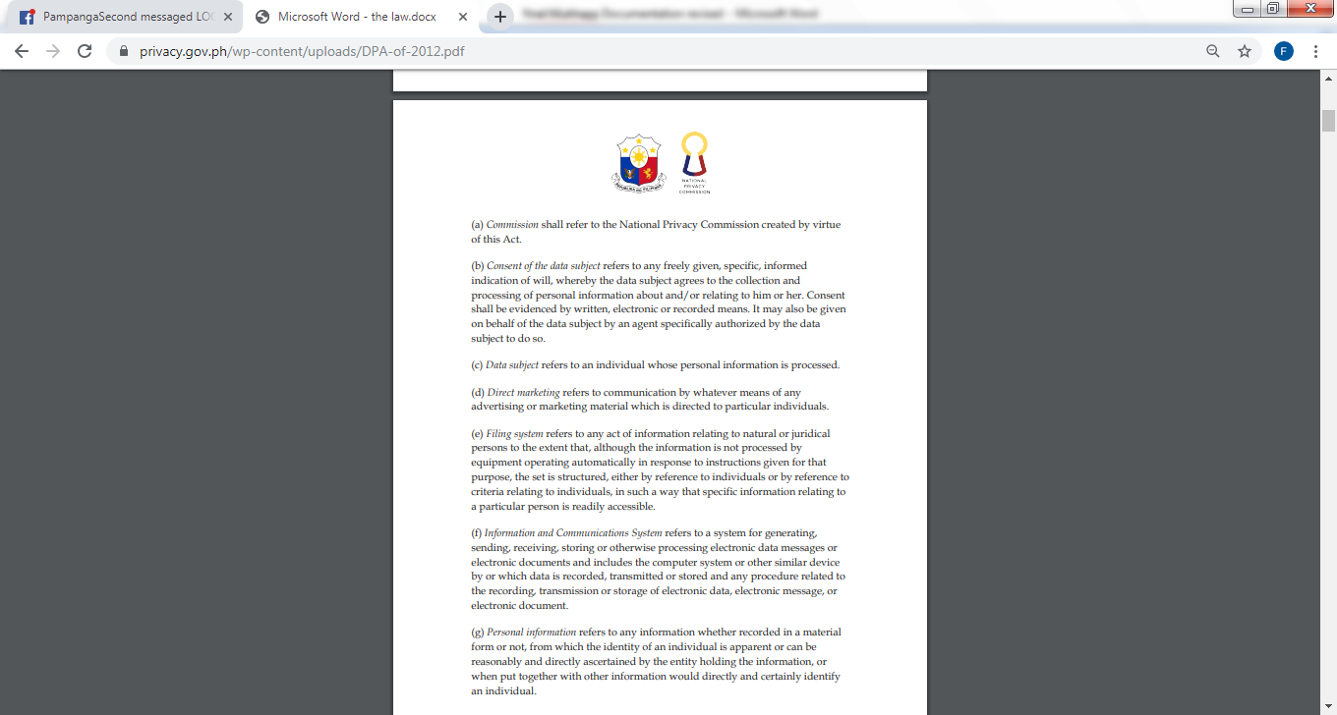

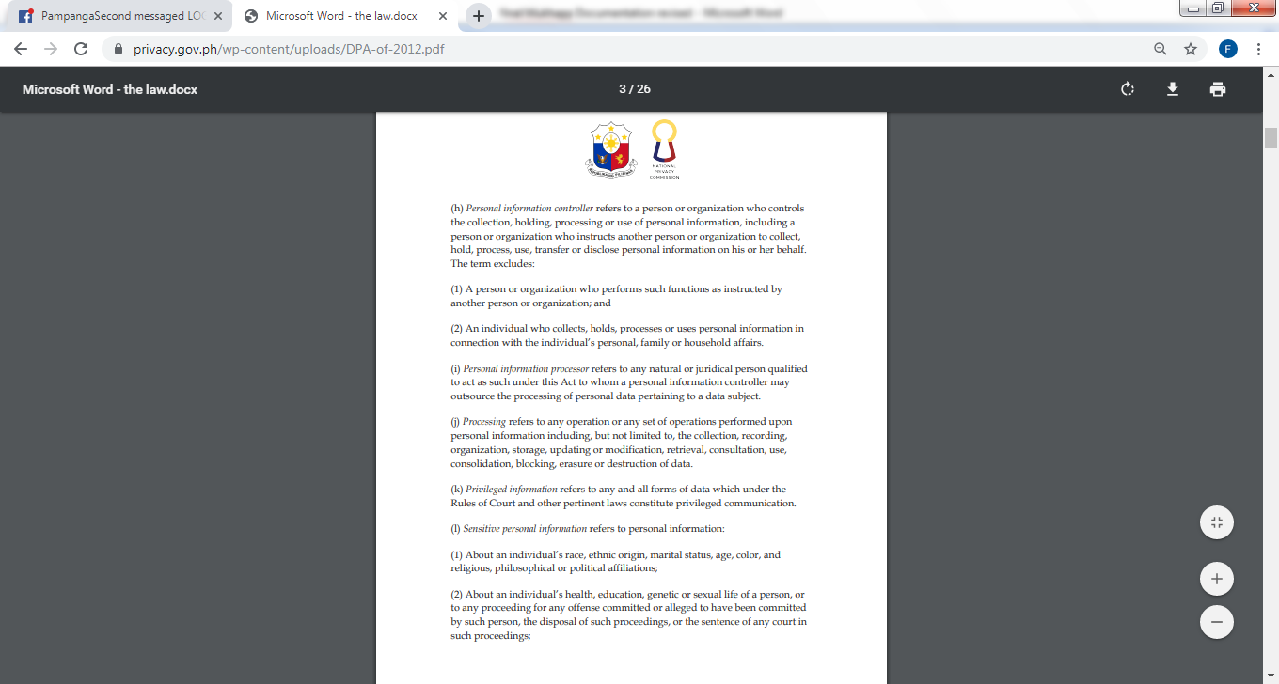

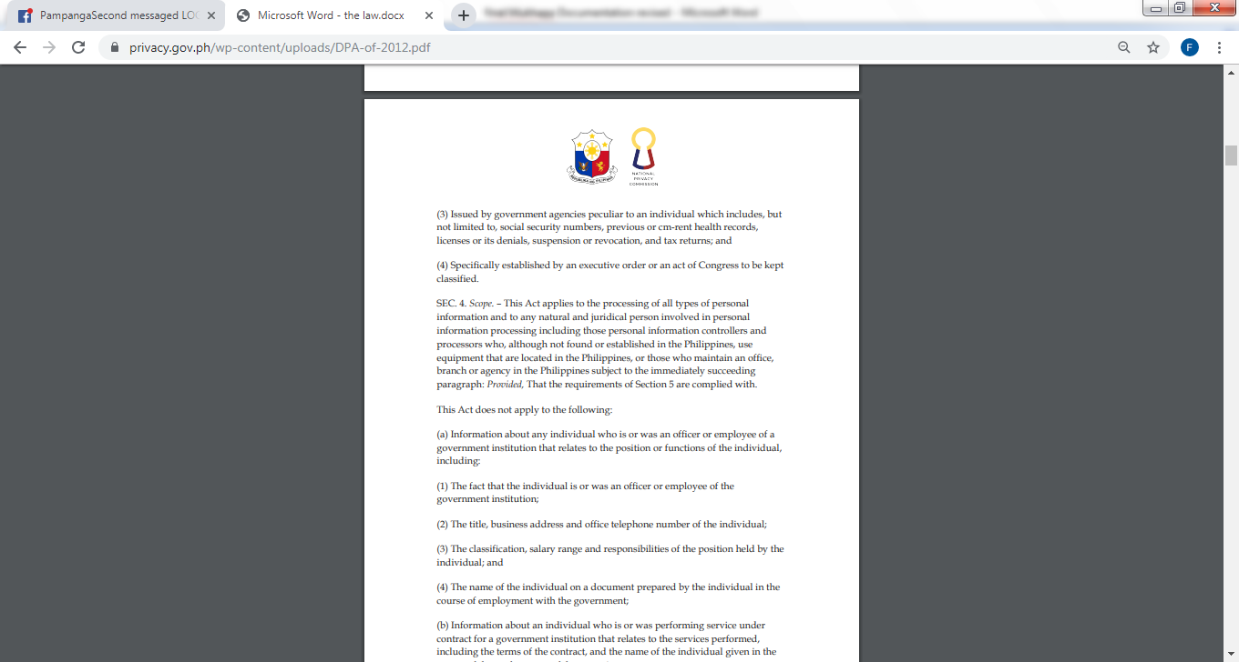

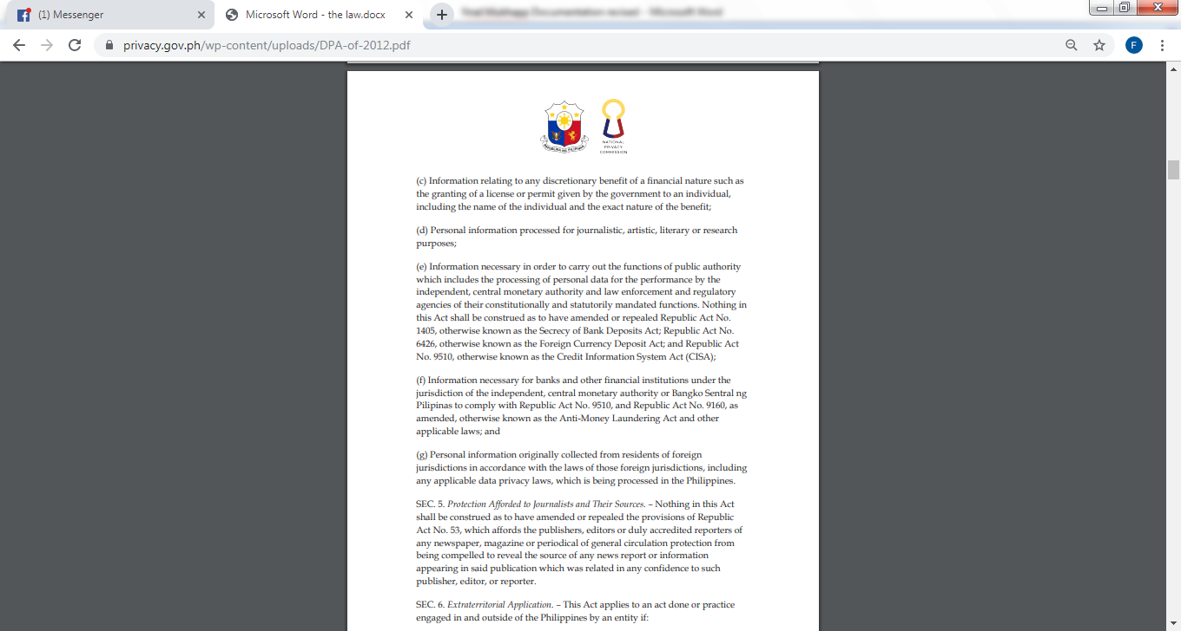

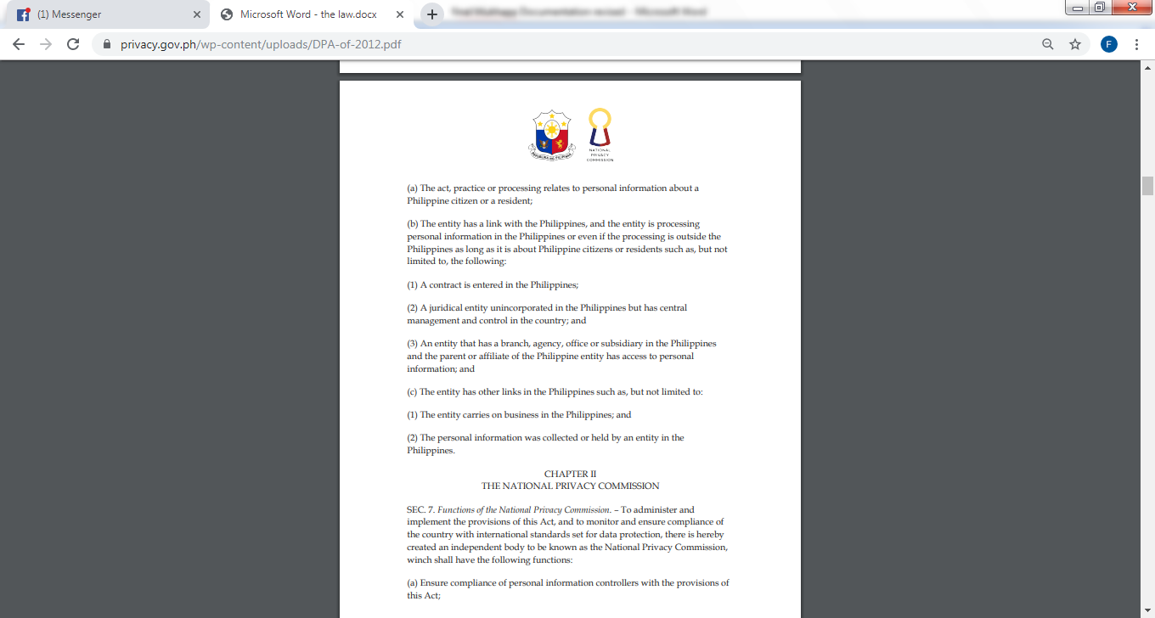

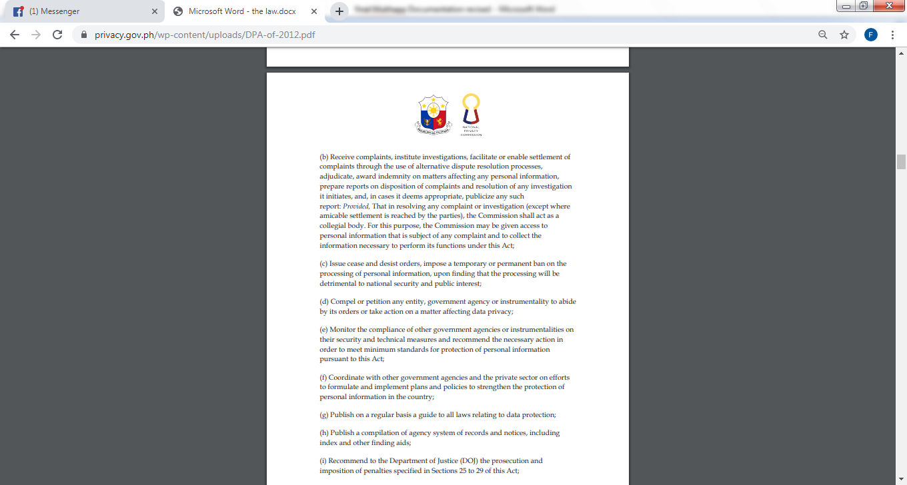

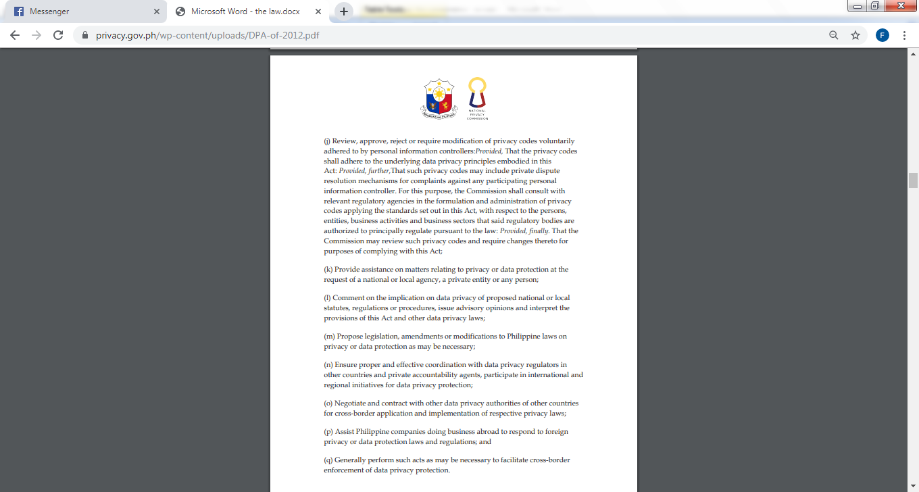

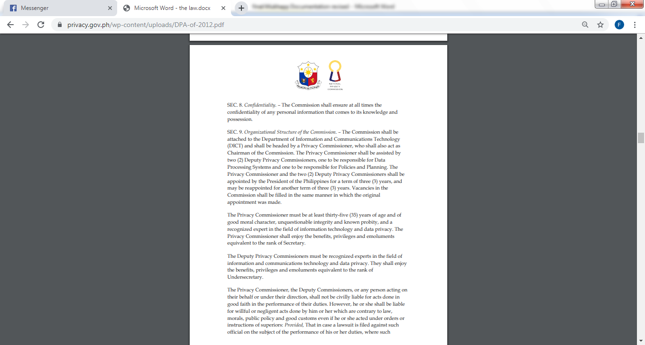

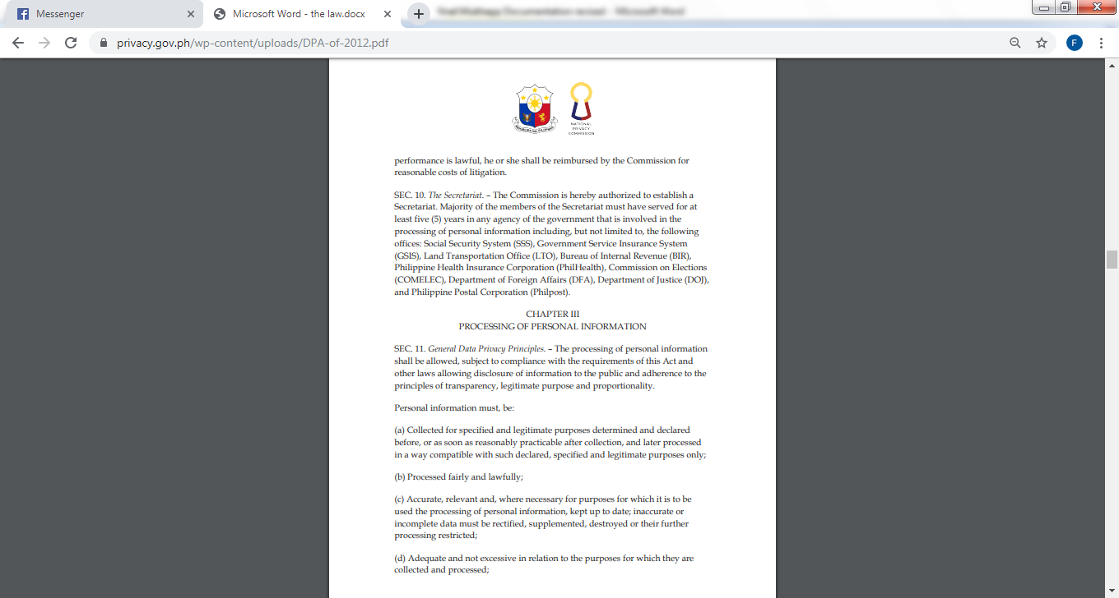

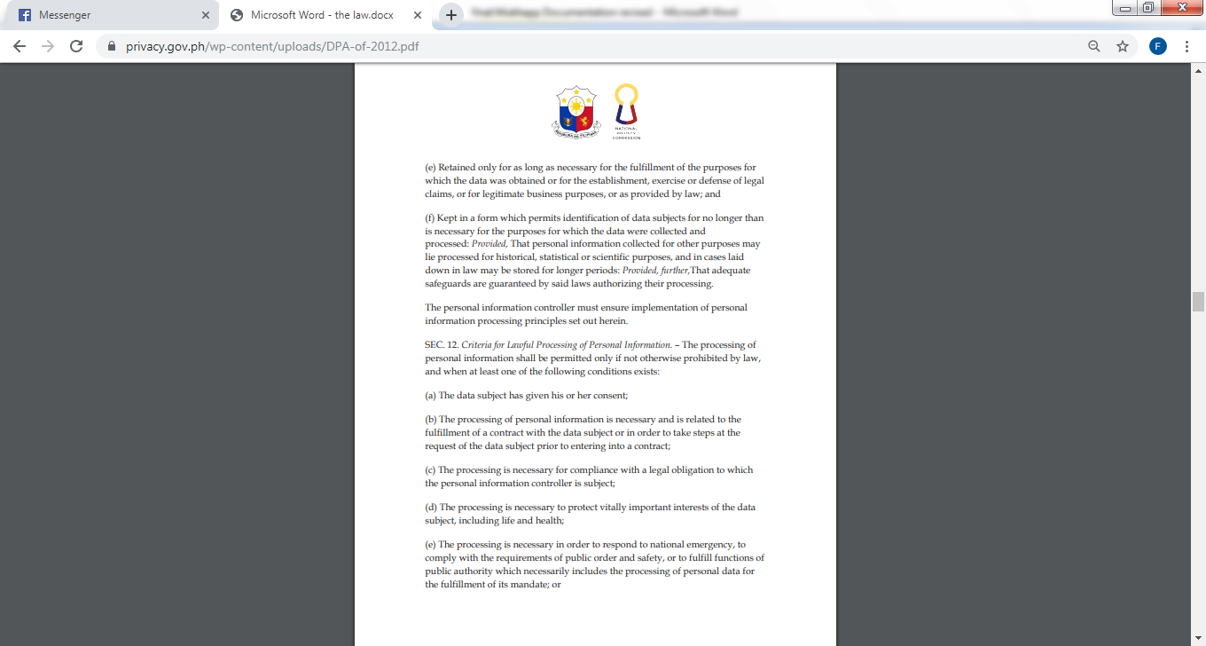

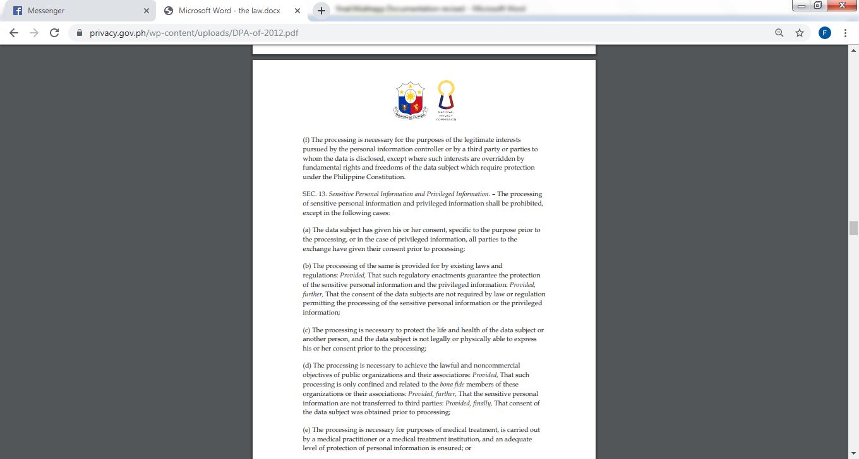

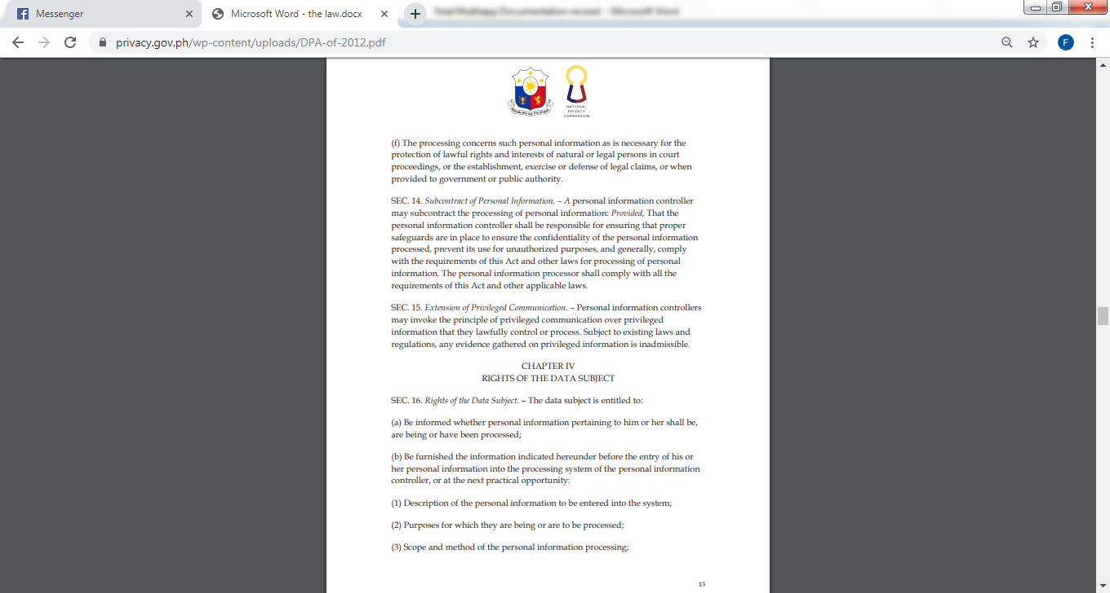

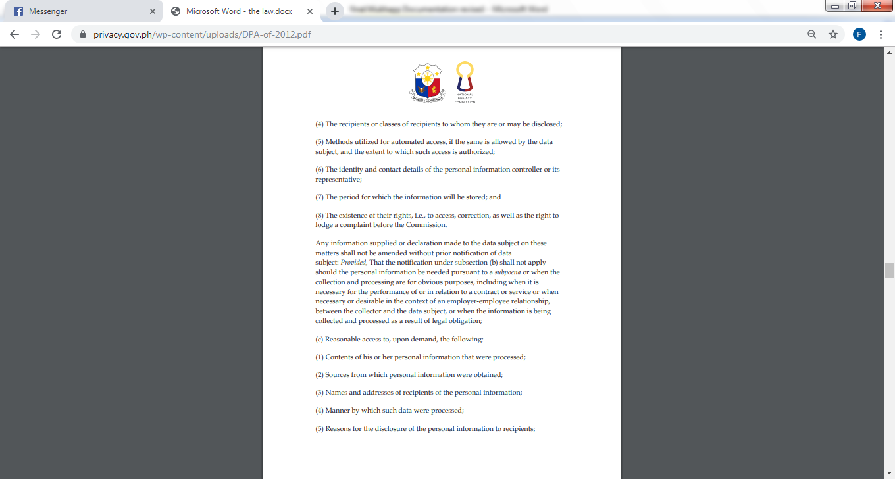

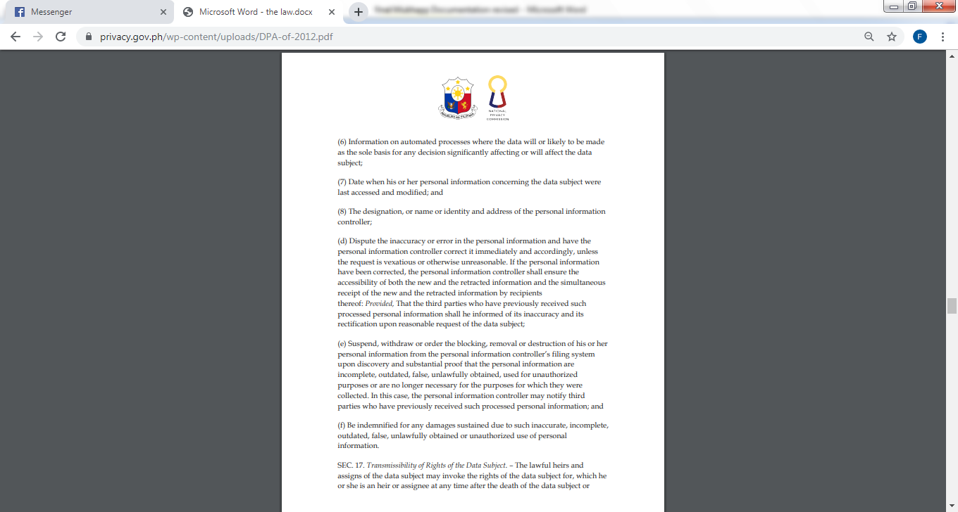

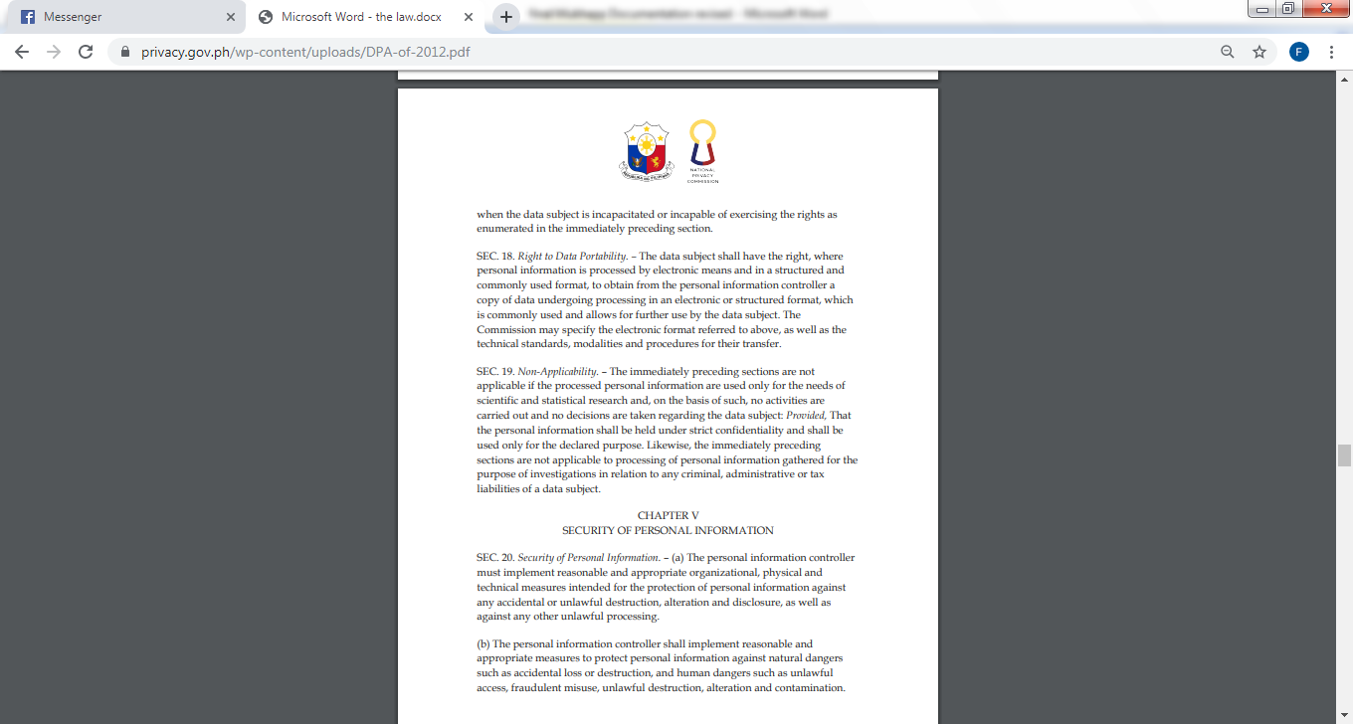

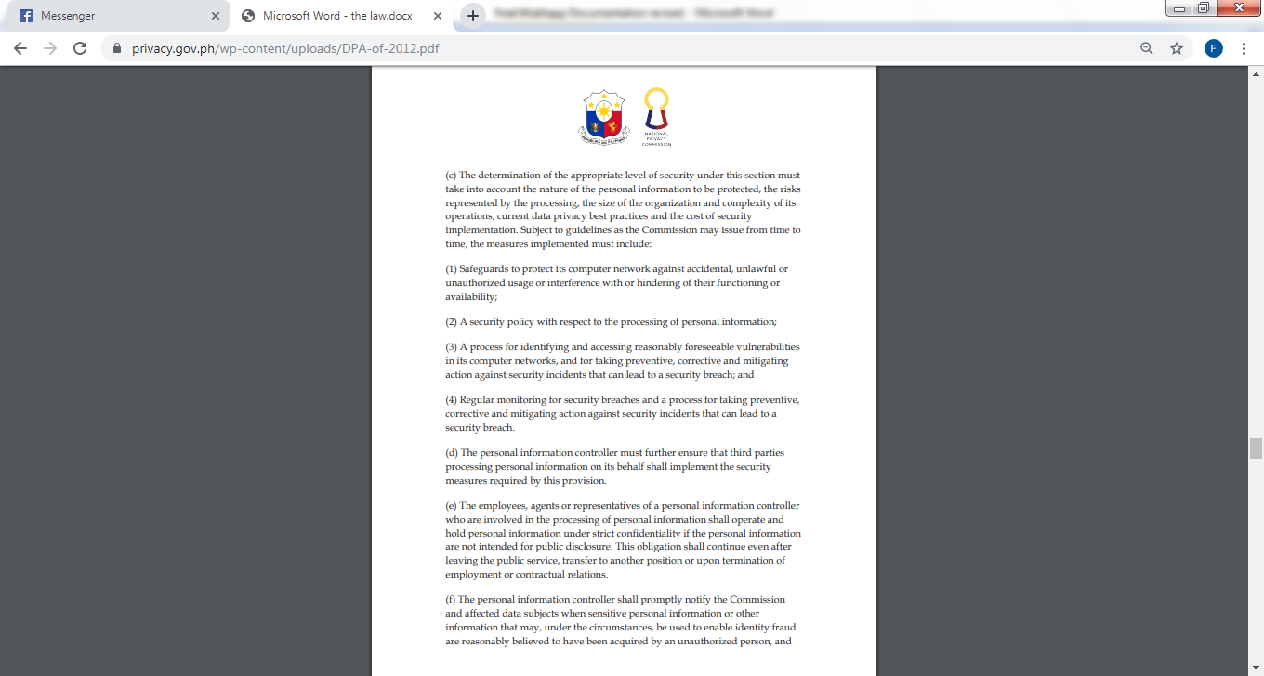

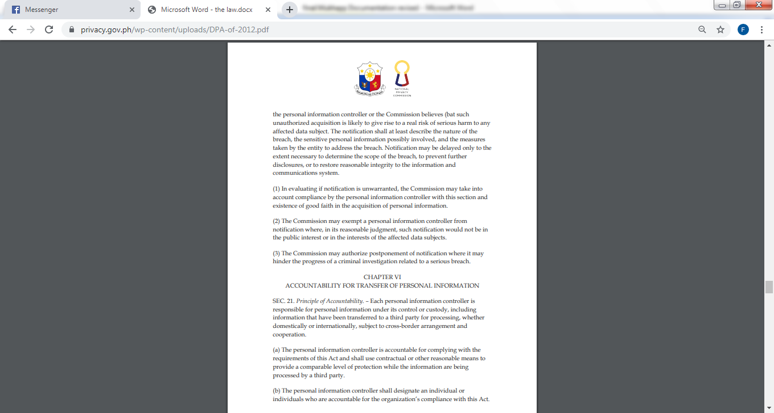

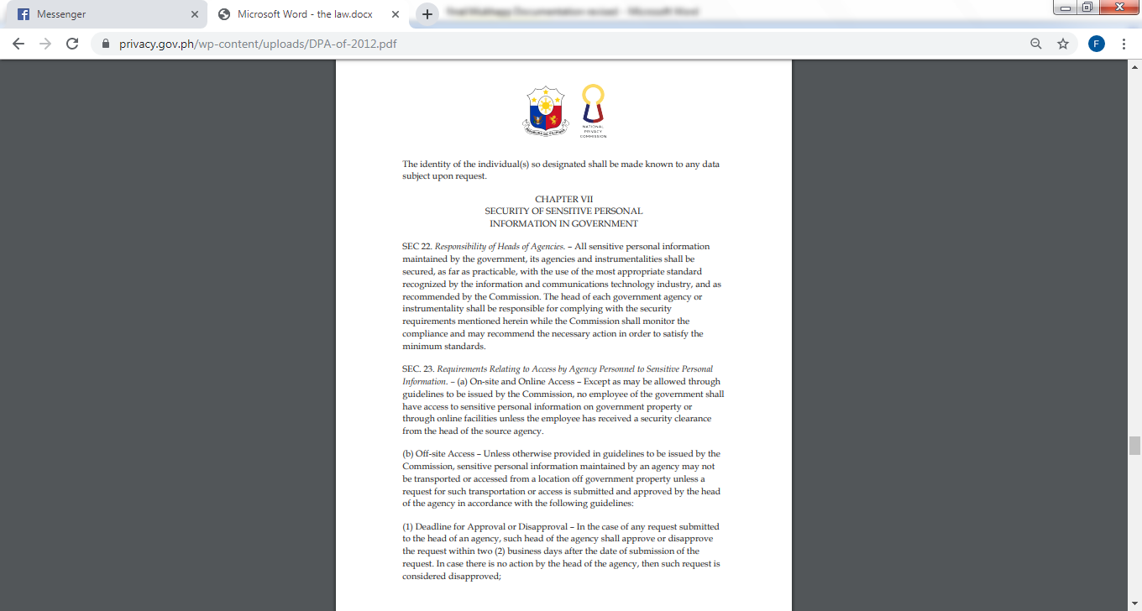

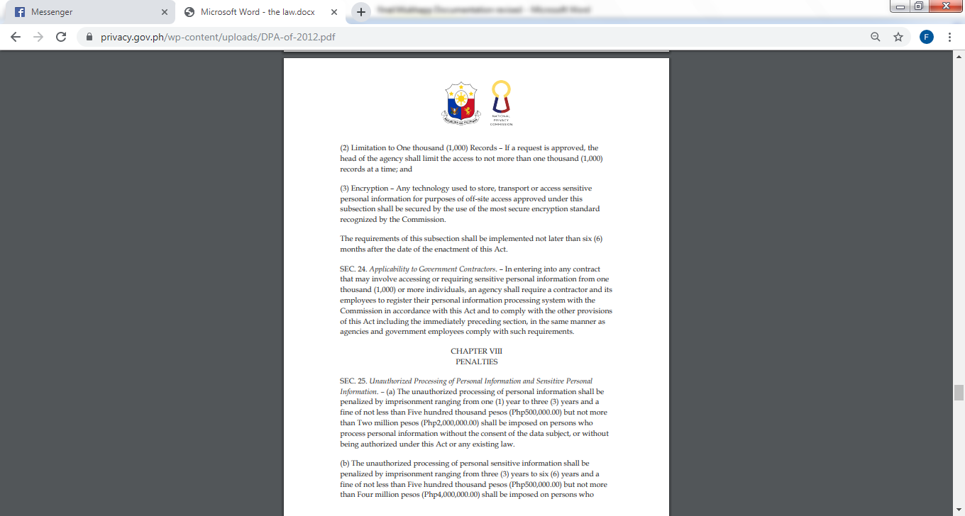

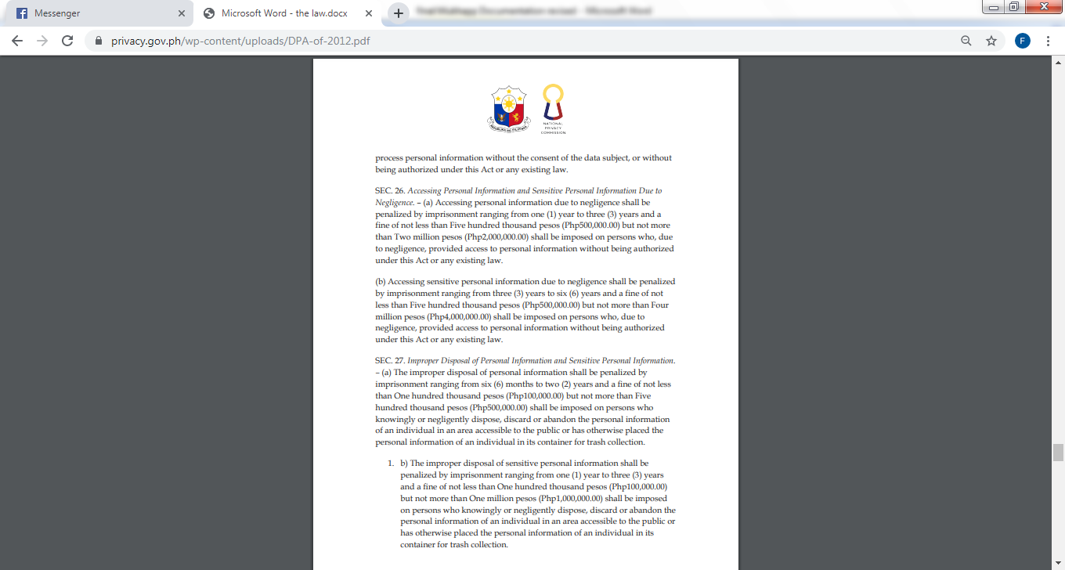

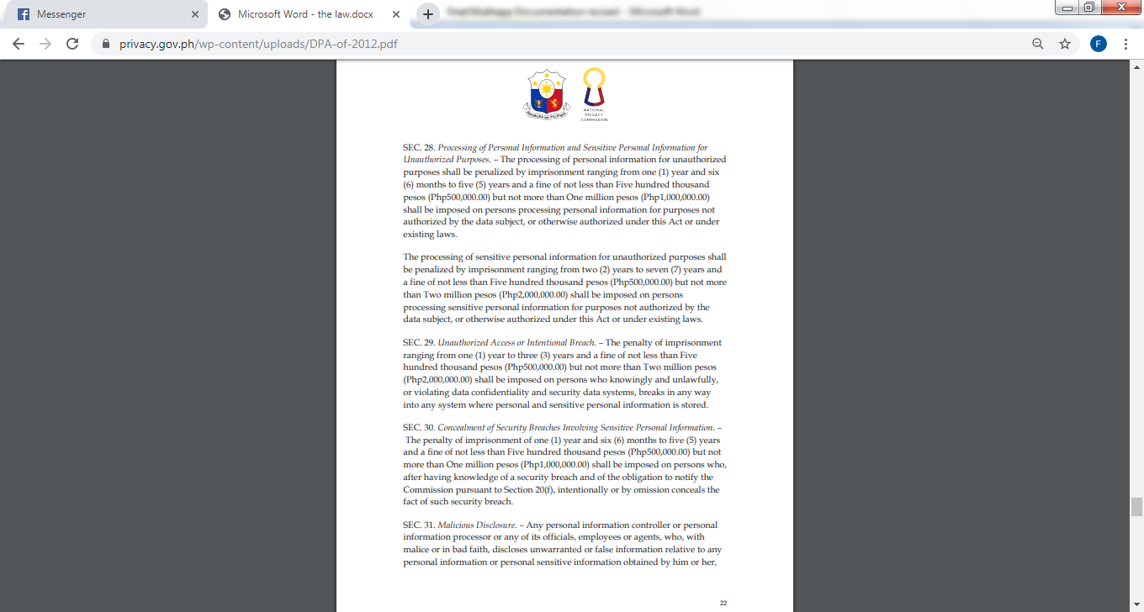

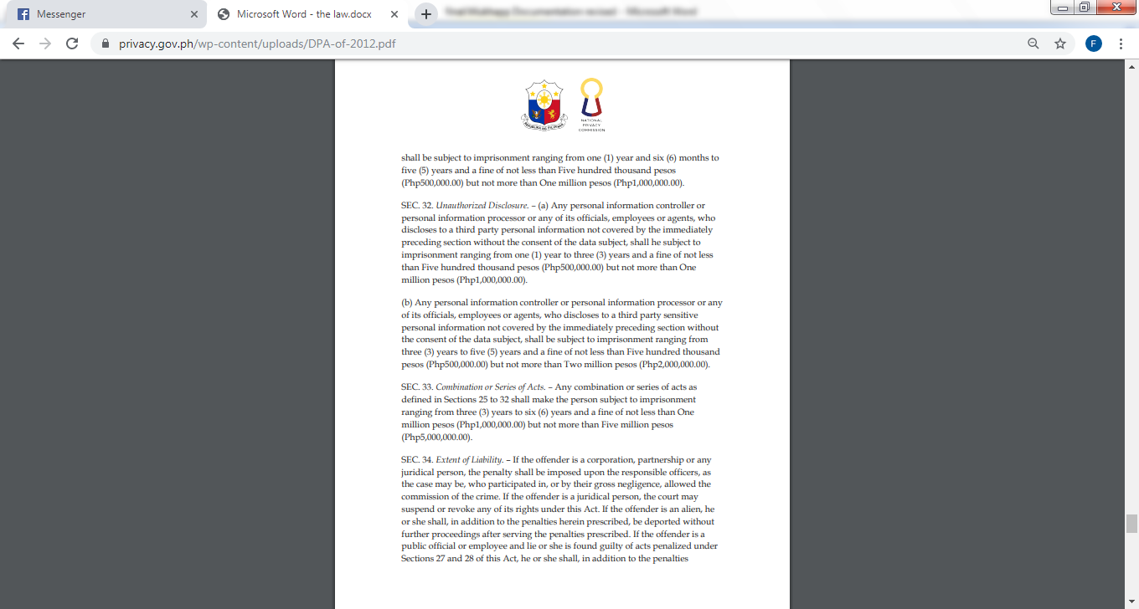

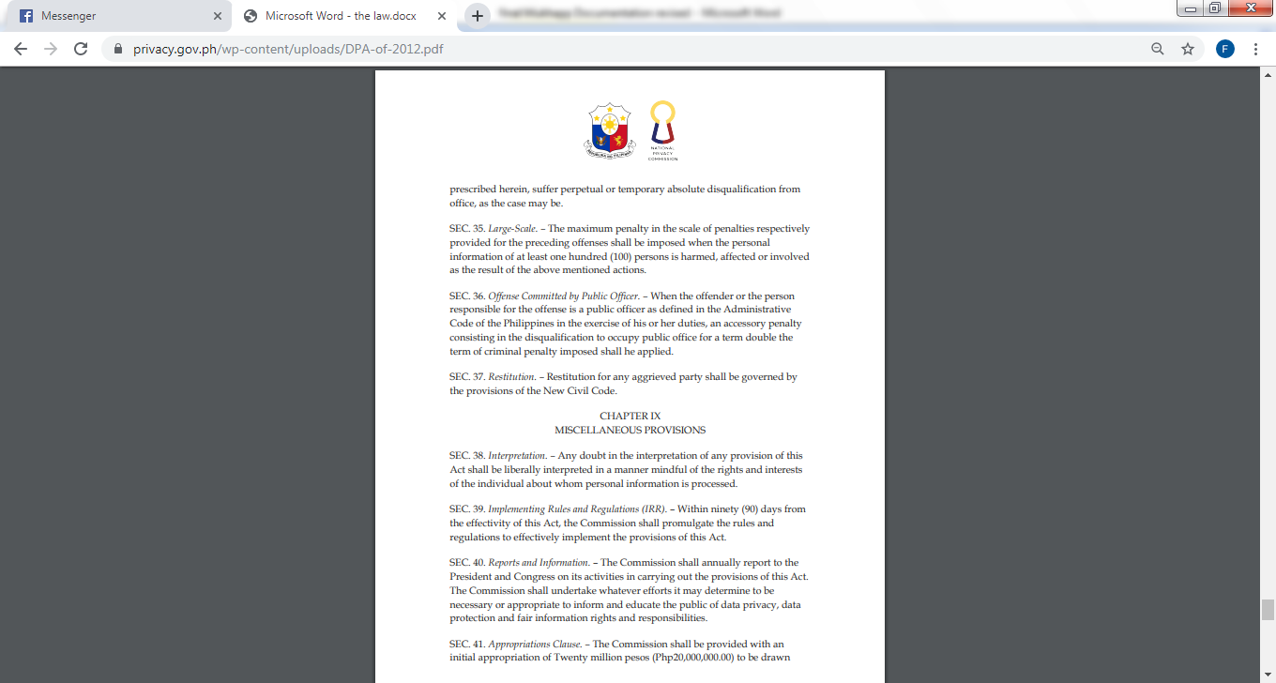

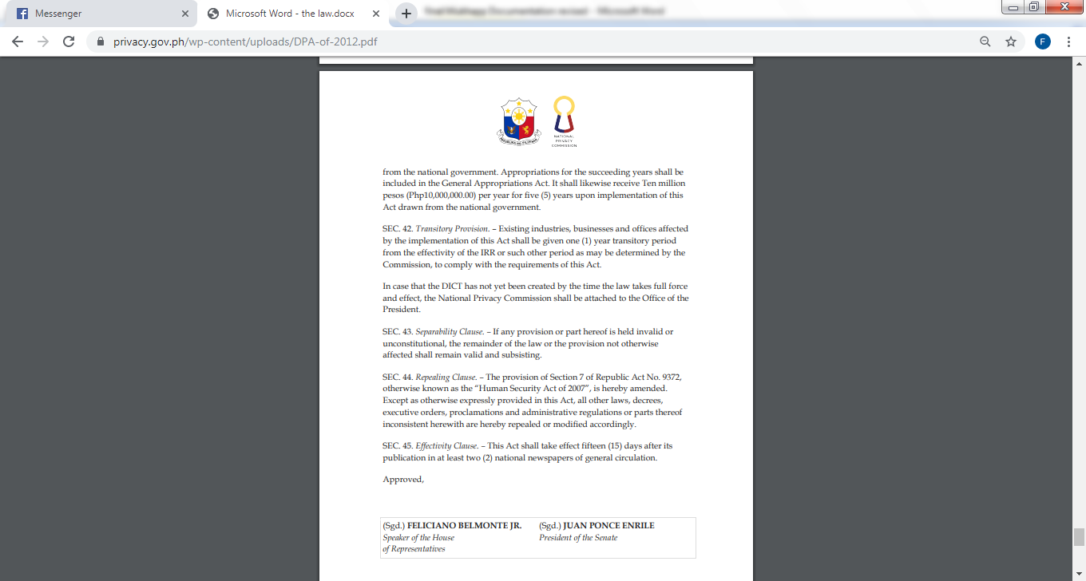

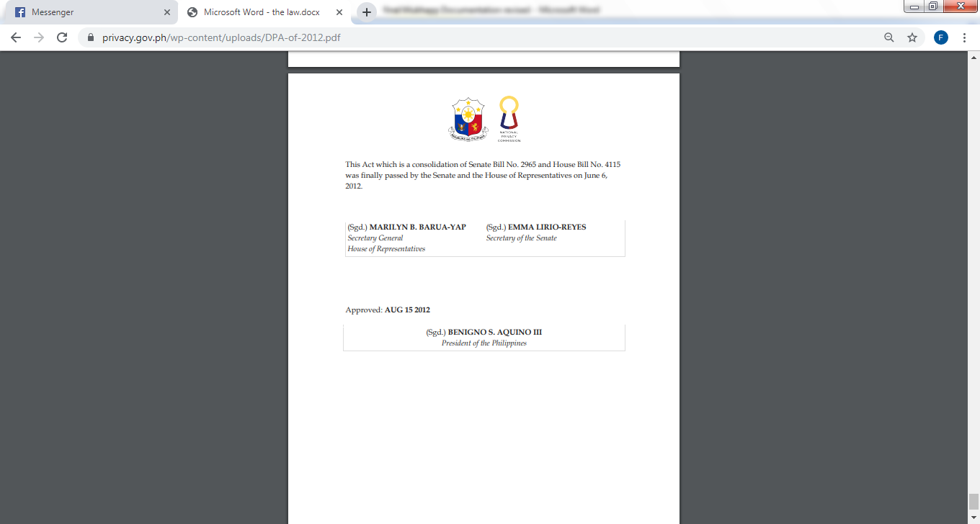

APPENDIX M

(Sample Copy of NBI Clearance)

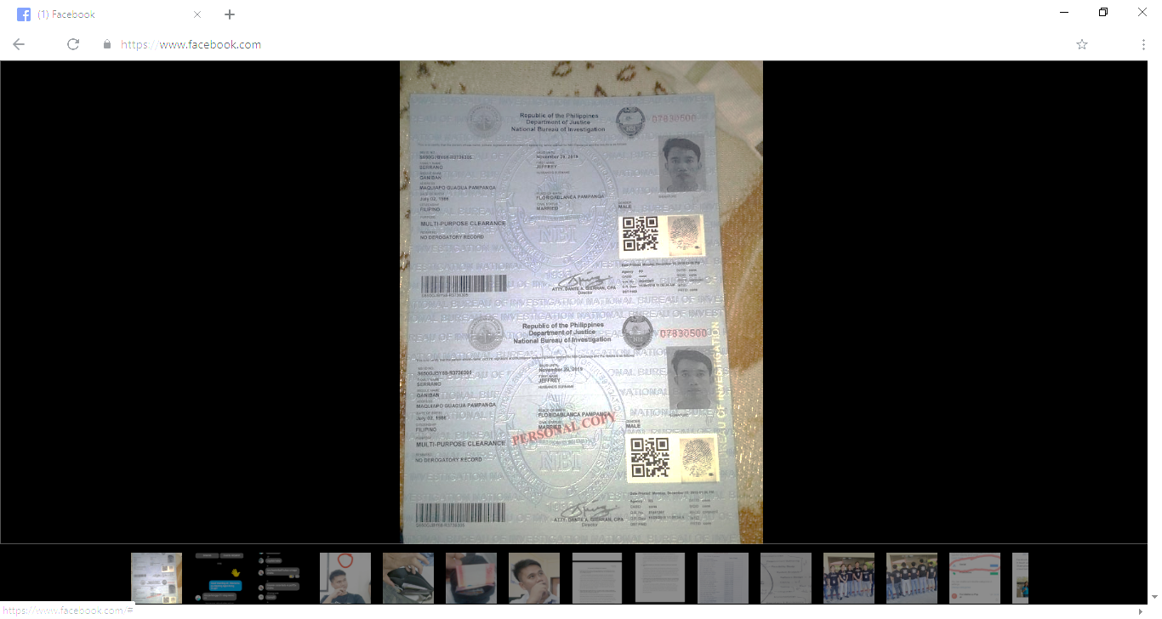

**Figure 9: Sample Copy of NBI Clearance**

APPENDIX N

(Certification from NBI)

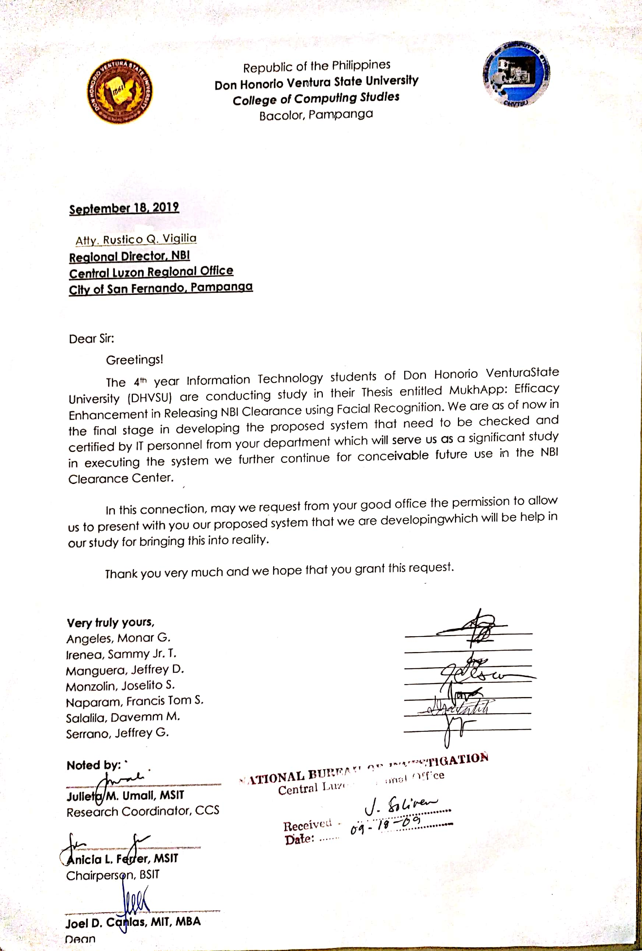

**Figure 10: Letter Request of Certification to NBI**

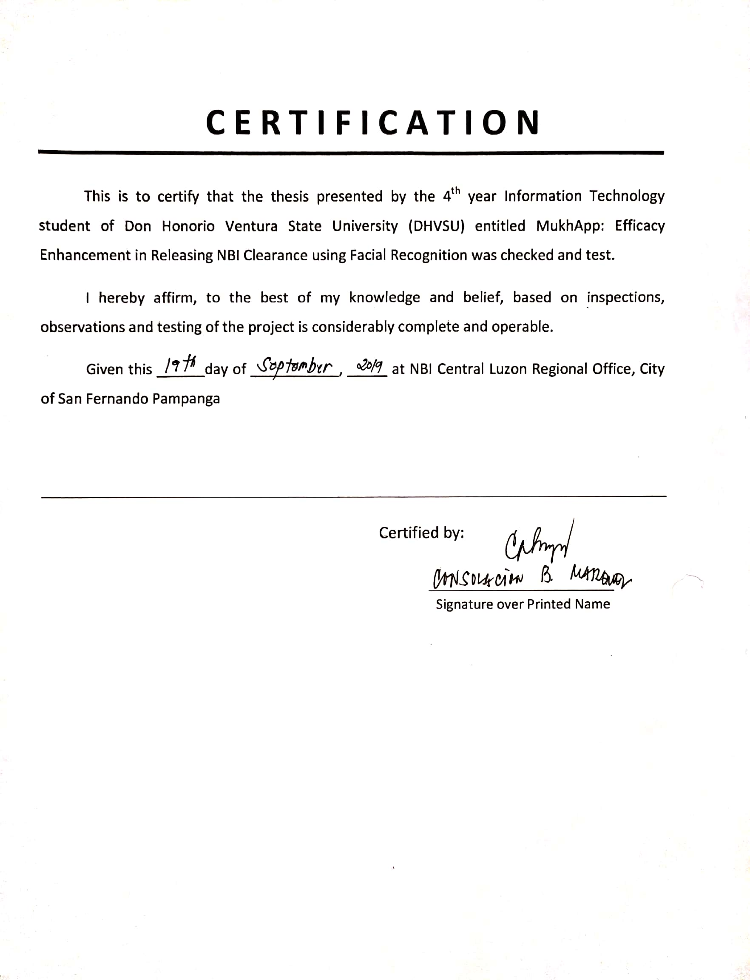

**Figure 10.1: Certificate from National Bureau of Investigation**

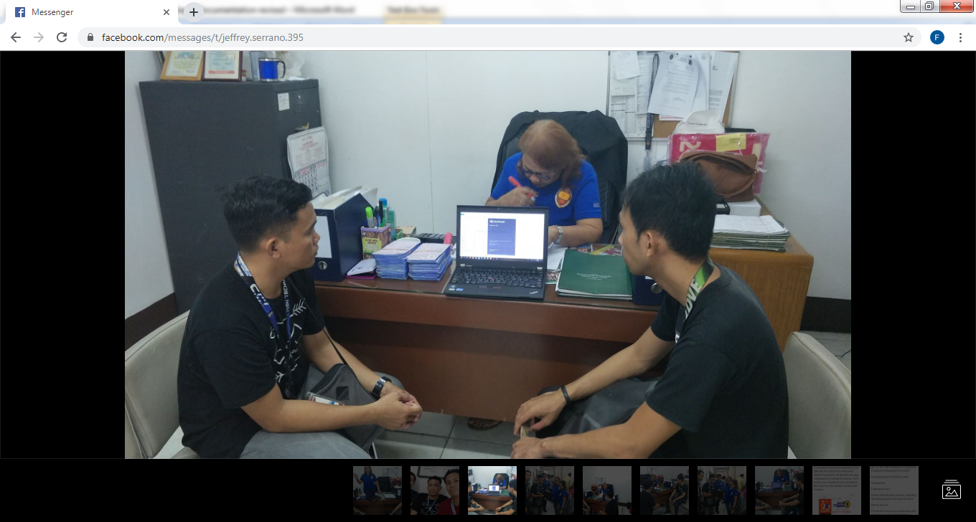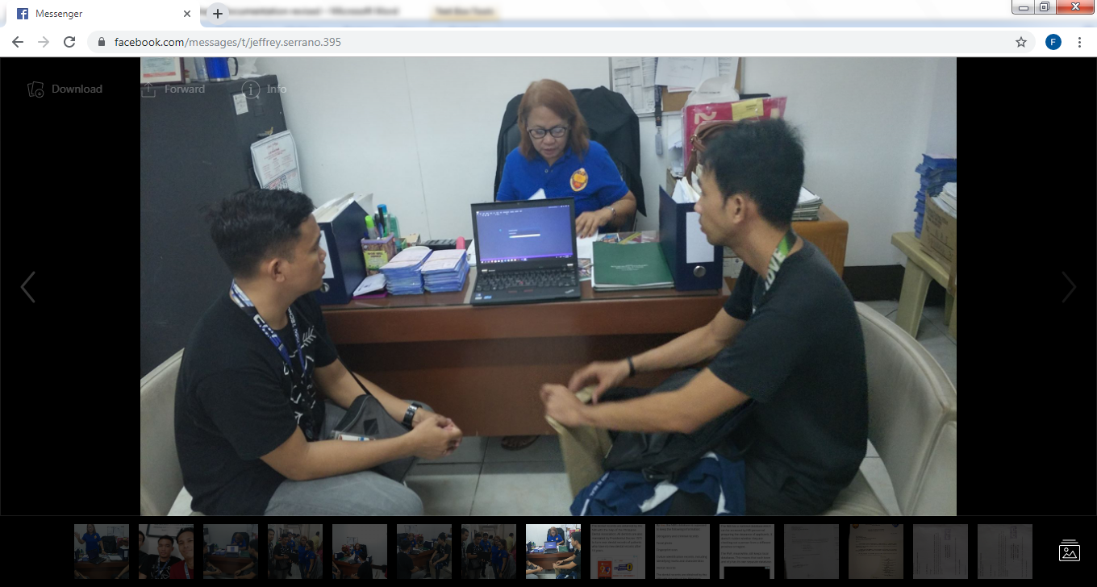

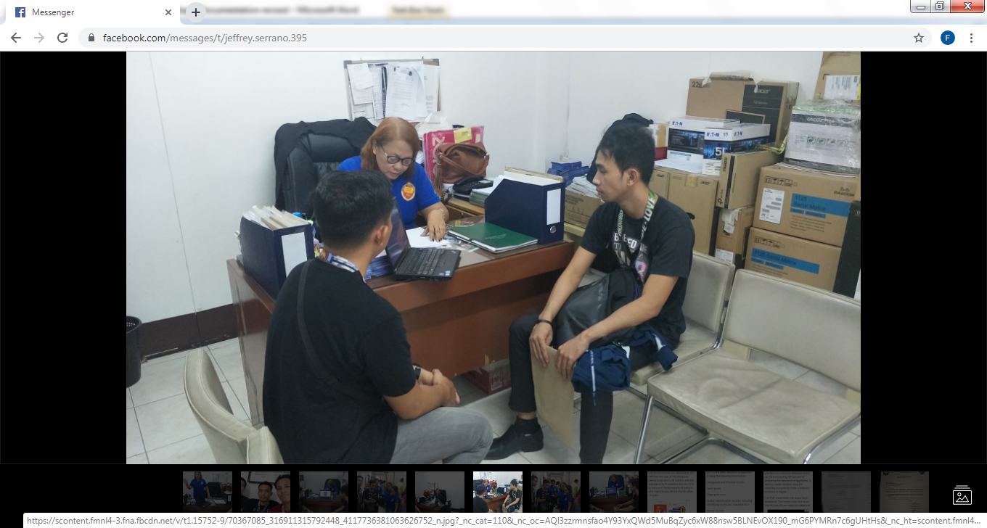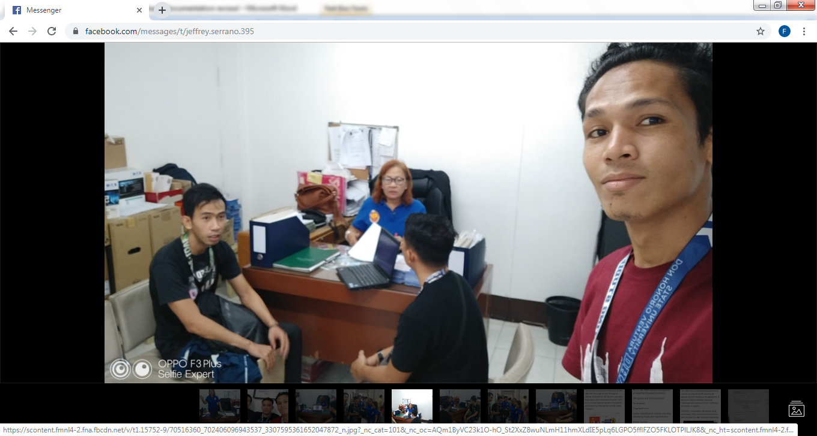

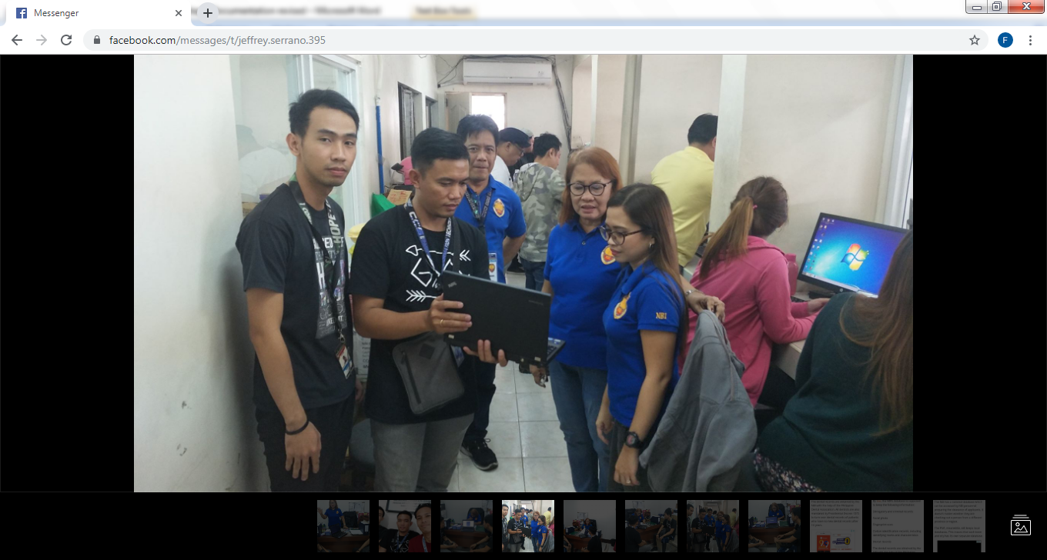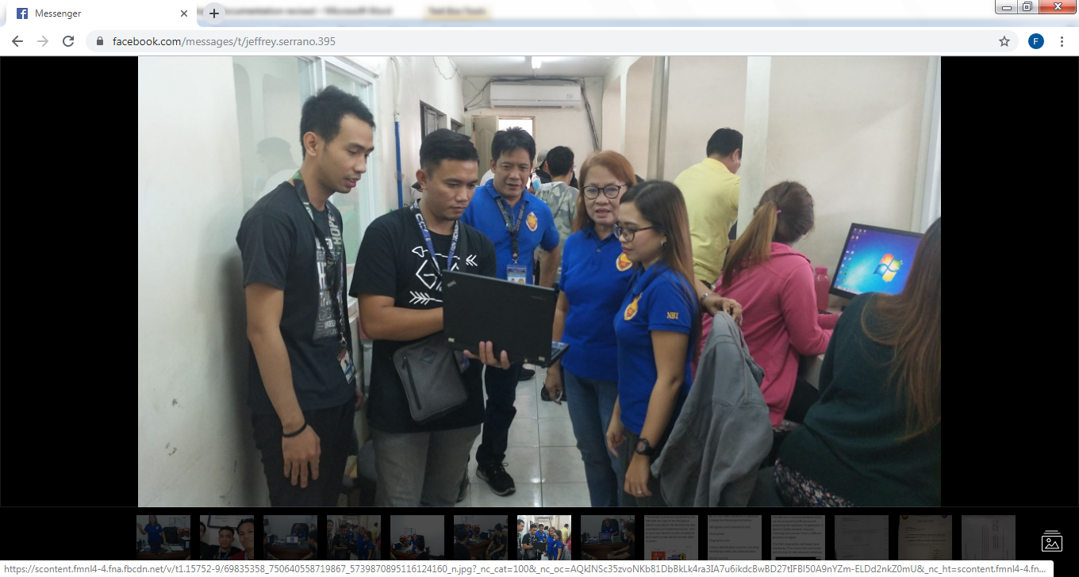

Photo showed that the proponents went to NBI Regional Office in City of San Fernando, Pampanga for the acceptance testing of the proposed system and requesting a certification that the system is considerably complete and operable.

APPENDIX O

(Curriculum Vitae of the Proponents)

|  |  |  |
| --- | --- | --- |
| **Monar Gabrino Angeles**  Address: #0601 Purok 2 San Agustin Betis, Guagua, Pampanga  Contact No.: 0905 143 1439/0947 711 3533 | |  |
|  | | |
| * To be part of the company by actively participating in achieving goals while enhancing my knowledge and skills, gain more experience and develop my potentials professional growth. * **EXPERIENCE**   04/2018-05/2018 **LGU Guagua**  SPES Administrative Aide  (Office Staff)  Guagua, Pampanga  04/2017-05/2017 **LGU Guagua**  SPES Administrative Aide  (Data Enumerator)  Guagua, Pampanga  12/2013-11/2015 **SMK Electronics Phils.**  **Corporation**  Production Engineering  Support (Machine Technician)  Clarkfield, Pampanga  04/2013-09/2013 **Universal Robina**  **Corporation**  Production Operator  City of San Fernando,  Pampanga  04/2012-05/2012 **LGU Guagua**  SPES Administrative Aide  (Data Enumerator)  Guagua, Pampanga  04/2011-05/2011 **LGU Guagua**  SPES Administrative Aide  (Data Enumerator)  Guagua, Pampanga | **Personal Information**  Date of Birth: December 13, 1992  Place of Birth: City of San Fernando, Pampanga  Gender: Male  Civil Status: Single  Height: 1.77 m  Weight: 64 kg  Age: 26  Religion: Roman Catholic  Citizenship: Filipino  **Skills**  Computer literate and drafting  **Languages**  English  Intermediate  Tagalog  Very Good  Pampango  Very Good | |
| 11/2012-03/2013 **Pampanga Electronic**  **Cooperative (PELCO II)**  On the Job Training  Guagua, Pampanga | | |
| * **EDUCATION**   College Don Honorio Ventura State University (2016-2020)  Course BS in Information Technology  Vocational Don Honorio Ventura Technological State University (2011-2013)  Course Evening Opportunity Class Major in Electrical Technology  Secondary Don Honorio Ventura College of Arts and Trades (2005-2009)  Elementary San Agustin Elementary School (1999-2005)  I declare under oath that this Curriculum Vitae has been accomplished by me, and is a true, correct and complete statement pursuant to the provisions of pertinent laws, rules and regulations of the Republic of the Philippines. I also authorize the agency head / authorized representative to verify / validate the contents stated herein. I trust that this information shall remain confidential.    Monar G. Angeles | | |

|  |  |  |
| --- | --- | --- |
| Sammy Tabanas Irenea Jr.  Address: #759 St. Dominic Subd. San Miguel Betis, Guagua, Pampanga  Contact No.: 0932 980 0387 | |  |
|  | | |
| To build up a career, this is not merely a means of living but that will provide me an opportunity to utilize and develop my creativity, capability, skill and qualifications to take the challenge of the day.   * **EXPERIENCE**   04/2018-05/2018 **LGU Guagua**  SPES Administrative Aide  (Office Staff)  Guagua, Pampanga  04/2017-05/2017 **LGU Guagua**  SPES Administrative Aide  (Office Staff)  Guagua, Pampanga  12/18/17-12/22/17 **Jollibee**  JPLS Crew  Guagua, Pampanga  01/2015-04/2017 **Partyland**  Dishwasher/Kitchen Helper  City of San Fernando  Pampanga | **Personal Information**  Date of Birth: March 12, 1988  Place of Birth: Busuanga, Palawan  Gender: Male  Civil Status: Single  Height: 1.68 m  Weight: 65 kg  Age: 31  Religion: Roman Catholic  Citizenship: Filipino  **Skills**  Computer literate and Communication Skills  **Languages**  English  Intermediate  Tagalog  Very Good  Pampango  Very Good | |
| * **EDUCATION**   College Don Honorio Ventura State University (2016-2020)  Course BS in Information Technology  Secondary Guillermo D. Mendoza High School (2001-2005)  Elementary Guagua Elementary School (1995-2001)  I declare under oath that this Curriculum Vitae has been accomplished by me, and is a true, correct and complete statement pursuant to the provisions of pertinent laws, rules and regulations of the Republic of the Philippines. I also authorize the agency head / authorized representative to verify / validate the contents stated herein. I trust that this information shall remain confidential.    Sammy T. Irenea Jr. | | |

|  |  |  |
| --- | --- | --- |
| Jeffrey Duque Manguera  Address: #304 Purok 2 PulungSantol, Porac, Pampanga  Contact No.: 0950 525 9819 | |  |
|  | | |
| * To be able to work and be part of your prestigious company that would further enhance my knowledge and discipline that built me in me and would give an opportunity to learn and handle new things and tasks. * **EXPERIENCE**   04/2017-06/2017 **Jenra Supermarket**  Merchandizer  (Kraft/Emperador)  Angeles City  09/2014-06/2016 **Chuzon Supermarket**  Merchandizer (Monde  Nissin/Rebisco)  Cangatba, Porac, Pampanga  11/2012-06/2013 **Jollibee**  Service Crew (Grill Station)  City of San Fernando,  Pampanga | **Personal Information**  Date of Birth: October 1, 1995  Place of Birth: Sta. Rita, Pampanga  Gender: Male  Civil Status: Single  Height: 1.65 m  Weight: 54 kg  Age: 24  Religion: Roman Catholic  Citizenship: Filipino  **Skills**  Computer literate, Self-motivation and Communication skills  **Languages**  English  Intermediate  Tagalog  Very Good  Pampango  Very Good | |
| * **EDUCATION**   College Don Honorio Ventura State University (2016-2020)  Course BS in Information Technology  Secondary Pulung Santol High School(main) (2008-2012)  Elementary PulungSantol Elementary School (2002-2008)  I declare under oath that this Curriculum Vitae has been accomplished by me, and is a true, correct and complete statement pursuant to the provisions of pertinent laws, rules and regulations of the Republic of the Philippines. I also authorize the agency head / authorized representative to verify / validate the contents stated herein. I trust that this information shall remain confidential.    Jeffrey D. Manguera | | |

|  |  |  |
| --- | --- | --- |
| Joselito Sabal Monzolin  Address: blk 4 lot 4 ph 2 Empresa Homes SanFernando, CSFP  Contact No.: 09364339759 | |  |
|  | | |
| * To enhance my educational and professional skills in a stable and dynamic workplace and to build a long term career in IT industry with opportunities for career growth. * **EXPERIENCE**   11/2015-5/2016 **Gaisano Grand Group of**  **Companies**  Sales Associate  Mandaue City Centro, Cebu  04/2015-10/2015 **Vecsal Development**  **Corporation**  Baker  Mandaue Pacific Mall, Cebu  09/2014-03/2015 **Gaisano Dynasty**  Sales Utility Clerk  Mandaue City, Cebu | **Personal Information**  Date of Birth: March 15, 1994  Place of Birth: Sogod, Cebu  Gender: Male  Civil Status: Single  Height: 1.72 m.  Weight: 56 kg  Age: 25  Religion: Roman Catholic  Citizenship: Filipino  **Skills**  Computer literate and Communication skills  **Languages**  English  Intermediate  Tagalog  Very Good  Cebuano  Very Good | |
| * **EDUCATION**   College Don Honorio Ventura State University (2016-2020)  Course BS in Information Technology  Secondary Cabalawan National High School (2007-2011)  Elementary Cabalawan Elementary School (2001-2007)  I declare under oath that this Curriculum Vitae has been accomplished by me, and is a true, correct and complete statement pursuant to the provisions of pertinent laws, rules and regulations of the Republic of the Philippines. I also authorize the agency head / authorized representative to verify / validate the contents stated herein. I trust that this information shall remain confidential.    Joselito S. Monzolin | | |

|  |  |  |
| --- | --- | --- |
| Francis Tom Sagum Naparam  Address: #323 San Juan, San Luis, Pampanga  Contact No.: 0905 757 3309 | | C:\Users\user\Downloads\54433181_301531090539150_5237023751962361856_n.jpg |
|  | | |
| * To be part of the company by actively participating in achieving goals while enhancing my knowledge and skills, gain more experience and develop my potentials professional growth. * **EDUCATION**   College Don Honorio Ventura State University  (2016-2020)  Course BS in Information Technology  Vocational TESDA (2015)  Course Welding  Secondary San Juan High School (2010-2014)  Elementary San Juan Elementary School (2004-2010) | **Personal Information**  Date of Birth: February 24, 1998  Place of Birth: City of San Fernando, Pampanga  Gender: Male  Civil Status: Single  Height: 1.77 m  Weight: 95 kg  Age: 21  Religion: Roman Catholic  Citizenship: Filipino  **Skills**  Computer literate  **Languages**  English  Intermediate  Tagalog  Very Good  Pampango  Very Good | |
| I declare under oath that this Curriculum Vitae has been accomplished by me, and is a true, correct and complete statement pursuant to the provisions of pertinent laws, rules and regulations of the Republic of the Philippines. I also authorize the agency head / authorized representative to verify / validate the contents stated herein. I trust that this information shall remain confidential.    Francis Tom S. Naparam | | |

|  |  |  |
| --- | --- | --- |
| **Davemm Manglalan Salalila**  Address: #451 Purok 1 Ascomo, Guagua, Pampanga  Contact No.: 09036 031 2868 | |  |
|  | | |
| * To be able to work and be part of your prestigious company that would further enhance my knowledge and discipline that built me in me and would give an opportunity to learn and handle new things and tasks. * **EXPERIENCE**   11/2014-08/2015 **7-Eleven Philippines**  Lead Clerk  Dau, Mabalacat, Pampanga  07/2013-07/2014 **Cheong-bo Electronics**  Computer Technician/CCTV  Installer  Timog Park Homes, Angeles  City, Pampanga | **Personal Information**  Date of Birth: December 9, 1996  Place of Birth: Floridablanca, Pampanga  Gender: Male  Civil Status: Single  Height: 1.75 m  Weight: 59 kg  Age: 22  Religion: Baptist  Citizenship: Filipino  **Skills**  Computer literate, Self-motivation and Communication skills  **Languages**  English  Intermediate  Tagalog  Very Good  Pampango  Very Good | |
| * **EDUCATION**   College Don Honorio Ventura State University (2016-2020)  Course BS in Information Technology  Vocational Asia Institute of E-Commerce (2011-2013)  Course Electronic Commerce  Secondary Megabyte College (2007-2011)  Elementary Christian Home Learning Center (2001-2007)  I declare under oath that this Curriculum Vitae has been accomplished by me, and is a true, correct and complete statement pursuant to the provisions of pertinent laws, rules and regulations of the Republic of the Philippines. I also authorize the agency head / authorized representative to verify / validate the contents stated herein. I trust that this information shall remain confidential.    Davemm M. Salalila | | |

|  |  |  |
| --- | --- | --- |
| Jeffrey Ganiban Serrano  Address: Purok 1Maquiapo, Guagua, Pampanga  Contact No.: 0945 517 5359 | |  |
|  | | |
| * To enhance my educational and professional skills in a stable and dynamic workplace and to build a long term career in IT industry with opportunities for career growth. * **EXPERIENCE**   10/2014-Present **Philippine National Police**  Non-Uniformed Personnel  (NUP)  Floridablanca MPS,  Floridablanca Pampanga  10/2009-10/2014 **Edermcenters Inc.**  Branch Assistant  Robinsons, Starmills, City of  San Fernando, Pampanga  10/2008-03/2009 **ACE Hardware Philippines**  Sales Utility Clerk  SM City Pampanga, City of  San Fernando, Pampanga  01/2008-07/2008 **New Centennial Plastic and**  **Printing Corporation**  Packer/Helper  Valenzuela City  062007-12/2007 **Mekeni Food Corporation**  Delivery Crew  Balubad, Porac, Pampanga  05/2005-04/2007 **During’s BBQ and**  **Restaurant**  Service Crew  Kalawaan, Pasig City | **Personal Information**  Date of Birth: July 2, 1986  Place of Birth: Floridablanca, Pampanga  Gender: Male  Civil Status: Married  Height: 1.68 m  Weight: 65 kg  Age: 33  Religion: Roman Catholic  Citizenship: Filipino  **Skills**  Computer literate and Communication skills  **Languages**  English  Intermediate  Tagalog  Very Good  Pampango  Very Good | |
| * **EDUCATION**   College Don Honorio Ventura State University (2016-2020)  Course BS in Information Technology  Vocational Systems Technology Institute (STI) (2003-2005)  Course Diploma in Computer Studies  Secondary San Roque Dau High School (1999-2003)  Elementary Maquiapo Elementary School (1993-1999)  I declare under oath that this Curriculum Vitae has been accomplished by me, and is a true, correct and complete statement pursuant to the provisions of pertinent laws, rules and regulations of the Republic of the Philippines. I also authorize the agency head / authorized representative to verify / validate the contents stated herein. I trust that this information shall remain confidential.    Jeffrey G. Serrano | | |